September 2006
Project I - Requirements Elicitation
SynergySoft Distributed Meeting Scheduler


Instructor : Dr. Chung
Project Group : Duk-Jin Kim
Tu Peng
Yan Shi

Table of Contents
-------------------------------------------------------------------------------------------------------------------------------------------------------------------------
Introduction 2
General Overview 2
Purpose 2
Document Overview 2
The Process 3
Development Process 3
Stakeholders 3
Team Members and Responsibilities 3
Problem Analysis Step 3
Sources of Requirements 4
Semi-formal Requirement Description: Preliminary Definition 5
Enterprise Requirements 5
Functional Requirements 6
NonFunctional Requirements 7
Issues 9
Enterprise Requirement 9
System Functional Requirement 11
System Nonfunctional Requirement 13
Improved Understanding 14
Enterprise Requirements 14
System Functional Requirements 20
System Nonfunctional Requirements 24
Prototype 26

Introduction
-------------------------------------------------------------------------------------------------------------------------------------------------------------------------

General Overview
Human interactions and communication is base of our society. Every organization and group has proposed its objective by interactions among each member. Scheduling meeting is underneath of all group activities. As growing of complexity of the society, people involve more tasks than ever so finding time to meet each other becomes more complex.
As the growing demand of the automated scheduling system, SynergySoft Inc. starts developing the web based scheduling system, known as SDMS software system, which allows the user more flexibilities of scheduling meeting simply by proposing meeting and agendas. The system will automatically generate possible meeting date and locations based on the meeting participants’ responses. This document contains possible issues of current requirement specification and our understandings and solutions of the enterprise specification, the system functional specification, and the non-functional specification. Also, this document provides the mockup prototype of SDMS software system.

Purpose
This project is to present a brief introduction of the SDMS system. This is an online Meeting Scheduling software system. SDMS or SynergySoft Distribute Meeting Scheduler simply refers to automated on-line scheduling system.

Document Overview
- Introduction provides an overview of the entire SDMS system document,.
- The Process Identify the stakeholders and describes how our team is divided up and what role each of our team member plays; Identify and describe what sources were considered.
- Preliminary Semi-formal Requirement Description is about three parts: Enterprise Requirements, System Functional Requirements and Nonfunctional requirements.
- Issues show the inconsistency, incompleteness, ambiguity, redundancy, etc. The solutions of these problems are also included.
- Improved Understanding shows the improved requirement description based on discussions of 3 and 4. It also contains three parts: Enterprise Requirements, System Functional Requirements and Nonfunctional Requirements.
- Mockup Prototype shows the SDMS software web interfaces.

The Process
-------------------------------------------------------------------------------------------------------------------------------------------------------------------------

Development Process

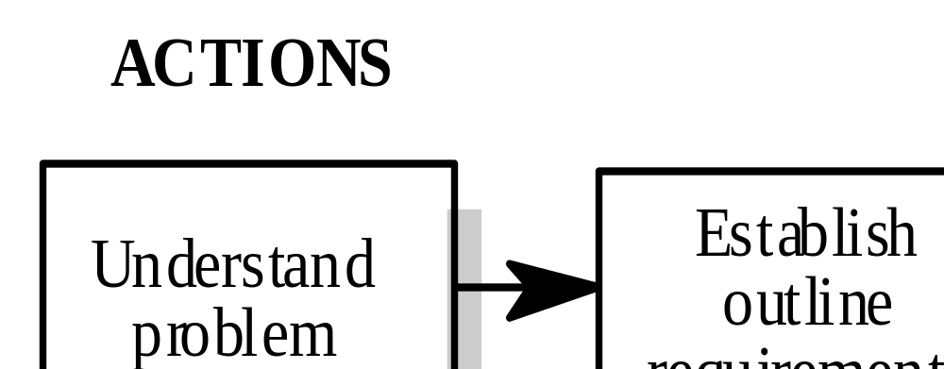
for prototyping [Kotonya&Sommerville98]

Figure 1: Development Process

Stakeholders
The category of stakeholders includes:
- End user
- Domain Expert
- Requirement Engineer
- Project Manager
- Software Engineer

Team Members and Responsibilities
Our team consists of three people: Tu Peng, Yan Shi, and Duk-Jin Kim. All three members in our team play the above roles as discussed in stakeholders section.

Problem Analysis Step
- Analysis the previous requirement specification
- Learn about the problem domain
- Understand the needs of potential users
- Understand all constraints on the solution
- Perform trade-offs between constraints
- Consider alternatives.
The major source of our information is through observing the activities of how people schedule meeting and using SDMS system.

Sources of Requirements
[1] CS6361 Project1: first Iteration – Requirements Elicitation: Initial Understanding, Prof. Chung
[2] Sample deliverable and previous project presentations
[3] www.meetingwizard.com

Semi-formal Requirement Description: Preliminary Definition

Enterprise Requirements
-------------------------------------------------------------------------------------------------------------------------------------------------------------------------

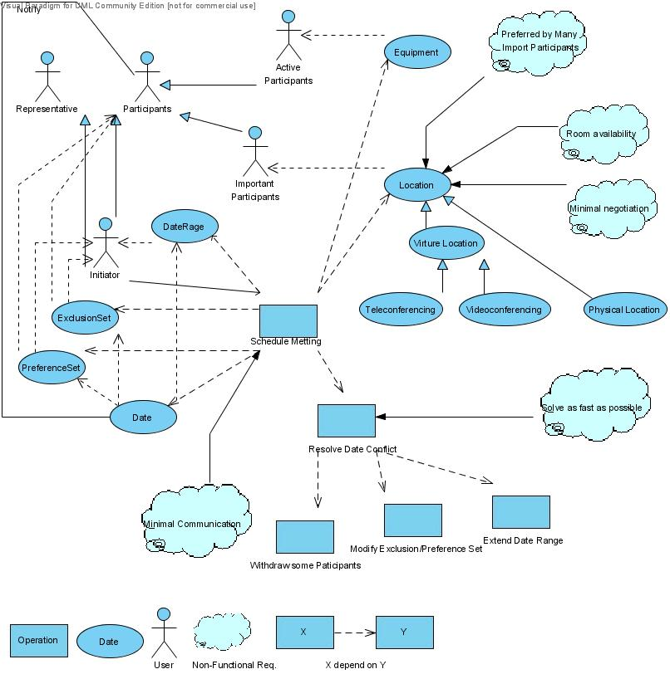

Figure 1 Enterprise Dependency Diagram

Semi-formal Requirement Description: Preliminary Definition

Functional Requirements
-------------------------------------------------------------------------------------------------------------------------------------------------------------------------
According to the informal preliminary definition, we derive the following dependency graph for system functional requirement.
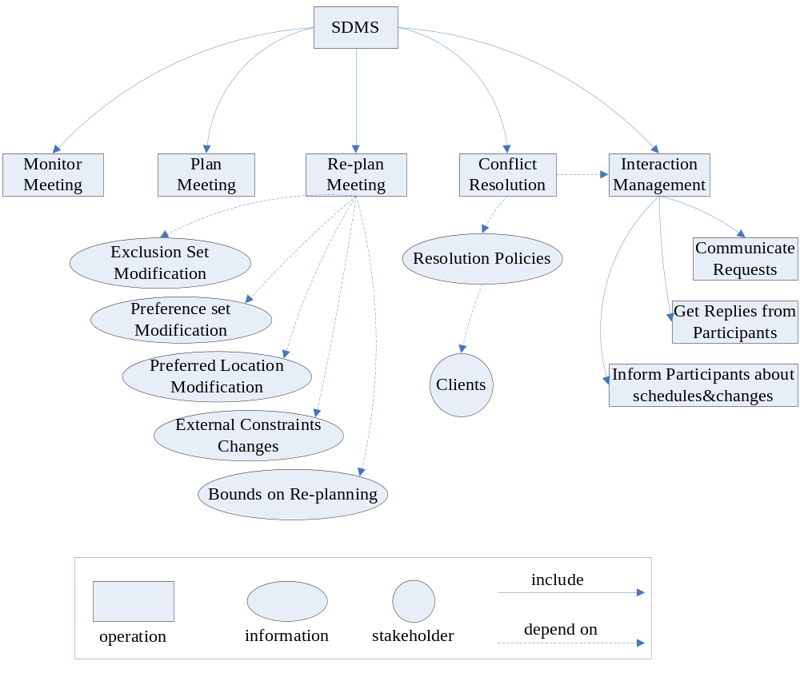
Figure 2 Preliminary Dependency Graph of System Functional Requirement

Semi-formal Requirement Description: Preliminary Definition

NonFunctional Requirements
-------------------------------------------------------------------------------------------------------------------------------------------------------------------------
According to the preliminary description, we derive a system nonfunctional requirement dependency graph:
- Words inside clouds describe the key features of NFR
- Classify NFRs into 3 categories: Meeting Management, Remote Communication and Meeting in use.
- issues are marked with color.

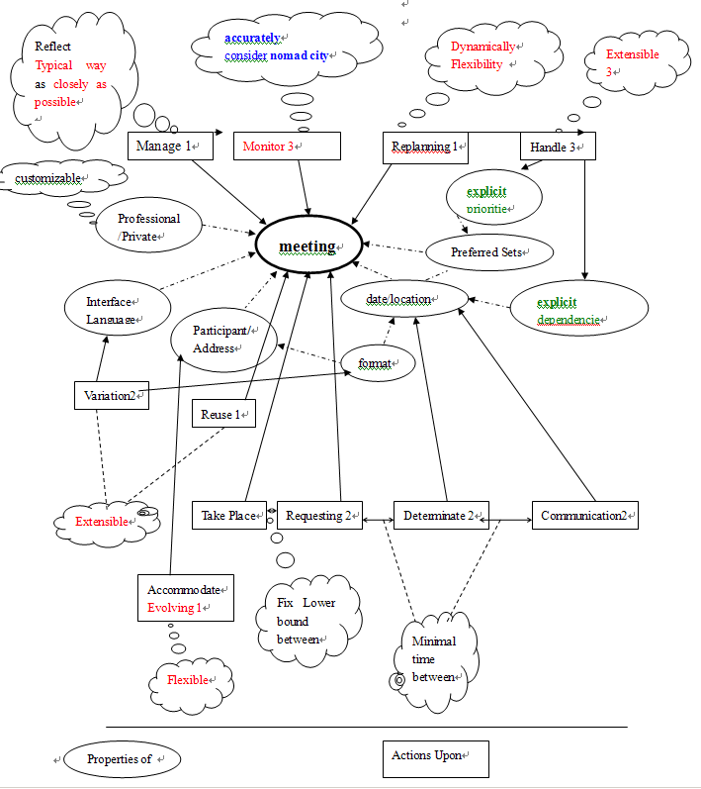

Figure 3 Nonfunctional Requirements: Meeting Management
Minimal
Interaction among participants
Considerably reduce overhead
Attendees communicate via internet2
Decentralized request
be accommodated
user from any location
Figure 4: Nonfunctional Requirement: Remote Communication

Non-privileged participant shouldn’t know others’ constraints

Meeting date
and Location
Non experts
convenient
available
early2
Privacy2
Usable
Figure 5: Nonfunctional Requirement: Meeting In Use

Issues

Enterprise Requirement
-------------------------------------------------------------------------------------------------------------------------------------------------------------------------
Incompleteness
Problem: The SDMS system needs to include cancellation process.
Option 1: Initiator cancels the meeting.
Option 2: Important participants cancel the meeting.
Solution: option 1.
Reason: To prevent the confusion, give the cancellation permission only to the initiator.
Ambiguity
“All potential meeting attendees, Active Participant, Important Participant”
Problem: The meaning of the terms are not defined
Solution: Initiator defines the meaning of the potential, active, and important participants.
Reason: Every user has different definition, and at this time those definition is meaningless.
Only when an initiator asks about locations and special equipments, and e-mail notifications,
those roles becomes important.
“A meeting date shall be defined perhaps by a pair.”
Problem: Word “perhaps” is not clear.
Solution: delete “perhaps”.
Reason: Keep It Clear.
“As quickly as possible.”
Problem: Word “As quickly as” is not clear.
Solution: initiator shall set maximum bound of conflict resolving time
Reason: Keep It Clear.
“no more interactions than is really needed.”
Problem: Word “really” is not clear.
Solution: change a whole clever to “minimal interactions”
Reason: Keep It Clear.
“It should ideally belong to one of the locations.”
Problem: Word “ideally” is not clear.
Solution: delete “ideally”
Reason: Keep It Clear.
“It is absolutely necessary.”
Problem: Word “absolutely” is not needed.
Solution: delete “absolutly”
Reason: Keep It Clear.
“This flexibility is considered critical in future.”
Problem: Word “flexibility” is not clear.
Solution: give more detail explanation on “flexibility”
Reason: Keep It Clear.
Redundancy
“Attendee, participants.”
Problem: “attendees” is used as “participants”.
Option 1: replace “Attendee” with “participant”.
Solution: option 1.
Reason: It is simple and clear.

Issues

System Functional Requirement
-------------------------------------------------------------------------------------------------------------------------------------------------------------------------
Incompleteness
Problem: Is the system available to everyone? Does every user play the same role?
Solution: Add a Login/Logoff module to set the users’ authorization level. Users with different authorization level have different constraints to using the system. For example, only meeting initiator can plan and re-plan meetings, and only meeting initiator and system administrators can handle conflicts.
Reason: users’ authorization levels are fundamental to all function modules.
Ambiguity
“Monitor meetings, especially whne they are held in a distributed manner.”
Problem: How to monitor meetings is not mentioned in the functional requirement.
Option 1: When having a virtual meeting in a distributed manner, every participant should have his/her status, for example, giving presentation, online/offline, etc, displayed publicly so that every participant can see it.
Option 2: Since this requirement is ambiguous, we can just consider it as not part of the system’s core functions and dispose it.
Solution: Option 1
Reason: Enhance the functionality of the system.
“Plan meetings under the constraints expressed by participants.”
Problem: what kind of constraints expressed by participants should the meeting initiator consider? How to derive these constraints?
Option 1: Design a sub-module within the meeting plan module to derive all kinds of constraints from participants.
Option 2: Get the exclusion set and preference set from the interaction management module and use them as constraints.
Solution: Option 2.
Reason: Decrease the redundancy of the system, and exclusion set and preference set are enough for the initial planning of a meeting.
“Support conflict resolution according to resolution policies stated by the client.”
Problem: what does this “client” refer to?
Option 1: system administrator
Option 2: meeting initiator
Solution: Both Option 1 and Option 2
Reason: System administrator should have the predominate decisions on resolution policies. In the meantime, meeting initiator’s opinion also weighs.
Issues

System Nonfunctional Requirement
-------------------------------------------------------------------------------------------------------------------------------------------------------------------------
Ambiguity
Problems:
- What is typical ways of managing meeting is very unclear.
- What does “monitor meeting” mean is unclear.
- Dynamically and flexibilities also are unclear.
Solutions: Since NFRs are by nature ambiguous, we have to prioritize them and implement the feather as close as possible, depend on how much time we have.
Priority of the NFRs
- 1 Manage
- 1 Replanning
- 1 Reuse
- 2 Variation
- 2 Requesting
- 2 Determinate
- 2 Communication
- 2 Communicate via Internet
- 2 Privacy
- 3 Monitor
- 3 Handle
Incompleteness
Problems:
- Can’t understand “explicit”
- nomadcity has no definition
Solutions: Those terms must be clarified against the stake holder, or they should be omitted from the implementation.
Others
- accurately and nomadcity are controversial
Solutions: This item must be clarified against the stake holder, or they should be omitted from the implementation.

Improved Understanding

Enterprise Requirements
-------------------------------------------------------------------------------------------------------------------------------------------------------------------------
Defining the Full Problem of Scheduling Meeting
To elicit enterprise requirements for SDMS, it’s better to define the problems being solved first. SDMS shall provide the solution for three key problems of most meeting scheduling contend with:
- Finding available time among meeting participants is time consuming and sometimes hard. If most important participants cannot find the common available time and date, the meeting cannot be held on posted date. So reschedule is required.
- Most interactions among all participants are complex as well as labor- and information-intensive. If the size of meeting participant is large or rescheduling is needed, a number of interactions among participants are exponential.
- Finding appropriate location which has all the necessary equipment and is preferred by all important participants is sometimes hard. It is possible that the desired location cannot be available on the meeting date, or more than one location is preferred by more than one import participants.
Enterprise Functional Objectives
Understanding Process of Meeting Schedule
- A meeting initiator ask following information to all participants
  - Exclusion Set
  - Preference Set
  - Date Range
    - Calendar Date
    - Time Period
- A meeting initiator ask following information to all important participants
  - Special equipments on the meeting location
  - Preferred meeting location
- The proposed meeting date shall be in the stated date rage
- The proposed meeting date shall belongs to as many preference set as possible
- The proposal shall be made as early as possible
Meeting Room Description
- Meeting room shall belong to one of the locations preferred by as many important participants as possible.
- The preferred meeting room shall be available at the selected meeting date.
- Meeting room shall meet the equipment requirements.
- If participants are geographically dispersed, virtual meeting rooms shall be included like teleconferencing through notebook computers, pc etc.
- Participants shall have the ability to negotiate for rooms. Negotiations should be kept minimal, but a new round of negotiations may be required when no such room can be found.
Meeting Conflicts
- A date conflict occurs when a strong date conflict occurs when no data can be found within the date range and outside all exclusion sets.
- A weak date conflict occurs when dates can be found within the date range and outside all exclusion sets, but no date can be found at the intersection of all preference sets.
Meeting Conflict Resolution
- If a strong or weak conflict occurs while generating a meeting, the system shall notify the initiator and ask to
  - notify a participant to remove a date from his exclusive set,
  - propose a participant with low importance level to extend the date set or withdraw from the meeting,
  - propose a participant with high importance level to extend a date range
  - Propose the initiator to cancel the meeting.
  - Each conflict resolution should be done as soon as possible and with no more interactions than is really needed.
- If none of the proposed locations can meet the equipment requirements while making a meeting schedule, the system should inform the initiator. The initiator can propose other locations or cancel the meeting.
  - In the first case, the initiator first inputs some new locations and then restarts a new round of meeting scheduling.
  - In the second case, the initiator cancels the meeting, and all participants should be informed of the cancellation.
Enterprise Non-Functional Objectives
- Negotiations for meeting rooms shall be kept minimal, but a new round of negotiations may be required when no such room can be found.
- All conflicts shall be resolved within minimum round of interactions between initiator and participants.
- Any physical changes to the meeting room and its equipments shall be kept up-to-date.
- If any physical changes to the meeting room and its equipments shall occur after a scheduled meeting and before the meeting date, the initiator shall be notified promptly.
- All participants shall not need to be using the system; in that case, the non-user participant shall receive a plain email message.
Enterprise Requirements for SDMS
Now we are ready to elicit enterprise requirements specifically for SDMS system.
Stakeholders
Stakeholders are any people or organizations that are related with the system. Stakeholders are Potential end-user, Project Manager, and Product Manager
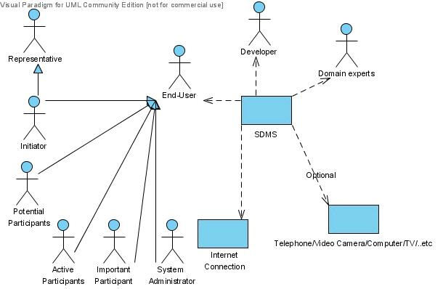
Figure 6: Stakeholders
At this time, only internet connection and SDMS system are provided.

Seeting Location
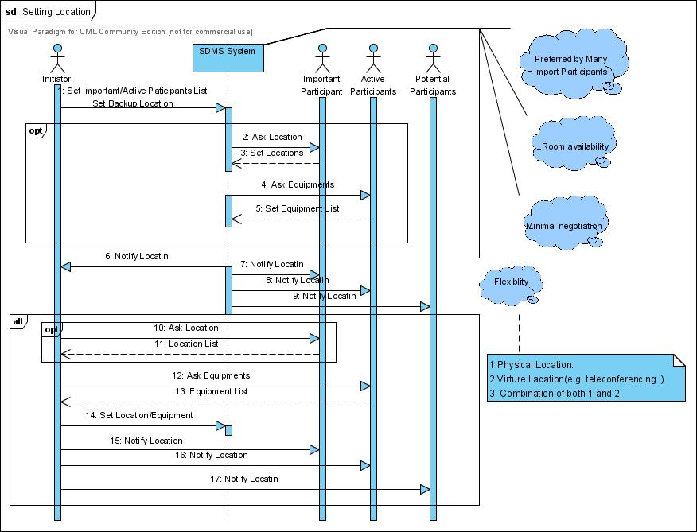

Figure 7: Sequence Diagram for Setting Meeting Location
- A meeting initiator shall set important participants and active participants. SDMS system shall send an e-mail message to important participants asking meeting locations. At the same time, SDMS system shall send an e-mail message to all active participants asking about any special equipment.
- SDMS system schedule meeting location based on the responses of all active and important participants.
- If initiator cannot get any answer from important participants, initiator shall set the location and notify it to all participants.
- Location and date conflict can only be revolved by the initiator. By SDMS system default, meeting location is depend on the meeting date.
- If participants cannot be reached though the SDMS system, the system notify it to the initiator, and the initiator shall set data and notify it to them.

Setting Date
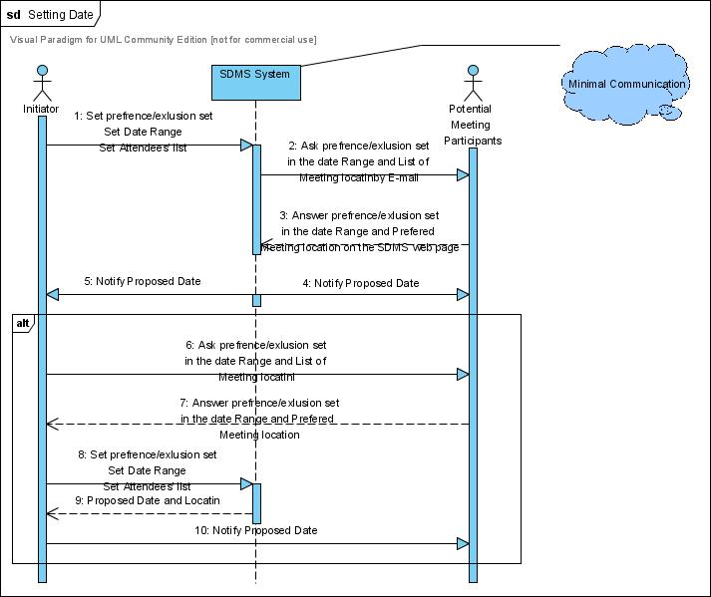

Figure 8: Sequence Diagram for Setting Meeting Date
- A meeting initiator shall set Date Range on SDMS system.
- The SDMS system send e-mail asking preference set and exclusion set within date range.
- Each participant answers back to SDMS system.
- SDMS system will find the proposed meeting date and notify it to all participants.
- If participants cannot be reached though the SDMS system, the system notify it to the initiator, and the initiator shall set data and notify it to them.

Meeting Cancellation
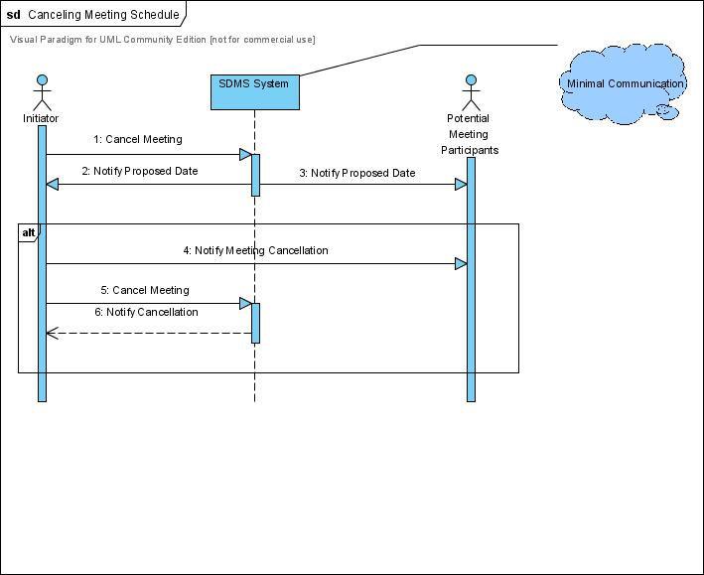
Figure 9: Sequence Diagram for Canceling Meeting
- If meeting needs to be canceled, an initiator cancel the meeting, and SDMS system will notify it to all participants.
- If participants cannot be reached though the SDMS system, the system notify it to the initiator, and the initiator shall notify it to them.

Improved Understanding

System Functional Requirements
-------------------------------------------------------------------------------------------------------------------------------------------------------------------------
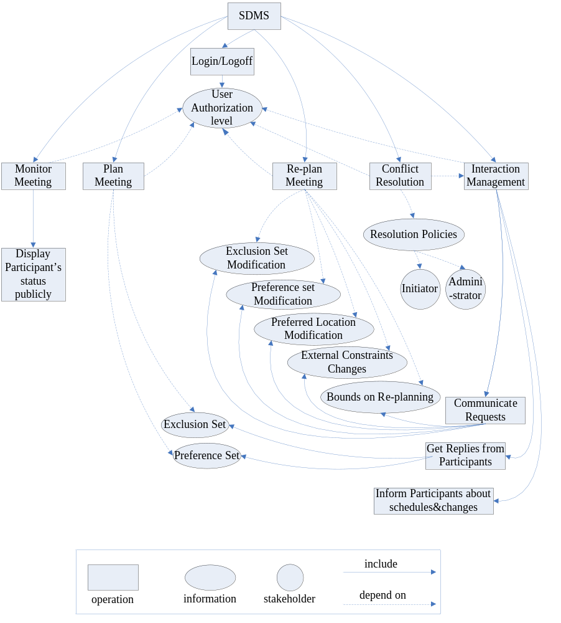
Figure 10: Improved Understanding of System Functional Requirements
1 Login/logoff
Introduction:
Decide the authorization level of each user so that the system can define what some users can do and cannot do.
Input:
User name and password
Process:
Compare the user name and password to the user information database. Decide the user’s authorization level: system administrator, meeting initiator, important participant, regular participant or guest.
Output:
The user’s membership status and authorization level
2 Monitor Meeting
Introduction:
When having a virtual meeting in a distributed manner, every participant should have his/her status, for example, giving presentation, online/offline, etc, displayed publicly so that every participant can see it.
Input:
Every user’s authorization level and status
Process:
For each meeting, display all participants’ status to every user who is attending this meeting.
Output:
All participants’ status
3 Interaction Management
3.1 Get Replies from Participants
Introduction:
After initiator propose the meeting, system ask the participants for the preference and exclusive set of date and location, get the replies and store them.
Input:
User’s authorization level
User’s replies
Process:
Participants’ preference and exclusive sets of date and location are processed and stored according to their authorization level.
Output:
Preference set
Exclusion set
3.2 Communicate Request
Introduction:
Accept and process the modification request from meeting participants.
Input:
User’s authorization level
User’s request
Process:
According to the authorization level and type of request, the user’s request is stored in different categories. For example, bounds on replanning can only be requested by meeting initiator or system administrator.
Output:
Exclusion set modification
Preference set modification
External constraints changes
Bounds on replanning
3.3 Inform Participants about Schedules and Changes
Introduction:
When the meeting schedule is finally settled or there is any change on the schedule, an email is sent to every participant about it.
Input:
User’s authorization level
Settled or changed schedule
Process:
Send an email to every user who is a participant of the meeting about the settled or changed schedule.
Output:
Emails about the settled or changed schedule
4 Plan Meeting
Introduction:
Every user can initiate and plan a meeting, proposing the scale of date and location and the theme of the meeting.
Input:
User’s authorization level
Preference set
Exclusion set
Process:
Meeting initiator can propose a date and location according to the participants’ preference and exclusion set.
Output:
Proposed date and location
5 Conflict Resolution
Introduction:
Resolve the conflict of date and locations according to the conflict resolution policies.
Input:
User’s authorization level
Conflict resolution policies
Process:
When conflict occurs, a priority set should be derived according to the conflict resolution policies initiator or administrator has proposed.
Output:
Priority set
6 Re-plan Meeting
Introduction:
When there’s changes request for the meeting date, location or attendance, the meeting should be re-scheduled.
Input:
User’s authorization level
Exclusion set modification
Preference set modification
External constraints changes
Bounds on replanning
Process:
Only initiator can re-plan the meeting. According to the exclusion set and preference set modification, external constraints changes and bounds on re-planning, the initiator should re-plan the meeting and propose a new schedule.
Output:
New schedule

Improved Understanding

System Nonfunctional Requirements
-------------------------------------------------------------------------------------------------------------------------------------------------------------------------

System Non-Functional Requirements Description
All NFRs are numerated with priority. [1] refers to immediate implementation, [2] refers to further implementation, [3] refers possible implementation, and [N] refers to be eliminated from implementation.
- User friendliness
- The system should be usable by non-experts, where the user can learn to operate easily.
- Performance
- Elapsed time between determination of meeting and communication of this information should be minimal (i.e.) Ensure that the application or component does not make a user wonder whether or not it has received the user’s request. [1]
- Lower bound should be fixed between determination of meeting date and actual meeting. [1]
- The elapsed time between the submission of a request and the computation time should be minimal. [1]
- Robustness
- The system should be accurately monitored, especially when it is held in a virtual place. Hence, nomadicity will be taken into consideration. [N]
- The intended system should considerably reduce the amount of overhead usually incurred in organizing meetings where potential attendees are distributed over many different places and communicate with each other (e.g. via Internet). [2]
- Extensibility
- The system should be able to handle explicit priorities among dates in preference sets. [2]
- It also has the ability to handle explicit dependencies between meeting date and meeting location. [2]
- Then again, it manages participation through delegation, in which a participant may ask another person to represent him/her at the meeting. [3]
- There may also be variations in date formats, address formats, interface language, partial reuse in other contexts, such as helping establish course schedule, etc. [3]
- Security
- Privacy rules should be enforced a non-privileged participant should not be aware of constraints stated by other participants. [2]
- Usability
- The system should accommodate as much decentralized requests as possible. Therefore, any authorized user should be able to request a meeting independently of his/her whereabouts. [1]
- The system should reflect as closely as possible to the way meetings are typically managed. [N]
- Then again, physical constraints should not be broken (e.g. a person may not be at two different places at the same time, a meeting room may not be allocated to more than one meeting at the same time, etc.). [1]
- Also, the meeting date and location should be convenient as possible, and is available as early as possible to all potential participants. [3]
- Customizable
- The system shall be customizable to two modes (1) Private (2) Professional meetings –Characterized by different restrictions on the time period that may be allocated (e.g. meeting during office hours, private activities during leisure time). [2]
- Flexibility
- Rescheduling of a meeting should be done dynamically and with as much flexibility as possible. [3]
- Also, the system should be flexible enough to accommodate evolving data (e.g. the sets of concerned participants may be varying, the address at which a participant can be reached may be varying, etc.). [2]

Prototype
Login Page
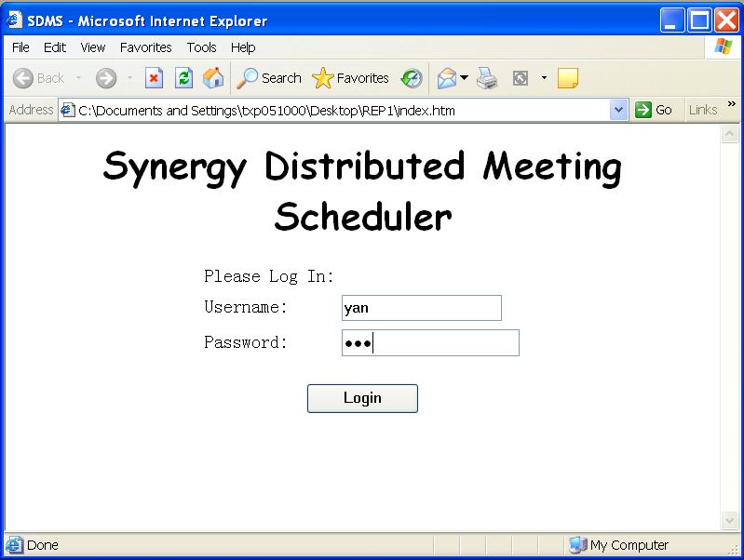

View Meeting Status Page
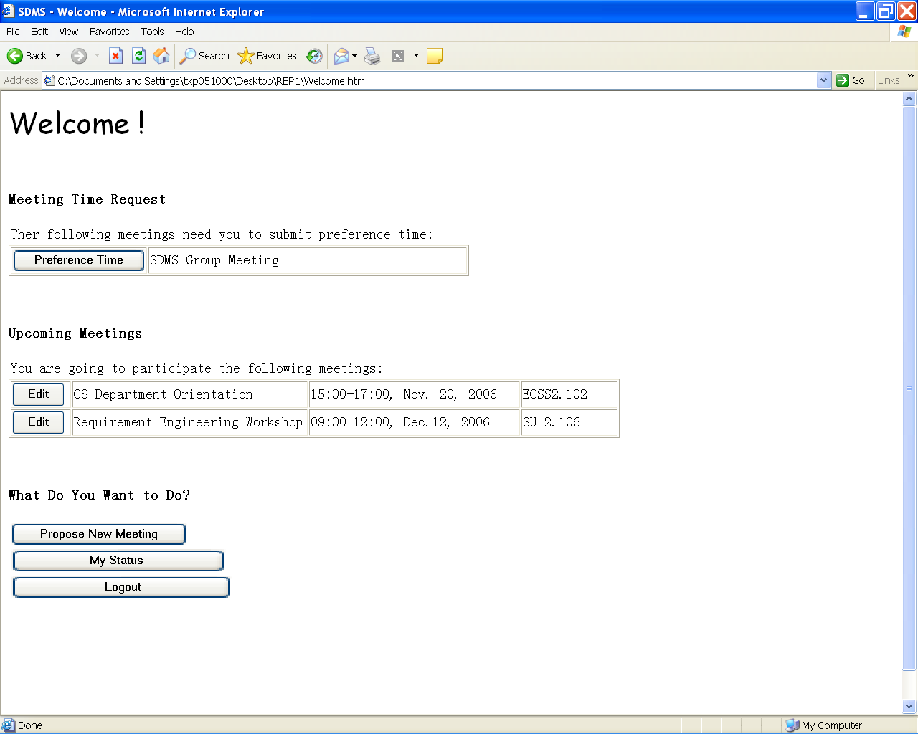

Propose a Meeting
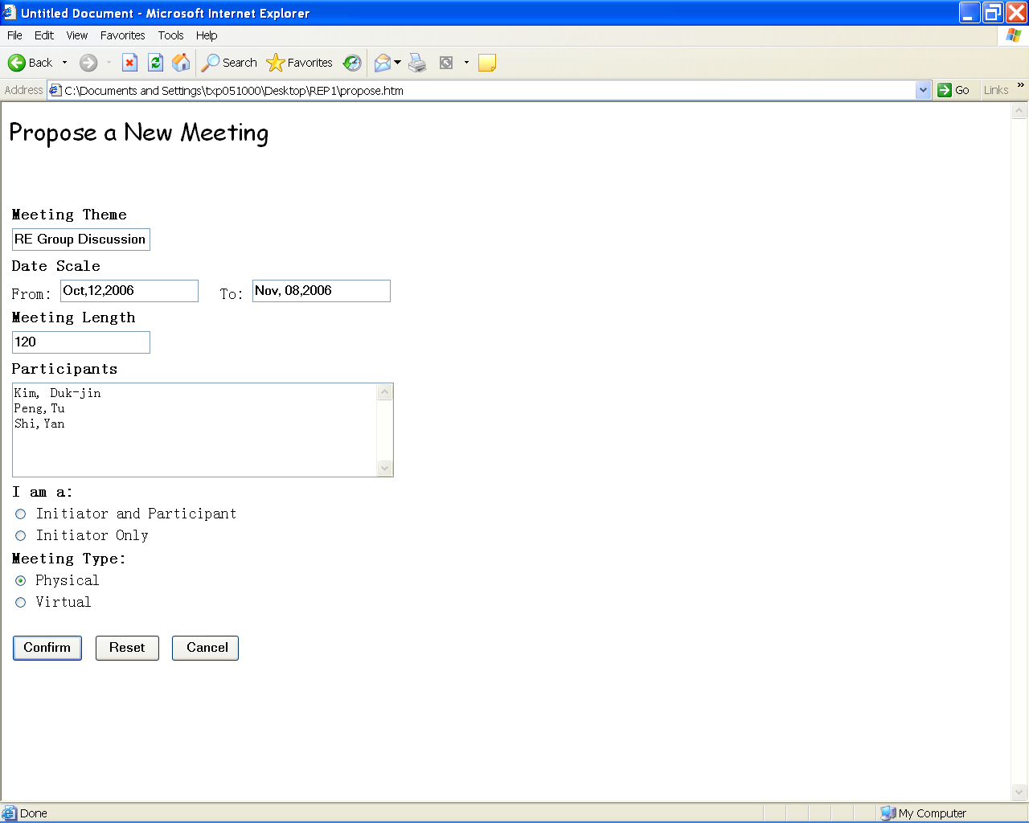

Enter Preference and Exclusion Set


