Web based Meeting Scheduler System
Project phase 2.2

CS 6361 – Advanced Requirements Engineering, Spring 2010

University of TEXAS at DALLAS

pRODUCT Specification
Version 2.0

Team–“call of duty”

Anuj Gupta (axg094220@utdallas.edu)................Team Lead for final report 1.2
Hariharan Rajagopalan (hxr088000@utdallas.edu)
Kawaljit Grover (kxg098020@utdallas.edu)
Kerem kulak (kxk080100@utdallas.edu)
Neha Priyadarshini (nxp083000@utdallas.edu)................Team Lead for interim phase 1.1
Priya Priya (pxf081000@utdallas.edu).................Team Lead for interim phase 2.1
Satwant Singh (sxs094920@utdallas.edu).................Team Lead for final report 2.2
Sujatha Sridhar (sxs061400@utdallas.edu)

Team Website URL: http://callofdutyutdallas.web.officelive.com/default.aspx

Submitted to:
Dr. Lawrence Chung
Associate Professor,
Department of Computer Science,
The University of Texas at Dallas

Revision History
Author | Date | Description | Version
Priya | 04/4/2010 | Initial version of the document and added class diagram use case diagram | 0.1
Neha | 04/09/2010 | Formatted and merged | 0.2
Kerem | 04/09/2010 | Added Sequence diagram | 0.3
Neha | 04/09/2010 | Added fishbone diagram | 0.4
Sujata | 04/07/2010 | Added Process specification | 0.5
Anuj and kawal | 04/09/2010 | Added Use case description | 0.6
Neha | 04/10/2010 | Activity Diagram | 0.7
Sujatha | 04/11/2010 | Added Activity Diagram | 0.8
Priya | 04/12/2010 | Updated new requirements | 0.9
Team | 04/12/2010 | Baseline version | 1.0
Neha | 04/25/2010 | Added SADT diagrams for product and Process | 2.0
Table of Contents

1 Preliminary Requirement Changes 6
2 Process Specification 8
2.1 Purpose 8
2.2 Scope 8
2.2.1 Stake-Holders 8
2.2.2 Definitions and Glossary 9
2.2.3 References 9
2.3 Organizational Structure 10
2.3.1 Vision and Goals 10
2.3.2 Team Roles 10
2.4 Workflow 11
2.4.1 Requirements Engineering Model 11
2.5 Project Organization 13
2.5.1 Project Phases 13
2.5.2 Interim Phase I- Description: (Jan12th, 2010 –March4th, 2010) 14
2.5.3 Final Phase I- Description: (March 4th, 2010 – March 25th, 2010) 19
2.5.4 Interim Phase II- Description: (March 25th, 2010 – April 15th, 2010) 22
2.5.5 Final Phase II- Description: (April 15th, 2010 –April 27th, 2010) 26
2.5.6 Traceability 30
3 SADT DIAGRAMS 31
3.1 Level 0 Context diagram 31
3.2 Level 1 Diagram for Process: 32
4 Product Specifications 33
4.1 Fish Bone Diagram 33
4.2 Class diagram 33
4.3 SADT diagram for Product 35
4.4 Use Case 36
4.4.1 UC Diagram 36
4.4.2 Use Case Description 37
4.4.2.1 Login 37
4.4.2.2 Manage User 37
4.4.2.3 Register 38
4.4.2.4 Initiate Meeting 38
4.4.2.5 Cancel Meeting 39
4.4.2.6 Request Equipment 39
4.4.2.7 View Scheduled Meeting 40
4.4.2.8 Respond to Meeting 41
4.4.2.9 Decline 41
4.4.2.10 Request Location 42
4.4.2.11 Conflict Resolution 43
4.4.2.12 Finalize Meeting 44
4.5 Sequence Diagram 45
4.5.1 Login 45
4.5.2 Initiate Meeting 46
4.5.3 Cancel Meeting 47
4.5.4 Respond to Meeting 48
4.6 Activity Diagram: 50
4.6.1 Schedule Meeting Activity Diagram: 51
4.6.2 Business Activity Diagram: 52

Preliminary Requirement Changes
1. Some meetings are organized and scheduled at the same time, as a chunk, where partial attendance can be allowed.
Issues: The word Partial and chunk are not clearly defined. The requirement does not indicate if this option is available for all users or only a particular category of users.
Option 1: The system provides the option for important and active participants to attend meeting partially. The term “partially” indicates that important and active user shall be allowed to attend more than one meeting at the same time by providing an option to attend part of the meeting. The work “chunk” is ignored, and meetings can only be initiated one at time by the meeting initiator.
Option 2: The word “chunk” indicates that meeting initiator can schedule more than one meeting at a time. The work partial is ignored and users are allowed to attend only one meeting at a time.
Rationale: Option 1 was chosen as this provides more flexibility for the important and active users to attend more than one meeting in case their presence is expected in all the meetings. The schedule for partial meetings of active and important participants will not be marked as conflict for meeting that is marked as “Partial”. Option2 imposes a more restricted rule hence is not considered as an option.
2. Meeting locations should be convenient, and information about meetings should be secure.
Issues: The requirement does not define the meaning of the word “convenient”. It also does not indicate in what terms the meeting should be secure.
Option 1: “Convenient” means that during resolving location conflicts if the number of regular participants is more than 70% of total participants attending the meeting then the location of the regular participants is considered and location that is chosen by the majority of participant is chosen. If the number of regular participants is less than 70% of the total participants attending the meeting, then only important and active participant’s location preferences are considered and the location that is chosen my majority of the participants is used as the location for the meeting.
Option 2: The word “convenient” emphasis on the need to resolve the meeting location conflict with the requirement that only important and active participant’s location preference is considered. For location conflict resolution certain threshold (say 50%) of the important and active participant’s preferences on location will be considered for the meetings location. Secure means that only authorized users are allowed to use the system. Users shall be able to register in the system, but permission will be provided only after receiving the email confirmation from the admin. Users shall be able to view the meetings that are either initiated by them or to which they are invited, they shall not be able to view other users meeting details.
Decision Rationale: Option 2 is considered for this requirement as this would entail emphasis on the important and active participants, whose presence is more important for the meeting,
3. For helping with conflict resolution and negotiation support, video conferencing (e.g., through Skype) should be available on the system and each video conferencing session should be recorded and analyzed for the purpose of monitoring.
Option 1: Video conferencing option if offered to support virtual meetings. Conferencing option is allowed between only 2 attendees of the meeting.
Option 2: Requirement is ignored.
Decision Rationale: Option 1 is chosen as it provides the ability to schedule and monitor virtual meetings without having restrictions on the geographical location of the participants.
4. Some stakeholder has also requested that your meeting system provide such features that can be found, for example, in Microsoft Office Outlook
Option1: Of the several options provided by Microsoft outlook, the following options shall be considered.
- Cancel a single meeting If a meeting is cancelled by the meeting initiator an email notifying the cancellation is sent to all participants who were invited.
- Meeting reminder: System shall send a reminder to all attendees one day in prior to the meeting date.
- Meeting Responses
  - Decline the meeting completely with a reason
  - Tentatively accept meeting and provide preference/exclusion sets and location preferences
Option 2: Requirement is ignored.
Design Rationale: Option 1 is selected as it provides more user friendly features offered by other meeting scheduler products like Outlook.

Process Specification

Purpose
Process Specification document describes precisely the process that our team ”Call of duty” has successfully carried out in achieving the development of Web based meeting scheduling process.

Scope
Process describes the transformation of given input to output. Process consists of a set of activities.
Quality of product depends on:
- Quality of starting Point
- Process

Process is very important because “a high quality process will ultimately lead to a high quality product” and thus in order to obtain a good product, a good process is required. There is a saying “Garbage in garbage out” which means if the quality of process or starting point is garbage then the resulting product will be garbage.
The document addresses the following about our team “Call of duty”:
- Organizational structure
- Vision
- Goals
- Roles and Responsibilities of team members
- Work Flow which describes the complete flow of the process
- Process Specification, which describes the process that our team adopted along with the phases of each process
- Project Organization which describes each phase of the project that includes goals, process, stakeholders, activities, roles, inputs and outputs.

Stake-Holders
There are primarily three stakeholders involved in Meeting Scheduler System:
- Web based company Omni-soft: The Company for which the Meeting Scheduling System needs to be developed.
- Team Call of Duty: The team responsible for developing the Meeting Scheduling System for web based company
- Professor Lawrence Chung: Primarily the facilitator between company and Team Call of Duty. He was responsible for the Phase I requirements elicitation and now acting as a communication point between company and team Call of Duty.

    - Definitions and Glossary

Stakeholder – The project’s outcome, interests some people and those people are called stakeholders.
Deliverable – Output of an activity or the work product are the deliverables of the project.
Software Project Management Plan – A software development process consists of many activities and a document that captures all these activities in detail is called a software project management plan.
Software Requirements Specification – The outcome of the Requirement analysis stage in the software lifecycle is captured in a document called SRS that contains the features of the requirements that the software has.
Process Specification – Development of software needs many processes to be carried out by the team to do an activity which is the process
Vision Document – The starting point of any project is the Vision document which has 3 wares, the hardware, software and people-ware who interact with the s/w system.
Report –This will contain the detailed description of the product models.
Prototype – A working model of the software system that is to be developed.
User Manual – A document that has the prototype which is given in the form of screenshots and description of how to use it and what it contains.
Requirements Engineering Incremental Model – cycles are divided into smaller, more easily managed iterations.
Semi-formal Notation – The notation that is neither too formal nor too informal (something in between the both) to understand properly.
Domain Requirements – Requirements of the domain.
Non-Functional Requirements – Requirements that cannot be formulated, but that can be fulfilled by different features and functions
Use Case Diagram – UML description of user and system interactions.
Class Diagram – A diagram that depicts classes in a s/w system and their associations.
Sequence Diagram – Object interactions can be described in this diagram.
Soft-Goal Interdependency Graph (SIG) – A hierarchical structure that shows the dependencies between various soft goals
Requirements Creeping Rate – It is the percentage of change divided by time
Traceability – Mapping of the requirements with the work product.
NFR Model – A goal oriented analysis model that establishes relationship between non-functional requirements soft-goals and operational soft-goals.
Activity Diagram – A semiformal diagram (UML) that depicts the process or activity.
    - References
[1]http://www.utdallas.edu/~chung/RE/Presentations09F/Blitzkrieg_SE6361_Fall_2009/Blitzkrieg_Phase_II_Interim_Fall_2009/

  - Organizational Structure
    - Vision and Goals
Vision
The vision is to organize the team in a way that there is proper interactions between them and they resolve the issues with mutual agreement and follow and respect each one’s suggestion which will ultimately lead to a product that the client actually needs and is happy about it.
Goals
- Deliverables should be met on time.
- Quality of deliverable should be high.
- Respect each and every team member’s thoughts and ideas.
- Accept the criticism and motivate the team on the whole.
- Proper communication should be there between team members.
    - Team Roles
Following are the roles in team “Call of Duty”:

Role | Team Member | Responsibilities
Project Manager | Neha | Determine deadlines, coordinate meetings, map out the process
Team Lead | Priya | Determine how the team members will work together and collaborate.
Subject Matter Expert | Anuj | Determine the scope of the problem, describe the process model and identify stakeholders and issues.
Module Lead | Sujatha | Deals with the module and functionality and working of one module.
Requirements Engineers | Satwant | Determine the system functional and system non-functional requirements from the specifications elaborate and expand on them to allow improved understanding.
Designer | kawal grover | Translate requirements into product by designing the layout
Client | Kerem kuluk, Hariharan | Helped in requirement gathering

Project Manager:
Maintain Project plan, timeline project schedule, maintain budget, makes frequent recurrent status calls, issues escalation and issues, and determines deadlines, coordinate meetings, map out the process.

Team Lead:
Determine how the team members will work together and collaborate. Resolve technical issues, watches everyone works or not.

Subject Matter Expert
Determine the scope of the problem, describe the process model, and identify stakeholders and issues. They are the Domain expert, understands domain problem and explains to development team.

Module Lead
Deals with the module and functionality and working of one particular module.

Requirements Engineers
Determine the system functional and system non-functional requirements from the specifications, elaborate and expand on them to allow improved understanding.

Designer
Translate requirements into product by designing the layout

Client
Helps in requirement gathering

  - Workflow
Following is the work flow diagram of team “Call of Duty”, indicating the methodology the team follows to successfully complete a task:
Process Specification
    - Requirements Engineering Model
We used incremental model. In our model, cycles are divided into smaller, more easily managed iterations.
A working version of software is produced during the first iteration, so we have working software early on during the software life cycle. Subsequent iterations build on the initial software produced during the first iteration.
Our model is easier to test and debug during a smaller iteration. It is easier to manage risk because risky pieces are identified and handled during its iteration and each iteration is an easily managed milestone .So, Project’s success is highly dependent on the risk analysis phase and it does not work well with small projects.
A role activity diagram (RAD) is a useful way to describe processes that can include actions and interactions among roles. Roles can be attributed to humans, software and hardware systems. It is a diagram that describes dependencies between roles in organizations. A Role Activity Diagram demonstrates activities, like actions of a role or interactions of multiple roles that participate in a certain process within a department, across an organization and beyond out into the marketplace. Each process should accomplish a goal or requirement for the project.
Our team has adopted a five step process to develop the WMS.
- Understand the problem
- Establish Outline Requirements
- Select Prototyping system
- Develop Prototype
- Evaluate Prototype

1. Understand the problem
Understanding the problem is the first step of the process that involves the Requirements Engineer, Domain Expert and the End user interaction in order to understand the problem. In this step we bring out the purpose and goal of the project.

2. Elicit and Establish Outline Requirements
Once the problem is understood, the next step in the process is to draw the requirements. The requirements are drawn from the interactions between the requirements engineer and the end user. We assumed roles of customer, initiator, and important, active and ordinary participants in the discussions in order to draw the requirements. We then ranked these requirements to differentiate between the most crucial functions and extra requirements. The elicitation raised a lot of issues and questions regarding the requirements. We posed these questions to the Users and Customer, and tried to get better understanding.

3. Select Prototyping system
After gathering the requirements, we determined the feasibility of the proposed functionalities of the system and imposed certain constraints wherever required. During this step, the roles of designers and developers are assumed. A prototype is created to present the customers a visual representation of what the system would offer to ensure that our understanding about the requirements is correct and also provide scope for the customer to add or delete from the requirements set.

4. Develop Prototype
Once the customer is satisfied with the sample representation of the project, the design and the implementation steps would be followed in order to build a working model.

5. Evaluate Prototype
The developed prototype is evaluated at this step. For the next iteration, the process goes back to the establish requirements stage and the steps are followed iteratively.
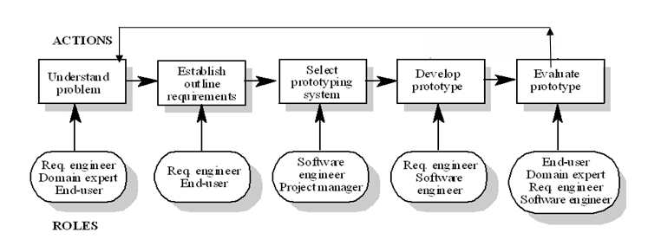
Figure 1 Evolutionary Iterative Model-Role Actor Diagram

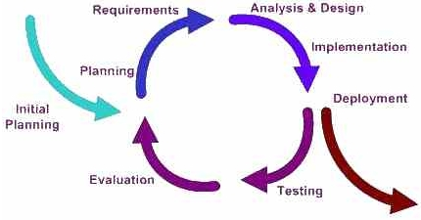
Figure 2 Software Lifecycle

  - Project Organization
    - Project Phases
Project is divided into 2 main parts which are called Phase I and Phase II respectively. These phases are in turn divided again into 2 sub-phases which are called interim and final. The Hierarchical overview of the Project Phases is represented by the following diagram:

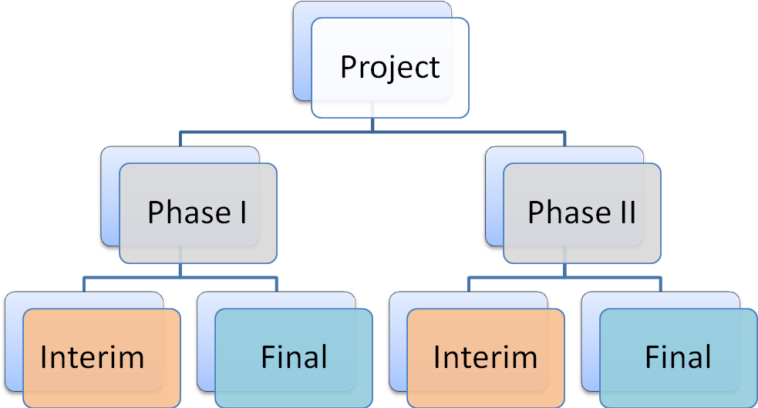
Figure 3 Hierarchical Overview of the Project Phases

The following is a brief overview of the top level phases:
Phase I:
Project starts with Phase I. Requirement understanding is the input to this phase which is initiated by the Omni-soft and professor Lawrence Chung. Here, the main goal is to preapre a preliminary Software Project Management Plan. Other sub-goals are analyzing the issues of requirements understanding and get the solutions to obtain better requirement understanding. Second step is to develop a Prototype using these requirements. Third step is the validation which shows whatever we developed as a prototype has to meet the requirements, so a Traceability matrix is built. Phase I is concluded with two additional deliverables including Requirements Creeping Rate and justification showing that our system is better than others in the class. Then, 2 sub tasks (Interim and Final) will follow which is described subsequently.
Phase II:
Phase II of the Project starts with the Process specifications which shows and discusses all the important and necessary processes that is followed in developing the Prototype. In this phase we have to use Semi-formal notation. New requirements are added so analysis of the issue the new added requirements are to be done using the semi-formal notations and we need to again understand the requirements better. Traceability Matrices are built and the product requirement model is also developed. Vision document is also prepared here. Then, 2 sub tasks (Interim and Final) will follow which is described subsequently.
    - Interim Phase I- Description: (Jan12th, 2010 –March4th, 2010)

Stake-holders
The following are the stake-holders in the Interim Phase I of the project:
- Omni-Soft(Company)
- Professor Lawrence Chung
- Team Call of Duty

Goals
The following are the major goals in the Interim Phase I of the project:
- Project management’s Preliminary Plan is to be prepared.
- Analyze and identify the requirement issues and rectify them.
- Perform Prototyping.
- Features of the Prototype have to be documented so that they can be shown to the users.
- Complete requirement engineering process is to be validated.

Inputs
The following are the major inputs in the Interim Phase I of the project:
- Initial understanding of the Requirements document.

Process
The following is a description of process followed during the Interim Phase I of the project:
- Conduct meetings regularly.
- Making sure all the team members participate in all the meetings.
- Taking regular attendance of the meeting participants.
- Identify the immediate deliverable that has the deadline.
- Discuss all the activities related to the immediate deliverable which in this case is Interim Phase I.
- Find out all the issues related to it and come up with solutions from each and every team member and also develop common understanding of the various issues.
- Divide the work and assign the work to every relevant team member and set the deadline so that work will be completed on time.
- Discuss the next meeting date along with time and venue.
- Prepare Meeting Agenda and Meeting minutes once a particular meeting gets over.
- Email the details to all team members so that they know what had happened that day and what the plan is in future too.
- Depending on team’s feedback modify the deliverables.

Activities
The following are the major activities performed during the Interim Phase I of the project:
- Understanding the Project is the foremost activity which is to be done collectively with the members of the team.
- Identify the Users and stake-holders (who form the major part) for the project.
- Identify the Phase I deliverable of the project.
- Form a organizational structure in the team to carry out the project effectively and efficiently.
- Determine roles and responsibilities in the organization of the team members and prepare a table too for it.
- Define and list all the domain requirements and identify issues in it and give many possible options to solve domain issues and select the best option after doing trade-offs.
- Similarly define and list all Functional requirements and identify all the issues in it and then give many possible options to solve that issue and then finally select the best option in it.
- In a similar fashion define and list all Non-Functional requirements and then identify all possible issues in it along with many possible options to solve that issue and then finally select the best solution for it.
- Systematically provide the improved understanding for Domain Requirements.
- Systematically provide the improved understanding for Functional Requirements.
- Systematically provide the improved understanding for Non Functional Requirements.
- Prepare User Manual containing the Screen shots of the prototype for the mock up.
- Prepare the Traceability matrix (Forward and backward) mapping all the requirements to the prototype’s screen shots.
- Prepare the presentation slides in the power point and with the team prior who is going to present what in the class.
- Presentation in the class along with the mock up of the prototype that we developed.

Outputs
The following are the major outputs of the Interim Phase I of the project:
- Preliminary Project Management Plan (Jan 28th, 2010)
- Software Requirements Specification Document (February 1st , 2010)
- Mock-up (Feb22nd , 2010)
- User Manual (Feb 24th, 2010)
- Project Presentation (March 2nd, 2010)

Roles and Responsibilities

Role | Team Member | Responsibilities
Project Manager | Neha | Determine deadlines, coordinate meetings, map out the process
Team Lead | Priya | Determine how the team members will work together and collaborate.
Subject Matter Expert | Anuj | Determine the scope of the problem, describe the process model, and identify stakeholders and issues.
Module Lead | Sujatha | Deals with the module and functionality and working of one module.
Requirements  Engineer | Satwant | Determine the system functional and system non-functional requirements from the specifications elaborate and expand on them to allow improve understanding.
Designer | kawal grover | Translate requirements into product by designing the layout
Client | Kerem kuluk, Hariharan | Helped in requirement gathering

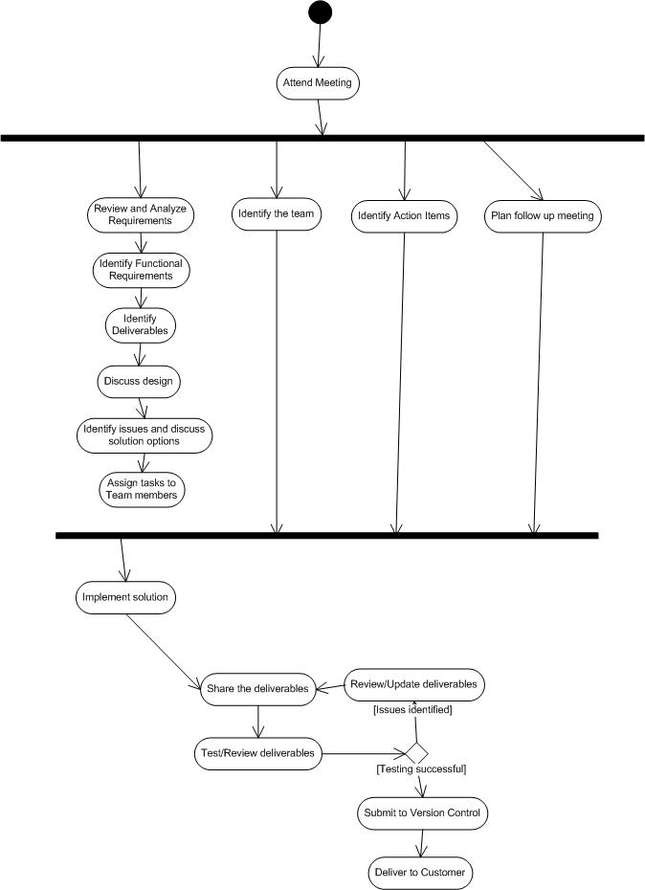
Figure 4 Activity Diagram: Interim Phase I Process
    - Final Phase I- Description: (March 4th, 2010 – March 25th, 2010)

Stake-holders
The following are the stake-holders in the Final Phase I of the project:
- Omni-Soft(Company)
- Professor Lawrence Chung
- Team Call of Duty
Goals
The following are the major goals in the Final Phase I of the project:
- Activities of the phase should be added in Project Plan so modify the project plan accordingly.
- Prepare SRS (Software Requirements Specification) document.
- Add new features in prototype.
- Add the prototype features in a document.
Inputs
The following are the major inputs in the Final Phase I of the project:
- Requirements Documents
- Preliminary project Plan
- SRS (Software requirements Specification Document), User Manual
- Project Presentation along with mock up.

Process
The following is a description of process followed during the Final Phase I of the project:
- Conduct meetings regularly.
- Making sure all the team members participate in all the meetings.
- Taking regular attendance of the meeting participants.
- Identify the immediate deliverable that has the deadline.
- Discuss all the activities related to the immediate deliverable which in this case is Final Phase I.
- Find out all the issues related to it and come up with solutions from each and every team member and also develop common understanding of the various issues.
- Divide the work and assign the work to every relevant team member and set the deadline so that work will be completed on time.
- Discuss the next meeting date along with time and venue.
- Prepare Meeting Agenda and Meeting minutes once a particular meeting gets over.
- Email the details to all team members so that they know what had happened that day and what the plan is in future too.
- Depending on team’s feedback modify the deliverables.

Activities
The following are the major activities performed during the Final Phase I of the project:
- Identify Phase II deliverables along with deadlines so that it will be delivered on time.
- Identify again the issues in Domain Requirements and find out the possible solutions to it and choose the best solution after doing tradeoffs to implement that in our system.
- Identify again the issues in functional Requirements and find out the possible solutions to it and choose the best solution after doing tradeoffs to implement that in our system.
- Identify again the issues in non-functional Requirements and find out the possible solutions to it and choose the best solution after doing tradeoffs to implement that in our system.
- Modify/Change the Improved Understanding for Domain Requirements.
- Modify/Change the Improved Understanding for Functional Requirements.
- Modify/Change the Improved Understanding for Non-Functional Requirements.
- Update the User Manual with added new screenshots of new features of the prototype.
- Provide our requirements creeping rate.
- Provide justification as to how and why our system is better than others in the class.
- Update the presentation to get final phase I information accommodated in the interim phase I.

Outputs
The following are the major outputs of the Final Phase I of the project:
- Revised Software Project Management Plan (March5th , 2010)
- Revised Software Requirements Specification Document (March 10th, 2010)
- Revised Mock-up (March 17th, 2010)
- Revised User Manual (March 18th, 2010)
- Revised Project Presentation (March 20th, 2010)

Roles and Responsibilities
Role | Team Member | Responsibilities
Project Manager | Neha | Determine deadlines, coordinate meetings, map out the process
Team Lead | Priya | Determine how the team members will work together and collaborate.
Subject Matter Expert | Anuj | Determine the scope of the problem, describe the process model, and identify stakeholders and issues.
Module Lead | Sujatha | Deals with the module and funtionality and working of one module.
Requirements  Engineer | Satwant | Determine the system functional and system non-functional requirements from the specifications, elaborate and expand on them to allow improved understanding.
Designer | kawal grover | Translate requirements into product by designing the layout
Client | Kerem kuluk, Hariharan | Helped in requirements gathering

Figure 5: Activity Diagram: Final Phase I Process
    - Interim Phase II- Description: (March 25th, 2010 – April 15th, 2010)
Stake-holders
The following are the stake-holders in the Interim Phase II of the project:
- Omni-Soft(Company)
- Professor Lawrence Chung
- Team Call of Duty
Goals
The following are the major goals in the Interim Phase II of the project:
- Activities of the Interim phase II are accommodated in the Interim Phase I Project Plan document. So, update the project plan accordingly.
- Prepare a document that captures the process specifications.
- Prepare a document that captures the product specifications.
- Define the vision and Goals. Prepare Vision document.
- Semi-Formal notations form the major part in this phase. So, use many UML diagrams to explain this phase of the project.
- Prepare Supplementary document.
- Prepare the presentation slides for the presentation.
- Prepare Glossary.
Inputs
The following are the major inputs in the Interim Phase II of the project:
- Requirements Document
- Preliminary project plan
- SRS which also has the user manual in the same document
- Presentation slides from the initial phases
- Professor’s Specifications in the website
- Prototype that we have developed
- Project Phase II Requirements(which form the major role)

Process
The following is a description of process followed during the Interim Phase II of the project:
- Conduct meetings regularly.
- Making sure all the team members participate in all the meetings.
- Taking regular attendance of the meeting participants.
- Identify the immediate deliverable that has the deadline.
- Discuss all the activities related to the immediate deliverable which in this case is Interim Phase II.
- Find out all the issues related to it and come up with solutions from each and every team member and also develop common understanding of the various issues.
- Divide the work and assign the work to every relevant team member and set the deadline so that work will be completed on time.
- Discuss the next meeting date along with time and venue.
- Prepare Meeting Agenda and Meeting minutes once a particular meeting gets over.
- Email the details to all team members so that they know what had happened that day and what the plan is in future too.
- Depending on team’s feedback modify the deliverables and control of versions for the deliverables.

Activities
The following are the major activities performed during the Interim Phase II of the project:
- Identify the Interim Phase II requirements and understand them.
- Identify the deliverables along with the deadlines.
- Discuss the work flow.
- Discuss and assign roles and responsibilities for this phase too.
- Map the project activities to the requirements engineering incremental model activities.
- Use Semi-formal notation (UML diagrams) to understand the project better.
- Establish traceability between the phases of the project.
- Prepare glossary.
- Identify the issues in domain requirements and provide many possible alternatives to the issue and then do tradeoffs and select the best solution by using semi-formal notations.
- Identify the issues in functional requirements and provide many possible alternatives to the issue and then do tradeoffs and select the best solution by using semi-formal notations.
- Identify the issues in non-functional requirements and provide many possible alternatives to the issue and then do tradeoffs and select the best solution by using semi-formal notations.
- Add semiformal notations to the Improved Understanding for Domain requirements and document the changes.
- Add semiformal notations to the Improved Understanding for Functional requirements and document the changes.
- Using NFR model, document the changes of the Improved Understanding for Non-functional requirements.
- Prepare Use Case Diagram, Class Diagram, and Sequence Diagram.
- Provide the Creeping rate for our project.
- Map all the requirements with the screens by using Traceability matrix.
- Prepare slides for the presentation of the Interim Phase II.
Outputs
The following are the major outputs of the Interim Phase II of the project:
- Revised Software Project Management Plan (April 2nd , 2010)
- Revised Software Requirements Specification Document (April 4th , 2010)
- Process Specifications (April7th, 2010)
- Vision Document (April 7th , 2010)
- Interim Phase II Report (April 8th , 2010)
- Interim Phase II Presentation (April 8th , 2010)
Roles and Responsibilities

Role | Team Member | Responsibilities
Project Manager | Neha | Determine deadlines, coordinate meetings, map out the process
Team Lead | Priya | Determine how the team members will work together and collaborate.
Subject Matter Expert | Anuj | Determine the scope of the problem, describe the process model, identify stakeholders and issues.
Module Lead | Sujatha | Deals with the module and functionality and working of one module.
Requirements Engineers | Satwant | Determine the system functional and system non-functional requirements from the specifications, elaborate and expand on them to allow improved understanding.
Designer | kawal grover | Translate requirements into product by designing the layout
Client | Kerem kuluk, Hariharan | Helped in requirement gathering

Figure 6Activity Diagram: Interim Phase II Process

    - Final Phase II- Description: (April 15th, 2010 –April 27th, 2010)
Stake-holders
The following are the stake-holders in the Interim Phase II of the project:
- Omni-Soft(Company)
- Professor Lawrence Chung
- Team Call of Duty

Goals
The following are the major goals in the Final Phase II of the project:
- Update Project Plan which has the activities and contents of the Final phase II from the specifications given the professor in his web site.
- Update Process Specification.
- Update all semi-formal notations that we used to describe the interim project phase II.
- Identify the issues in the new requirements and get solutions to rectify it.
- Perform testing to prototype that we have developed.
- Document the new prototype features so that it can be presented well to the Users.

Inputs
The following are the major inputs in the Final Phase II of the project:
- Requirements Document
- Updated Software project management plan
- SRS along with the User manual
- Vision document
- Process Specification
- Product specification
- Prototype
- Interim Phase II report
- Interim phase II presentation slides
- Project II final requirements
- Outlook meeting requests

Process
The following is a description of process followed during the Final Phase II of the project:
- Conduct meetings regularly.
- Making sure all the team members participate in all the meetings.
- Taking regular attendance of the meeting participants.
- Identify the immediate deliverable that has the deadline.
- Discuss all the activities related to the immediate deliverable which in this case is Final Phase II.
- Find out all the issues related to it and come up with solutions from each and every team member and also develop common understanding of the various issues.
- Divide the work and assign the work to every relevant team member and set the deadline so that work will be completed on time.
- Discuss the next meeting date along with time and venue.
- Prepare Meeting Agenda and Meeting minutes once a particular meeting gets over.
- Email the details to all team members so that they know what had happened that day and what the plan is in future too.

Activities
The following are the major activities performed during the Final Phase II of the project:
- Update and revise the Organizational structure and roles and responsibilities given to each and every team member.
- Update the work flow in the team.
- Update description of all the phases of the project including the phase I and phase II.
- Update the Traceability matrices (both forward and backward).
- Update the implemented model which in our case is the Incremental model to the project activities.
- Update the glossary.
- Update the semi-formal notations used for understanding the process specification and product specification.
- Final identification of the issues of the domain requirements and give the possible solutions to it and then after performing trade-offs come up with the best solution by using the updated semi-formal notations.
- Final identification of the issues of the functional requirements and give the possible solutions to it and then after performing trade-offs come up with the best solution by using the updated semi-formal notations.
- Final identification of the issues of the non functional requirements and give the possible solutions to it and then after performing trade-offs come up with the best solution by using the updated semi-formal notations.
- Update the modified improved understanding for Domain Requirements and add the updated semi-formal notation to it.
- Update the modified improved understanding for Functional Requirements and add the updated semi-formal notation to it.
- Update the modified improved understanding for Non functional Requirements by using NFR model to it.
- Update all UML diagrams (Use Case diagram, Class Diagram, Sequence Diagram etc).
- Finalize the prototype after testing it.
- Verify the creeping rate that we had mentioned in the last phase.
- Update the final Traceability Matrix.
- Update the Interim Phase II presentation along with the User manual.

Outputs
The following are the major outputs of the Final Phase II of the project:
- Final Software Project Management Plan
- Final Software Requirements Specification Document
- Revised Process Specifications
- Revised Vision Document
- Final Phase II Report
- Final Prototype
- Final User Manual
- Final Presentation

Roles and Responsibilities

Role | Team Member | Responsibilities
Project Manager | Neha | Determine deadlines, coordinate meetings, map out the process
Team Lead | Priya | Determine how the team members will work together and collaborate.
Subject Matter Expert | Anuj | Determine the scope of the problem, describe the process model, identify stakeholders and issues.
Module Lead | Sujatha | Deals with the module and funtionality and working of one module.
Requirements Engineers | Satwant | Determine the system functional and system non-functional requirements from the specifications, elaborate and expand on them to allow improved understanding.
Designer | kawal grover | Translate requirements into product by designing the layout
Client | Kerem kuluk, Hariharan | Helped in requirement gathering
Figure 7 Activity Diagram: Final Phase II Process

    - Traceability

Interim Phase I vs. Final Phase I

Interim Phase I Deliverable | Final Phase I Deliverable
Preliminary Project Management Plan | Updated Project Management Plan
Software Requirements Specifications | Updated Software Requirements Specifications
Mock-up | Updated Prototype
User Manual | Updated User Manual
Interim Phase I Presentation | Updated Phase I Presentation

Final Phase I vs. Interim Phase II

Final Phase I Deliverable | Interim Phase II Deliverable
Updated Project Management Plan | Updated Project Management Plan
Updated Software Requirements Specifications | Updated Software Requirements Specifications
Updated Mock-up | Updated Mock-up (no change)
Updated User Manual | Updated User Manual (no change)
Interim Phase I Presentation | Interim Phase II Presentation

Interim Phase II vs. Final Phase II

Interim Phase II Deliverable | Final Phase II Deliverable
Revised Project Management Plan | Final Project Management Plan
Revised Software Requirements Specifications | Final Software Requirements Specifications
Revised Mock-up | Final Prototype
Revised User Manual | Final User Manual
Interim Phase II Presentation | Final Presentation

SADT DIAGRAMS

Level 0 Context diagram

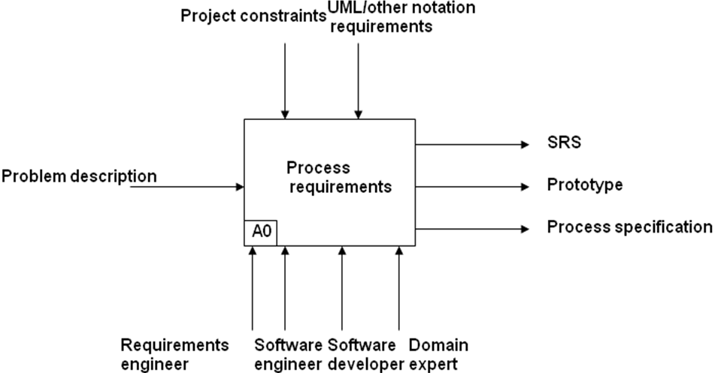

Level 1 Diagram for Process:

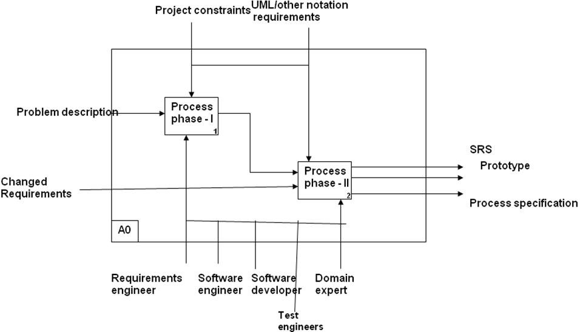
Level 2 Diagram for Process:
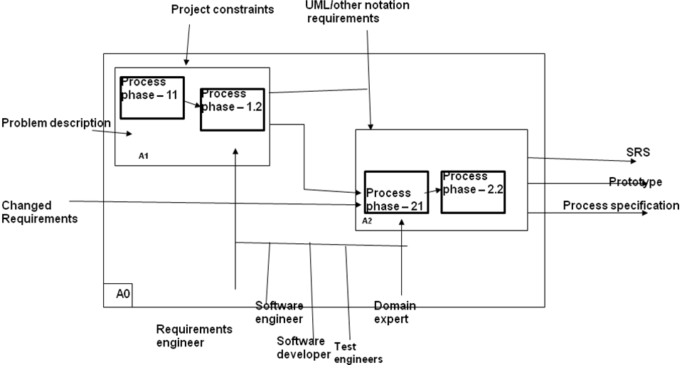

Product Specifications

Fish Bone Diagram
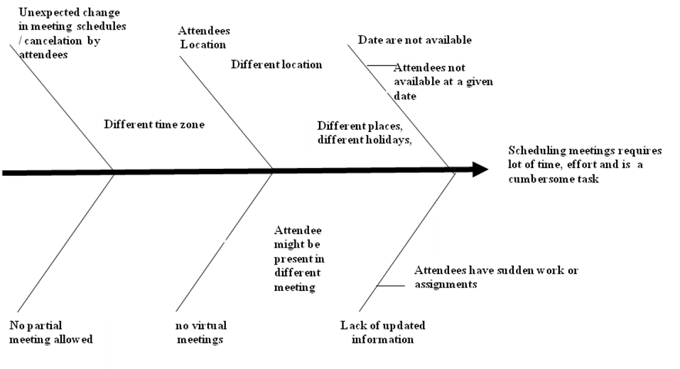

Class diagram

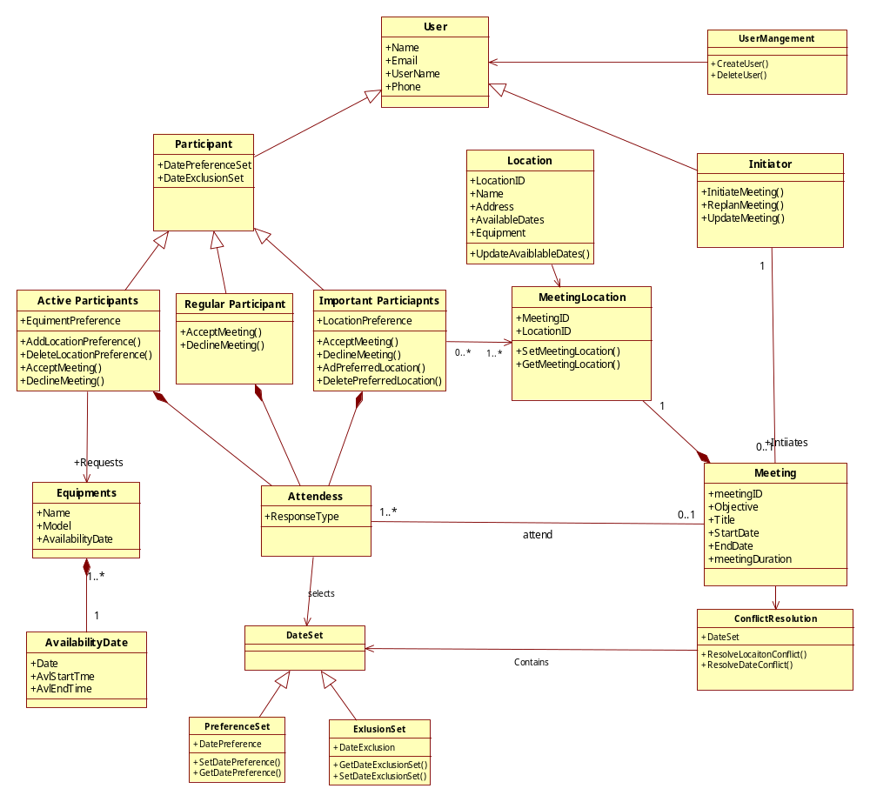

SADT diagram for Product
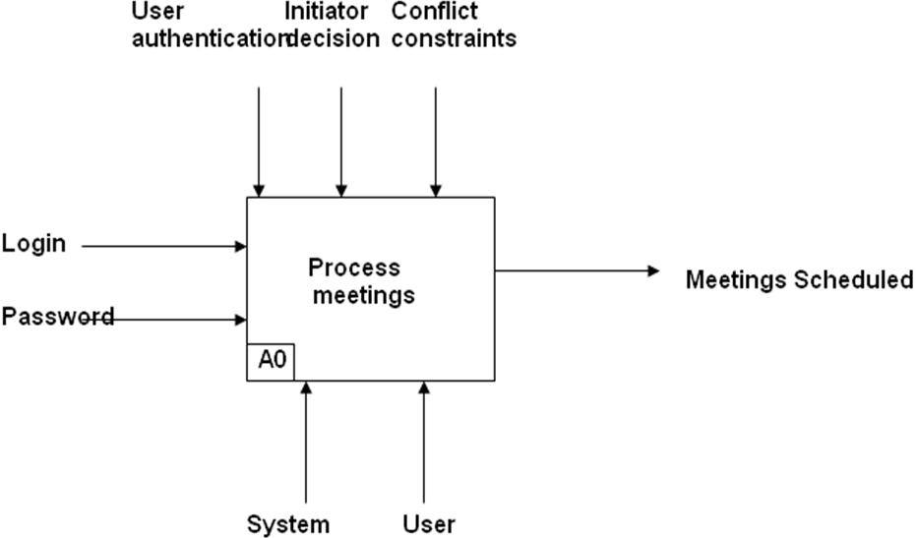

Use Case

UC Diagram
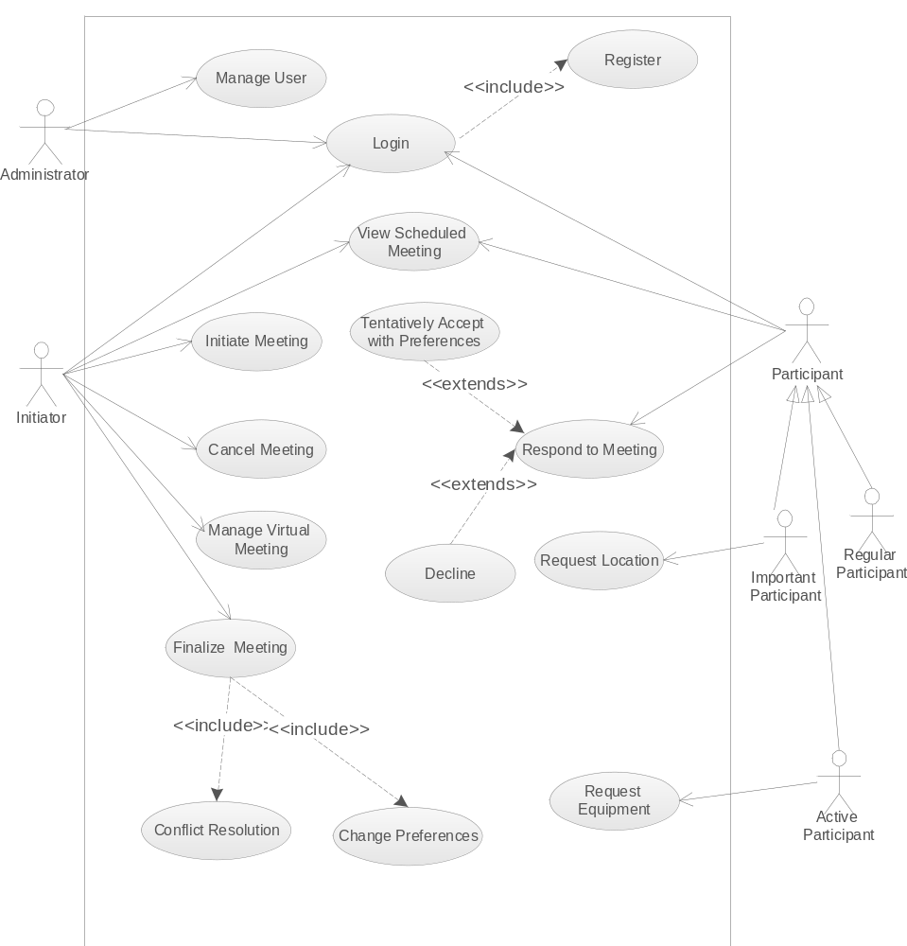

    - Use Case Description

Login

Login
UC Name | Login
Description | Allows user to enter in the system
Primary Actor | All Users of System
Stakeholders and Interest | Users wants to enter in the system
Precondition | User is not login in the system and he has not enter the system
Post condition | User is in the system after successful login
Main Success Scenario | - The User Enter Username and password  - System verifies the user  - User is able to login if user is validated else system doesn’t allow any anonymous user to enter into the system
Extension | Register
Special Requirements | None
Technology and Data variation list | - The use case will occur through the use of standard computer, keyboard and mouse.  - Email address and password is required
Frequency of Occurrence | Once
Miscellaneous | None

Manage User

Manage User
UC Name | Manages
Description | Allows admin to manage user details
Primary Actor | Admin
Stakeholders and Interest | Admin wants to manage user data
precondition | Admin is login as admin in the system
Postcondition | Admin updates or delete or do some modification in user details
Main Success Scenario | - The admin is able to update the user details.  - The admin is able to verify the user when user registers in the system.  - The admin is able to delete any user details.
Extension | None
Special Requirements | None
Technology and Data variation list | The use case will occur through the use of standard computer, keyboard and mouse.
 | Email address and password access is required
Frequency of Occurrence | Random
Extension | None

Register
Register
UC Name | Register
Description | Register the user so that user can access the system
Primary Actor | User
Stakeholders and Interest | User wants to register so that he can get access in the system
Precondition | User is not register with system
Postcondition | User is register in the system and get password to access the system
Main Success Scenario | User is able to enter the details.  If user is verified by admin he can get access into the system
Extension | None
Special Requirements | None
Technology and Data variation list | The use case will occur through the use of standard computer, keyboard and mouse.  Email address is required
Frequency of Occurrence | Once
Miscellaneous | None

Initiate Meeting

Initiate Meeting
UC Name | Initiate Meeting
Description | Allows registered members to initiate new meetings
Primary Actor | Meeting Initiator
stakeholders and Interest | Meeting initiator wants to initiate a new meeting
precondition | User is logged in as a meeting initiator
postcondition | Meeting Initiator sends new meeting request to all participants and confirms the meeting after resolving the conflicts.
Main Success Scenario | 1. The meeting initiator enters the meeting agenda, meeting duration and the proposed meeting date range with a start date and an end date.  2. The meeting initiator also fixes a freeze date.  3. The meeting initiator adds participant as important or active  4. The meeting initiator gives deadline to participants to respond.
Extension | None
Special Requirements | None
Technology and Data variation list | The use case will occur through the use of standard computer, keyboard and mouse.  Email address access is required
Frequency of Occurrence | Once
Miscellaneous | None

Cancel Meeting

Cancel Meeting
UC Name | Cancel Meeting
Description | Allows meeting initiator using the system to cancel meetings when the conflicts could not be resolved.
Primary Actor | Meeting Initiator
stakeholders and Interest | Meeting initiator wants to cancel the meeting if conflicts not resolved.
precondition | User is logged in as a meeting initiator
post condition | Meeting Initiator notifies cancelled meeting to all participants
Main Success Scenario | 1. The meeting initiator enters the why the meeting has to be cancelled.  2. The meeting initiator cancels the meeting and records it in log.
Extension | None
Special Requirements | None
Technology and Data variation list | The use case will occur through the use of standard computer, keyboard and mouse.  Email address access is required
Frequency of Occurrence | Once
Miscellaneous | None

Request Equipment

Request Equipment
UC Name | Request Equipment
Description | Initiator ask active Participant what equipment(s) they need for the given meeting via the meeting scheduler form
Primary Actor | Active Participant
stakeholders and Interest | Active Participant: Wants to be take the required equipments to the meeting and let every participant know about the equipments.
 | Participants: Wants to make sure all correct and working equipment are present when the meeting starts.
precondition | Initiator asks the active participant to take the required equipment.
Postcondition | All participants get to know what equipment is needed
Main Success Scenario | 1. Initiator enters login information to system.
 | 2. System validates initiator’s login and displays home page
 | 3. Initiator clicks Initiate Meeting
 | 4. System displays the Meeting Details Screen
 | 5. Initiator enters the name of participant
 | 6. Initiator enters Add
 | 7. System populates Participant field with name
 | 8. Repeat Step 6 till 11
 | 9. Initiator enters the subject of the meeting
 | 10. Initiator clicks submit button.
 | 11. System acknowledge the form submission and sends the request to the email addresses
Extension | Initiator has an option to request the active participant to take the equipments to the meeting.
Special Requirements | The email address of the participants must be accessible to the initiator, whether the emails are directly stored in the system or requires system’s accesses to an active email server.
Technology and Data variation list | - The use case will occur through the use of standard computer, keyboard and mouse.
 | - Email address access is required
Frequency of Occurrence | Once
Miscellaneous | None

View Scheduled Meeting

View Scheduled Meetings
UC Name | View Scheduled Meetings
Description | Allows meeting initiator and the participants to view upcoming meetings
Primary Actor | Meeting Initiator, Participants
stakeholders and Interest | Meeting initiator wants to view upcoming meetings and decide to initiate a meeting
 | Participants want to view upcoming meetings and decide to accept or decline a meeting request
precondition | User is logged in as a initiator or participant
postcondition | The user is able to view upcoming and already scheduled meetings
Main Success Scenario | The user is able to view upcoming and already scheduled meetings and all the related information viz:  Agenda, Duration ,Date range-Start Date, Date range-End Date ,Participant Status, Preference Set, Exclusion Set, Equipment, Scheduled Date, Time and Location, Deadline
Extension | None
Special Requirements | None
Technology and Data variation list | - The use case will occur through the use of standard computer, keyboard and mouse.  - Email address access is required
Frequency of Occurrence | Once
Miscellaneous | None

Respond to Meeting

Respond to Meeting Requests
UC Name | Respond to Meeting Requests
Description | Allows participants to state their preference and exclusion set.
Primary Actor | Participants
stakeholders and Interest | The participant can respond and conveys his convenience to the meeting initiator
precondition | User is logged in as a meeting participant.
postcondition | All the requested information is submitted to the initiator
Main Success Scenario | - Participant accepts the meeting if he/she is available.  - Participant give the exclusion set and preference to initiator.
Extension | None
Special Requirements | None
Technology and Data variation list | - The use case will occur through the use of standard computer, keyboard and mouse.  - Email address access is required
Frequency of Occurrence | Once
Miscellaneous | None

Decline
Decline
UC Name | Decline
Description | Meeting Participant resolve conflict by withdrawing from meeting
Primary Actor | Meeting Participant
Stakeholders and Interest | Initiator: Wants to be able to view withdrawals
precondition | The Participant received there is a conflict in date time and that they need to resolve conflict
post condition | Participant has withdrawn from the meeting
Main Success Scenario | 1. The Participant enters their login information
 | 2. System validates Participant’s login and directs to home page
 | 3. Participant Opens Existing Meeting
 | 4. System displays a List of assigned meetings
 | 5. Participant selects the meeting of interest
 | 6. Participant selects Decline
 | 7. System displays a Withdrawal Message
 | 8. System removes the prior’s Participant information from the meeting details
 | 9. System sends the meeting initiator a message notifying him of the withdrawal
Extension | None
Special Requirements | The meeting setup form must be intuitive to user
Technology and Data variation list | The use case will occur through the use of standard computer, keyboard and mouse.
Frequency of Occurrence | Once
Miscellaneous | None

Request Location

Request Location
UC Name | Request Locations
Description | Important Participants provide preferred Location
Primary Actor | Important Participants
stakeholders and Interest | Initiator: He/she also wants to get response from important participants so that he/she can set the final location for a meeting.
 | Important Participant: Wants to be able to access the application and enter the location request easily.
precondition | Important Participant received request for preference location
postcondition | Important Participant has provided preference location.
Main Success Scenario | 1. The important Participant enters their login information
 | 2. System validates login an directs to home page
 | 3. Opens Existing Meeting
 | 4. System displays a List Window with the Participant’s assigned meetings
 | 5. Participant selects the meeting of interest
 | 6. System displays Meeting Details Screen
 | 7. Participant enters preferred Location and respond to initiator.
Extension | The Participant can specify the preferred location to initiator.
Special Requirements | None
Technology and Data variation list | The use case will occur through the use of standard computer, keyboard and mouse.
Frequency of Occurrence | Once
Miscellaneous | None

Conflict Resolution
Conflict Resolutions
UC Name | Conflict Resolutions
Description | System will resolve conflict when user wants conflict to be resolved
Primary Actor | Meeting Initiator
stakeholders and Interest | Initiator: Wants to be able to access the application and resolve the date conflict easily.
 | Participants: Wants to make sure any date conflicts are resolved before they set it in the calendar and/or move other priorities (task, another conflicting meeting) around.
precondition | There is a conflict in date. The address of Participants field have already been populated.
postcondition | Either the conflict is resolves or initiator is asked to extend date range.
Main Success Scenario | 1. The Participant enters their login information
 | 2. System validates Participant’s login an diirects to home page
 | 3. System displays a List with the participant's assigned meetings
 | 4. Initiator selects the meeting of interest
 | 5. Initiator click solve conflict.
 | 6. System checks the date preference of all the participants of that meeting and try to resolve the conflict.
 | 7. System gives Initiator a resolved date or asked initiator to increase the date range.
Extension | None
Special Requirements | The meeting must not have occurred
Technology and Data variation list | The use case will occur through the use of standard computer, keyboard and mouse.
Frequency of Occurrence | Once
Miscellaneous | None

Finalize Meeting
Finalized Meeting
UC Name | Finalized Meeting
Description | Initiator Finalize the meeting
Primary Actor | Meeting Initiator
stakeholders and Interest | Initiator: Wants to be able to finalize meeting whose conflict is resolved.
 | Participant: Should be able to see the finalize meeting
precondition | Meeting is not finalized
post condition | Meeting is finalized
Main Success Scenario | 1. The Participant enters their login information
 | 2. System validates Participant’s login an diirects to home page
 | 3. System displays a List with the participant's assigned meetings
 | 4. Initiator selects the meeting of interest
 | 5. Initiator Finalize the meeting
 | 6. Initiator notifies the Change
 | 7. Participants are informed
Extension | Conflict resolutions and change preference
Special Requirements | The meeting must not have occurred
Technology and Data variation list | The use case will occur through the use of standard computer, keyboard and mouse.
Frequency of Occurrence | Once
Miscellaneous | None

Sequence Diagram

Login
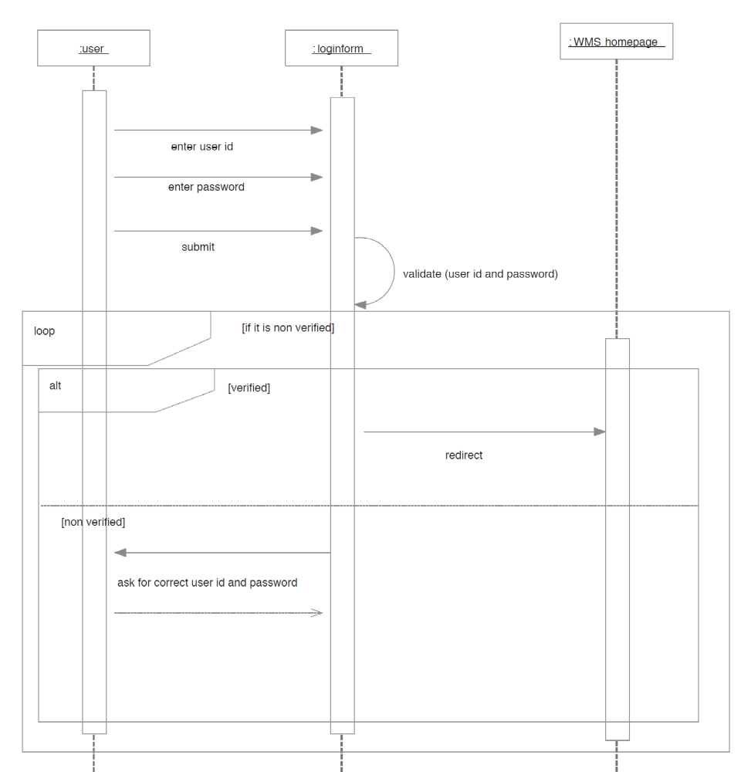

Initiate Meeting
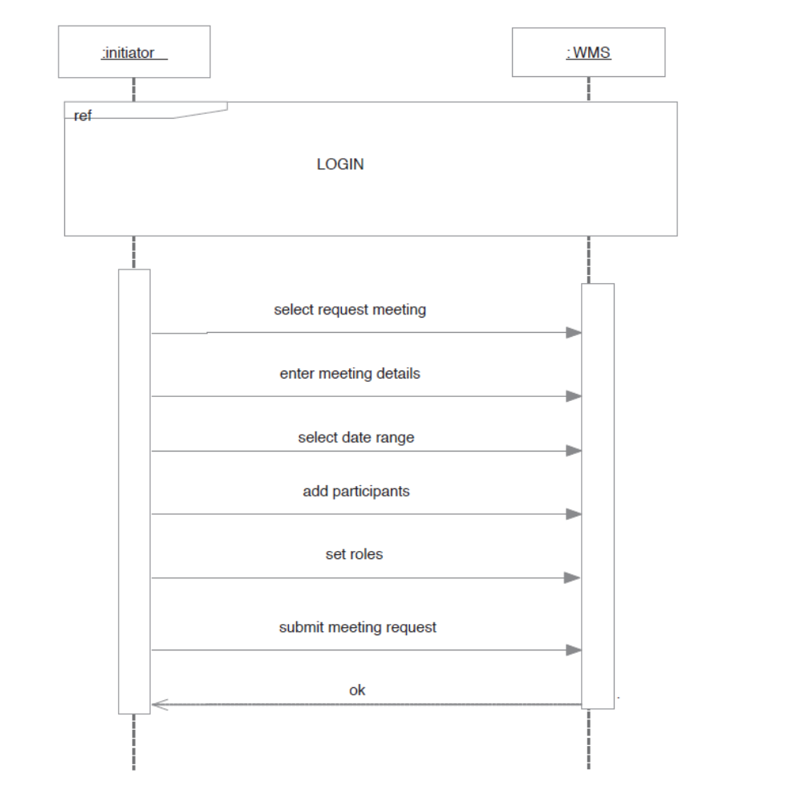

Cancel Meeting
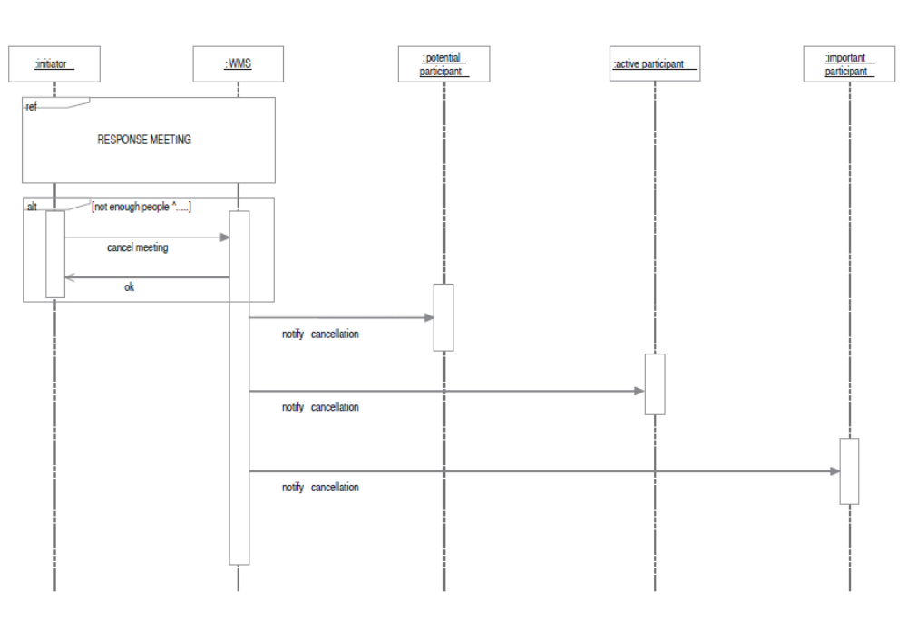

Respond to Meeting
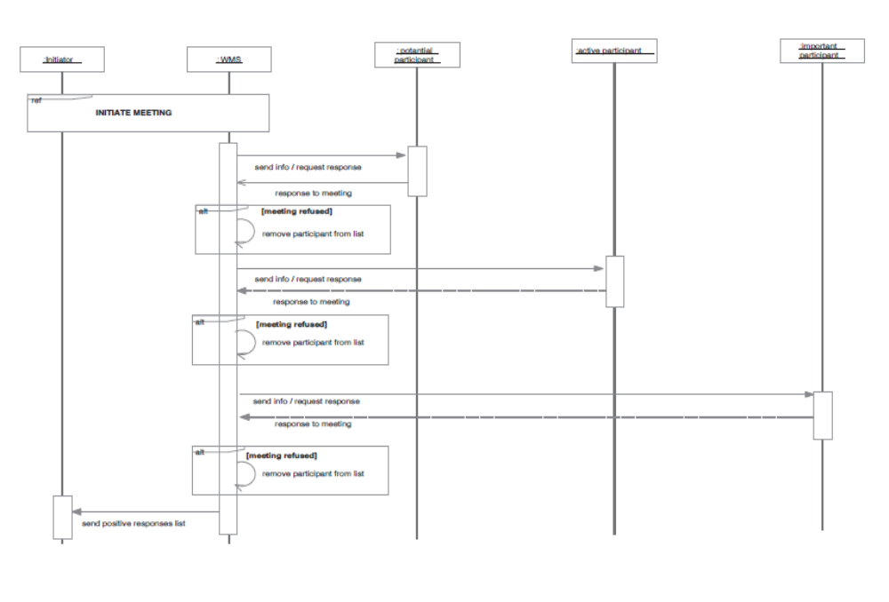
3.3.7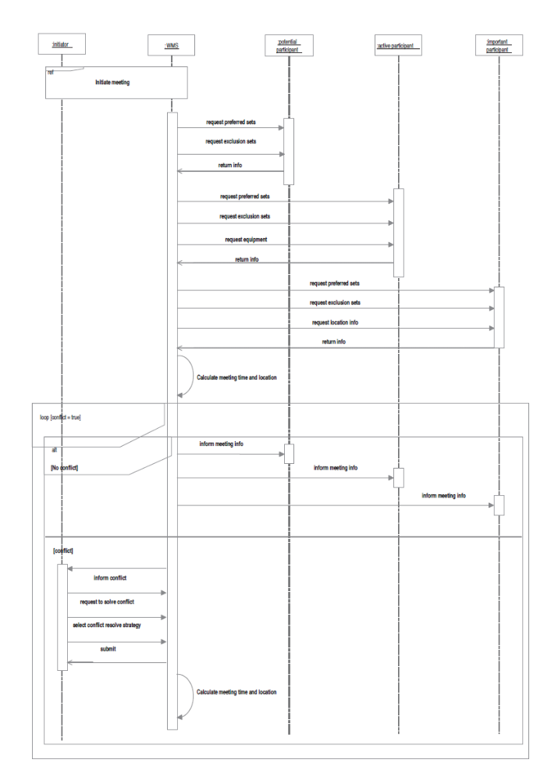

Activity Diagram:

Activity diagrams describe the workflow behavior of a system. Activity diagrams are similar to state diagrams because activities are the state of doing something. The diagrams describe the state of activities by showing the sequence of activities performed. Activity diagrams can show activities that are conditional or parallel. Activity diagrams should be used in conjunction with other modeling techniques such as Sequence diagram diagrams. The main reason to use activity diagrams is to model the workflow behind the system being designed. Activity Diagrams are also useful for: analyzing a use case by describing what actions need to take place and when they should occur; describing a complicated sequential algorithm; and modeling applications with parallel processes.
The diagrams have the following features:
- A starting point marked “Start” shows the starting point of the activity.
- Steps in the main Use Cases are taken from the events in the main Use Case diagram. The steps are modeled as Use Cases. These steps can be furthered decomposed using the same notation.
- Inputs, outputs, controls, and mechanisms are modeled in the following manner:

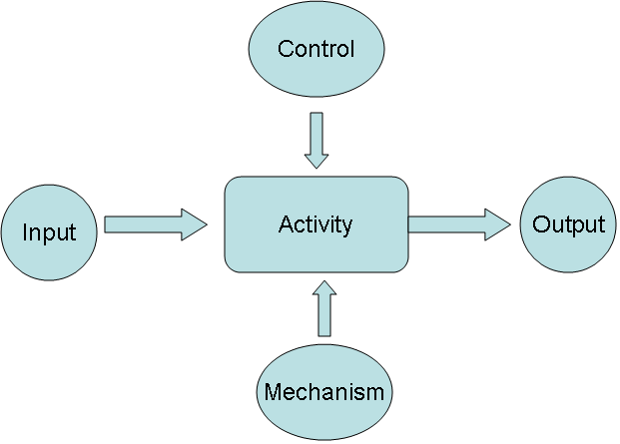
Inputs, outputs, and controls are involved objects in the application.
    - Schedule Meeting Activity Diagram:
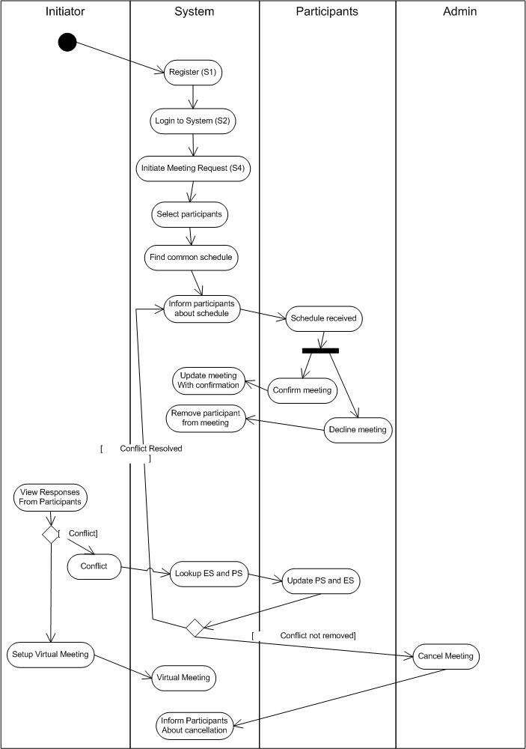
    - Business Activity Diagram:



