COTS-Aware Requirements Engineering and Software Architecting

Lawrence Chung  Department of Computer Science  The University of Texas at Dallas  chung@utdallas.edu | Kendra Cooper  Department of Computer Science  The University of Texas at Dallas  kcooper@utdallas.edu

Abstract
At the heart of a well-disciplined, systematic methodology that explicitly supports the use of COTS components is a clearly defined process for effectively using components that meet the needs of the system under development. In this paper, we present the CARE/SA approach which supports the iterative matching, ranking, and selection of COTS components, using a representation of COTS components as an aggregate of their functional and non-functional requirements and architecture. The approach is illustrated using a Digital Library System example.

Introduction
The use of commercial off-the-shelf (COTS) components is perceived to significantly shorten development time and cost, while improving quality, in developing large, complex software systems. Ideally, COTS components offer pre-packaged solutions which presumably have already gone through the various time-consuming and costly phases of requirements specification, design, coding, testing, and have been hardened over time. However, the effective use of COTS components requires a well-disciplined systematic methodology that facilitates the exploitation of the benefits of COTS components while guarding against their pitfalls.
This paper presents the COTS-Aware Requirements Engineering and Software Architecting (CARE/SA) Framework, which supports the iterative matching, ranking, and selection of COTS components, using a representation of COTS components as an aggregate of their requirements and architecture.
The CARE/SA Framework can be viewed as an extension to current methodologies with a systematic approach to match, rank, and select COTS components. The Rational Unified Process (RUP) is an object oriented software engineering technique [11] which is based on four phases (transition, construction, elaboration, and inception), and uses the unified modeling language (UML). In UML, a COTS component is represented as a component, a physical and replaceable part of the system that provides a set of interfaces and typically represents the physical packaging of classes, interfaces, and collaborations [12]. The Procurement Oriented Requirements Engineering (PORE) technique supports the evaluation and selection of COTS components [14]. PORE’s process model identifies four goals in COTS selection: acquiring information from the stakeholders, analyzing the information to determine if it is complete and correct, making the decision about product requirement compliance, and selecting one or more candidate COTS components. The Model Based Architecting and Software Engineering (MBASE) approach considers four types of models: success, process, product and property [3] and is consistent for use with COTS components [2]. The Evolutionary Process for Integrating COTS Based Systems (EPIC) framework has been presented to meet the challenges of building, fielding, and supporting component-based business solutions [1]. While leveraging the RUP, EPIC simultaneously defines and makes trade-offs among four spheres of influence: the stakeholders' needs and their business processes, the components currently available in the marketplace, the architecture and design of the system, and programmatics and risks.
Section 2 presents how COTS components are modeled and the process defined to match, rank, and select COTS components. An example illustrating the application of the CARE/SA approach is presented in Section 3. Conclusions are in Section 4.

Evaluate Components to Bridge the Gaps
At the heart of an effective COTS-aware methodology are techniques to assist the requirements engineer (RE) with the challenging task of matching, ranking, and selecting potential COTS components. Given an initial set of goals for a system under development (hereafter SUD), it is very unlikely that there is a simple, one to one mapping from the goals of the SUD and the goals (implemented as capabilities) of currently existing COTS components. The RE needs to search for matching components, rank them in terms of how well they meet the current SUD goals, and select components. The RE needs to iteratively bridge the gap between the currently available components in the repository and the stakeholders’ goals for the SUD (refer to Figure 1). The RE's options include making a request to search for additional COTS components available in the marketplace, change a COTS component, and/or change a goal for the SUD. The RE may ask a Component Engineer (CE), responsible for maintaining a repository of components, to either search for additional COTS components that may be added to the repository or request a change to a component (where the change is made by the vendor). For example, if a COTS component that provides the necessary functional capabilities is described as high performance and high cost, the development house may negotiate with a vendor to provide a modified component with moderate performance and moderate cost. Negotiations with the stakeholders to modify, or rewrite, a goal for the SUD may be possible. If a COTS component cannot be identified at this point to provide the capabilities needed, then the RE documents these results. Later in the development process, when the goals are refined into software requirements, the RE can search for suitable COTS components again. Throughout the CARE/SA process, the decisions and the rationale for making them are documented. For example, when the RE matches, ranks, and selects the components, the reasons, or rationale, for selecting the components as candidates are maintained. When the requirements need to be modified, the RE uses the rationale history as an aid.

Modeling COTS Components
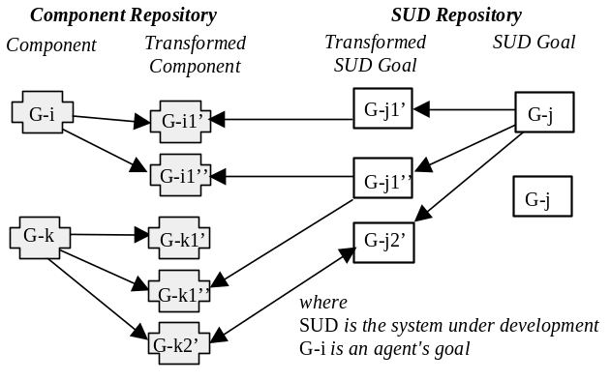The CARE/SA approach represents a COTS component as an aggregation of requirements and its architecture. The levels of abstraction are used to iteratively match, rank, and select COTS components as the definition of the SUD's requirements and architecture proceeds. The component requirements have a high-level, overview description of the functional and non-functional capabilities of a component, such as information found on marketing brochures for products. The description provides enough information for a reader to determine if the product appears to have the potential for use and warrants further investigation. The requirements also have detailed descriptions of the functional and non-functional characteristics of a component, such as information found on the data sheets for a product. The attributes stored and maintained for component include overview; type; name; list of keywords and weights (used for keyword and case based searching); functional overview; domain; vendor; standards compliance; interface type; performance; security; related subcomponents; and lessons learned (e.g., interactions among components - incompatibilities, emergent behavior, etc.). The architecture of a component [16] describes its (sub)component capabilities, connectors, constraints, patterns, styles, and rationale. Descriptions of a component's architecture can be determined, for example, from its API defined in a javadoc.
Figure 1. Bridging the Gaps Between SUD Requirements and the Capabilities of the COTS Components.

Match, Rank, and Select Components
In CARE/SA, the process model must define when and how to define the agents, goals, requirements, and architecture, all with respect to using COTS components. For example, the process description for defining system goals (with COTS) is presented as a collection of iterative activities. Once a collection of goals is defined, the RE analyzes them to identify errors of commission (conflicting, incorrect, and redundant goals) and omission (missing goals). The RE corrects goals, removes redundant goals, adds missing goals, and negotiates conflicting goals. The stakeholders validate the goals to ensure the RE understands their needs and wants. The process of eliciting, analyzing, correcting, and validating goals may be iterative. When the agents (stakeholders) have no major issues with the goals defined, then the RE begins to match, rank, and select COTS components.
Preliminary process definitions have been proposed involving agents [4], goals [6], and software architecture [5]. Here, we present the main activities in the CARE/SA process that involve defining and matching goals, and ranking and selecting components (refer to Figure 2).

Define Goals. The first step in the process is to elicit a set of initial goals. Since goals may be very abstract, the RE may need to decompose them. For example, a softgoal "the system should be scaleable" leads the RE to ask the question "scaleable in what way?" When interviewed, one stakeholder may intend this goal to mean the system should be scaleable to support a higher number of concurrent users. Another may intend this goal to mean supporting additional data in the database. In addition to decomposing the goals, the RE also needs to document the relationships among the goals. To characterize the relationships between goals, a goal-oriented framework is used. One such framework is the NFR Framework [8] which provides a set of rankings of the relationships between two (soft)goals, including: very positive (++), positive (+), negative (-), and very negative (--).
In this framework, goals (softgoals and hardgoals) are organized into a (soft)goal interdependency graph (SIG), much like the AND/OR trees used in problem-solving [15]. Unlike traditional problem-solving and planning frameworks, however, goals representing non-functional requirements (NFRs hereafter) can rarely be said to be “satisfied” in a clearcut sense. Instead, different design decisions contribute positively or negatively towards a particular goal. Accordingly, the Framework uses the notion of goal satisficing [18] to suggest that generated software is expected to satisfy within acceptable limits, rather than absolutely, NFRs.
The SUD artifacts include the goals and the architecture. The set of goals in the SUD are represented as follows (here, the term requirements is used to represent goals and refined subgoals):

SUD-R = SUD-NFR ∪ SUD-FR
where
SUD-R, SUD-NFR and SUD-FR respectively denote requirements (i.e., goals), NFRs, and functional requirements, for the SUD
SUD-NFR = {SUD-NFR.1, SUD-NFR.2, …, SUD-NFR.l},
SUD-FR = {SUD-FR.1, SUD-FR.2, …, SUD-FR.k}.

The architecture in the SUD is represented as:

SUD-Arch = SUD-Arch-component ∪ SUD-Arch-connector ∪ SUD-Arch-constraint ∪ SUD-Arch-pattern ∪ SUD-Arch-style ∪ SUD-Arch-rationale

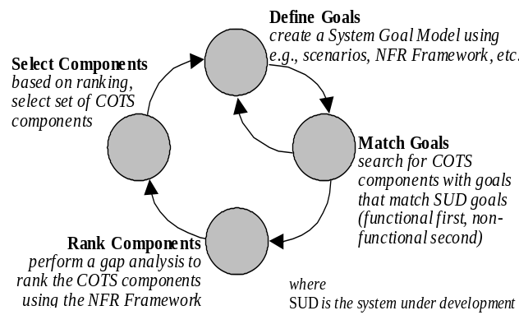Match Components. Here, the RE begins the process by identifying goals that may be candidates for implementing with one or more COTS components The goals may be functional or non-functional. For each candidate, the RE performs a search on the repository that returns an overview of the components that match the search criteria. The repository supports a keyword and case based search. The keywords used in the COTS component definitions are used to build a glossary of terms that is made available to the RE; the RE selects keywords from this glossary of terms. The RE evaluates the results of the preliminary search and determines which of the components (if any) may be a possible match to a goal. The RE performs a search on the repository for the components that appear to satisfy the preliminary match; detailed descriptions of the functional and non-functional descriptions of these components are returned. A case based reasoning [10] seems to be flexible, especially when knowledge about the stakeholder needs is incomplete. The incomplete knowledge will act as the search criteria, in the form of multiple prioritized attribute values, for the contents of the repository that will act as the more complete definition for the requirements being defined.
Figure 2. Matching, Ranking, and Selecting COTS Components in the CARE/SA Process

Each COTS component is an aggregate of its requirements and architecture. The requirements are described as:

COTS-R = {COTS-R1, COTS-R2, …, COTS-Rm}
where
COTS-R denotes a set of COTS component requirements
COTS-Ri = COTS-NFRi ∪ COTS-Fri
COTS-NFRi = {COTS-NFRi.1,COTS-NFRi.2,…,COTS-NFRi.p}
COTS-FRi = {COTS-FRi.1, COTS-FRi.2, …, COTS-FRi.q}

The architecture of the COTS component is described as:

COTS-Arch = COTS-Arch-component ∪ COTS-Arch-connector ∪ COTS-Arch-constraint ∪ COTS-Arch-rationale

As shown in Figure 2, matching occurs iteratively as the software is developed. The initial matching is at the requirements level (Level 1); subsequent matching is at the architecture level (Level 2). After each search, a set of zero or more components is identified as potential matches.
The matches are described in two cases (refer to Figure 3). The first case has a non-functional goal as the candidate; the second case has a functional goal as the candidate. After matching at the requirements level (Level 1), the two cases are (Figure 3-a and 3-c, respectively):

Case 1. Level 1Non-functional Match = {COTS | COTS-i-NFR matches SUD-j-NFR }
Case 2. Level 1 Functional Match = {COTS | COTS-i-FR matches SUD-j-FR }

Rank Components. The COTS components that appear to be potential matches are grouped into sets containing COTS components with varying degrees of satisficing the SUD requirements. After ranking at the requirements level (Level 1), the sets would include (in the order of decreasing degree of satisficing):
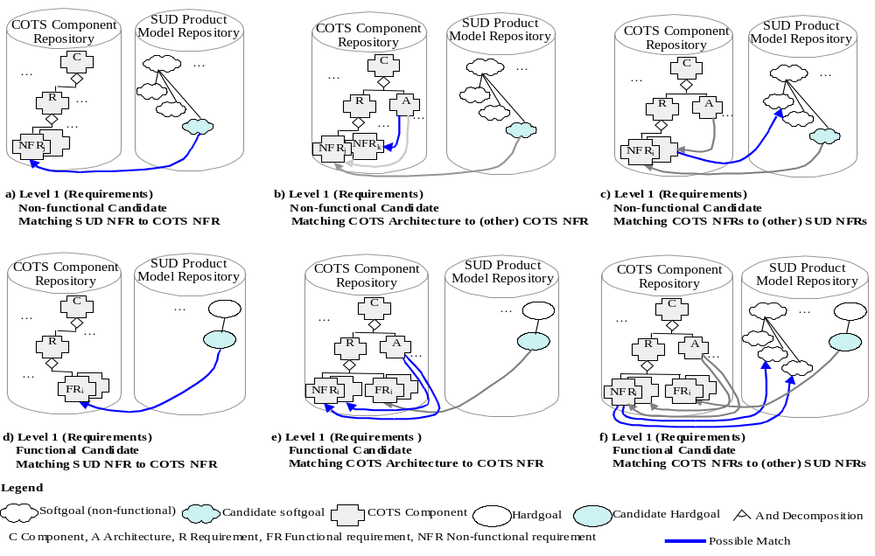
For Case 1: Let NFRj represent a NFR such as authentication. Then, the sets would include:
COTS-NFRj-MAKE-SUD-NFRj = {COTS-NFri| COTS-NFRi MAKE SUD-NFRj}
COTS-NFRj-HELP-SUD-NFRj. = {COTS-NFri| COTS-NFRi HELP SUD-NFRj}

For Case 2: COTS-FRs-MAKE-SUD-FRs = {COTS-Fri| COTS-FRi MAKE SUD-FRj} U {COTS-Fri.s| COTS-FRi.s MAKE SUD-FRj}
Figure 3. Matching, Ranking, and Selecting COTS Components. (There are two cases to consider. The first case has a non-functional candidate goal, as represented in a), b) and c). The second case has a functional candidate goal, represented in d), e), and f).
COTS-FRs-HELP-SUD-FRs = {COTS-Fri| COTS-FRi HELP SUD-FRj} U {COTS-Fri.s| COTS-FRi.s HELP SUD-FRj}

where MAKE means an exact match or one with minor, insignificant mismatch, and HELP means close match with tolerable mismatch. The matching should consider if COTS requirements are bigger/smaller in scope, or if they are similar overall, but with a different context or scope.
Matching COTS components needs to consider the NFRs in the SUD and their priorities. The resulting groups of this step include (assume that in each set below, the particular COTS-FRs are met by the particular COTSa, where COTSa is the architecture of a COTS component, and for Case 1, this implies the consideration of other NFRs, denoted as NFRk):

For Case 1: { COTSa | COTS-NFRj-MAKE-SUD-NFRj ∩ COTSa -MAKE-COTS-NFRj NFRj ∩ COTSa -MAKE-COTS-NFRk }
{COTSa | COTS-NFRj-MAKE-SUD-NFRj ∩ COTSa-HELP-COTS-NFRj ∩ COTSa -HELP-COTS-NFRk }

For Case 2: { COTSa | COTS-FRs-MAKE-SUD-FRs ∩ COTSa -MAKE-COTS-NFRs}
{ COTSa | COTS-FRs-MAKE- SUD-FRs ∩ COTSa-HELP-COTS-NFRs}

Further group the above, this time based on the match between the COTS component NFRs and the SUD NFRs. For Case 1, this implies the consideration of other NFRs (NFRk) interacting with the NFR in concern (NFRj). The resulting groups include (assume that in each set below, the particular COTS-FRs are met by the particular COTSi, and COTS-FRs and COTS-NFRj taken together constitute the particular requirements specification):

For Case 1: {COTSa | COTS-NFRj-MAKE-SUD-NFRj ∩ COTSa -MAKE-COTS-NFRj ∩ COTSa -MAKE-COTS-NFRk ∩ COTS-NFRk-MAKE-SUD- NFRk}
{COTSa | COTS-NFRj-MAKE-SUD-NFRj ∩ COTSa -MAKE-COTS-NFRj ∩ COTSa -HELP-COTS-NFRk ∩ COTS- NFRk HELP-SUD- NFRk }

For Case 2: {COTSa| COTS-FRs-MAKE-SUD-FRs ∩ COTSa -MAKE-COTS-NFRj ∩ COTS- NFRs MAKE-SUD- NFRs}
{COTSa | COTS-FRs-MAKE-SUD-FRs ∩ COTSa -MAKE-COTS-NFRs ∩ COTS- NFRs HELP-SUD- NFRs}

Select Components. The RE examines the results of the ranking in order to select among the COTS component sets with varying degrees of satisficing the SUD requirements. The RE may select only some of the components in only the best satisficing set, if it contains a large number of them. Or the RE may select whatever is available in the second best set, or even in the third, if the best satisficing set is empty, etc.
Due to the early stage of development, the RE is unlikely to have enough information to evaluate the component completely for its use in the SUD. For example, a component may support MPEG 3 but not MPEG 4; the RE may not know at this point if the earlier
standard (this is another kind of NFR) is suitable. The RE evaluates a component with the assistance of the CE and the SA. The CE may obtain additional information about the components or for new or modified components. The SA may provide additional information of the impact of components on the system architecture.
After one (or more) iterations at Level 1 matching, ranking and selecting, the COTS components are matched, ranked and selected at the architectural level (Level 2).

Illustration
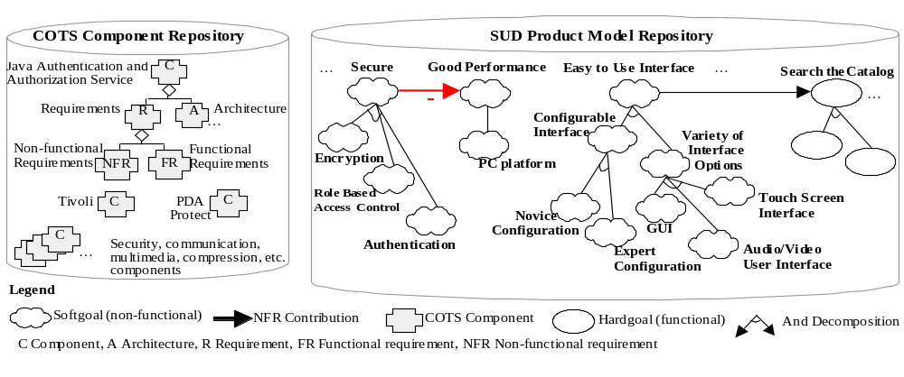
A Digital Library System (DLS) has been used to validate the CARE/SA approach. Figure 4 represents how part of the CARE/SA knowledge base can be instantiated. On the left, a COTS repository is illustrated with a collection of components that are currently available in the marketplace. These components have been found by searching the Internet and specified using information available from the vendors. This is quite variable, where the missing information about the components needs to be obtained by a component engineer by contacting the vendor or empirically evaluating the component. On the right, the functional (hardgoals) and non-functional (softgoals) of the SUD are represented in a SIG. Some of the softgoals for a DLS include security and being easy to use. Hardgoals include being able to search the catalog. As the CARE approach is applied, COTS components that may realize functional and non-functional goals of the SUD are identified using the matching, ranking, and selection process. The relationships between the COTS components in the repository and the goals for the SUD are explicitly defined, and their contributions are evaluated.
Figure 4. Preliminary Softgoal Interdependency Graph and COTS Component Repository (This illustrates how part of the CARE/SA knowledge base is populated for a DLS before the Goals of the SUD are matched, ranked and selected with respect to the Goals of the components).

Model Components
Of interest in this example are components that provide access and authentication capabilities. The CE does an Internet search and identifies a collection of components including IBM's Tivoli Access Manager for e-business [19], Sun's Java authentication and authorization service (JAAS) [9], and Transaction Security, Inc.'s PDA Protect [16]. The functional and non-functional goals available from the product information posted about the products are extracted; the components are added to the repository. For example, part of the JAAS component in the repository is described informally below:
Unique Identifier: C_021
Type:Software
Name:Java authentication and authorization service (JAAS)
Keyword1:security
Weight1:5
Keyword2:authentication
Weight2:4
Keyword3:authorization
Weight3:4
Keyword4:access control
Weight4:4
Overview: The JAAS enables developers to authenticate users and enforce access controls upon those users. JAAS can be used to reliably and securely determine who is currently executing Java code, regardless of whether the code is running as an application, an applet, a bean, or a servlet.
Vendor: Sun Microsystems Inc.
VendorEvaluation: Sun Microsystems, Inc. is a leader in the Java language specification and tool support
Webpage: java.sun.com/products/jaas/overview.html
Version Number: 1.0
Interface: set of APIs, binary
Environment: Java 2 SDK, v1.3
Domain: distributed, non-distributed
Standards Compliance: implements a Java version of the standard Pluggable Authentication Module (PAM) framework.
The keywords and their weights are used in a keyword based search to order the results presented to the RE.
The components are represented formally in the repository using the Telos [13] notation.

Match Goals
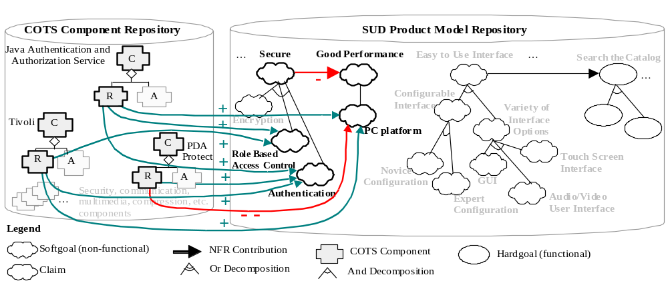
The RE searches for components in the repository that have goals that may match the goals of the SUD. The RE searches the repository for components to provide security capabilities including authentication and access control. The RE does a keyword-based search using "security", "authorization", "access control". Preliminary information, including the names and the overviews of the three components in the repository that match are returned. Based on this information, two of the components appear to be possible matches; one appears to be specific for personal data assistants (PDA):
Figure 5. Results of Matching, Ranking, and Selecting COTS components (This illustrates how part of the CARE/SA knowledge base is populated for a DLS after the Goals of the SUD are matched, ranked and selected with respect to the Goals of the components).
First component in search results:
Name:Java authentication and authorization service (JAAS)
Overview: The JAAS enables developers to authenticate users and enforce access controls upon those users with APIs. JAAS can be used to reliably and securely determine who is currently executing Java code, regardless of whether the code is running as an application, an applet, a bean, or a servlet.

Second component in search results:
Name:Tivoli Access Manager for e-business
Overview: The Tivoli Access Manager for e-business integrates with e-business applications. It provides authentication and authorization APIs and integrates with application platforms such as J2EE™.

Third component in search results:
Name: PDA Protect
Overview: The PDA-Protect is a remote authentication technology based upon the submission of a secret sign from a personal data assistant (PDA) device. It is used to control the release of the password to enable the device at power-up or whenever a password is required. The user does not need to remember or enter a password each time it is used; a record of a password may be stored in a secure location for access.

The RE requests additional information about the components to determine which may be possible matches by performing another search on the repository. Details about the components are returned. For example, a significant attribute of the PDA Protect component is the required operating system is the Pocket PC 2002, an operating system for mobile, personal data assistants. The Tivoli and the JAAS components, however, do not have operating system restrictions as they are Java based.

Rank and Select Components
Using the NFR Framework, the components are ranked by the RE. The PDA Protect component is placed into the "breaks" group of components, because the DLS is not intended to be a mobile, PDA based application. At this point, however, the Tivoli component and the JAAS component appear to be possible matches, and are placed into the "helps" group.
Given the current understanding of the SUD and the components, the JAAS and the Tivoli components are both selected as possible components (refer to Figure 5). In subsequent iterations, based on the detailed requirements and architecture of the SUD and the components, these two components are re-evaluated.

Conclusions
Here we have presented the CARE/SA Framework, an ongoing work for supporting the matching, ranking, and selection of COTS components, during the development of software/system architectures. The Framework represents a COTS component as an aggregate of its requirements, both functional- and non-functional requirements, and its architecture - each with its own set of attributes. The levels are necessary to understand and use the requirements of the COTS components in supporting the elicitation, specification and validation of the system-under-development (SUD) requirements, as well as the design of the SUD architecture. Matching SUD requirements to COTS components can be done using keyword or case based reasoning. This approach has been applied to a Digital Library System. There are several lines of future research, including the investigation of more heuristics for matching, ranking and selection of COTS components, a meta-model for the CARE/SA process and product, and web-based tool support.

References
- Albert, C. and Brownsword, L., Evolutionary Process for Integrating COTS-Based Systems (EPIC) Building, Fielding, and Supporting Commercial-off-the-Shelf (COTS) Based Solutions, CMU/SEI-2002-TR-005, 2002.
- Boehm, B. “Requirements that handle IKIWISI, COTS, and Rapid Change", IEEE Computer, 33(7), July 2000, pp. 99–102.
- Boehm, B., Port, D., Abi-Antoun, M., and Egyed, A. Guidelines for the Life Cycle Objectives (LCO) and the Life Cycle Architecture (LCA) deliverables for Model-Based Architecting and Software Engineering (MBASE), TR USC-CSE-98-519, USC-Center for Software Engineering.
- Chung, L. and Cooper, K., “Defining Agents in a COTS-Aware Requirements Engineering Approach”, Proc., 7th Int. Australian Workshop on Requirements Eng., 2002.
- Chung, L. and Cooper, K., “Defining an Architecture with a COTS-Aware Software Engineering Process”, Proc., Int. Council on Systems Eng. Symp., 2003, pp. 1219-1228.
- Chung, L. and Cooper, K., “Defining Goals in a COTS-Aware Requirements Engineering Approach”, System Engineering journal, 7(1), 2004, pp. 61-83.
- Chung, L. and Cooper, K., "Matching, Ranking, and Selecting Components: A COTS-Aware Requirements Engineering and Software Architecting Approach", submitted to Workshop Models and Processes for the Evaluation of COTS Components, co-located with ICSE 2004.
- Chung, L., Nixon, B., Yu, E., and Mylopoulos, J., Non-Functional Requirements in Software Engineering, Kluwer Academic Publishing, 2000.
- Java authentication and authorization service product description, available at: http://java.sun.com/products/jaas/overview.html
- Kolodner, J. Case-Based Reasoning, Morgan Kaufmann Publishers, San Mateo, CA. 1993.
- Kroll, P. and Kruchten, P., The Rational Unified Process Made Easy, Addison-Wesley, 2003.
- Kruchten, P., “Modeling Component Systems with the Unified Modeling Language”, Int. Workshop on Component-Based Software Eng., 1998.
- Mylopoulos, J., Borgida, A., Jarke, M., and Koubarakis, M., “Telos: Representing Knowledge about Information Systems”, ACM Transactions on Information Systems 8 (4), October 1990, pp. 325-362
- Ncube C. and Maiden N, “Guiding parallel requirements acquisition and COTS software selection”, Proc., IEEE Int. Symp. on Requirements Eng., 1999, pp. 133-140.
- Nilsson, N.J., Problem Solving Methods in Artificial Intelligence, McGraw Hill, USA, 1971.
- PDA Protect product description, available at: http://whitepapers.informationweek.com/detail/PROD/1072086990_744.html&src=iw
- Shaw, M. and Garlan, D., Software Architecture: Perspectives on an Emerging Discipline, Prentice-Hall, 1996.
- Simon, H., The Science of the Artificial, Second edition, Cambridge, MA., The MIT Press, 1981.
- Tivoli product description, available at http://www-306.ibm.com/software/tivoli/products/access-mgr-e-bus/

This is an extended and improved version of [7]; the extension considers both functional and non-functional requirements as candidates for the matching, ranking, and selection process.
Note that the architectural styles or patterns used to develop the COTS component are unlikely to be available, and not included in the representation.

