Lecture 2
Basic Vacuum System information

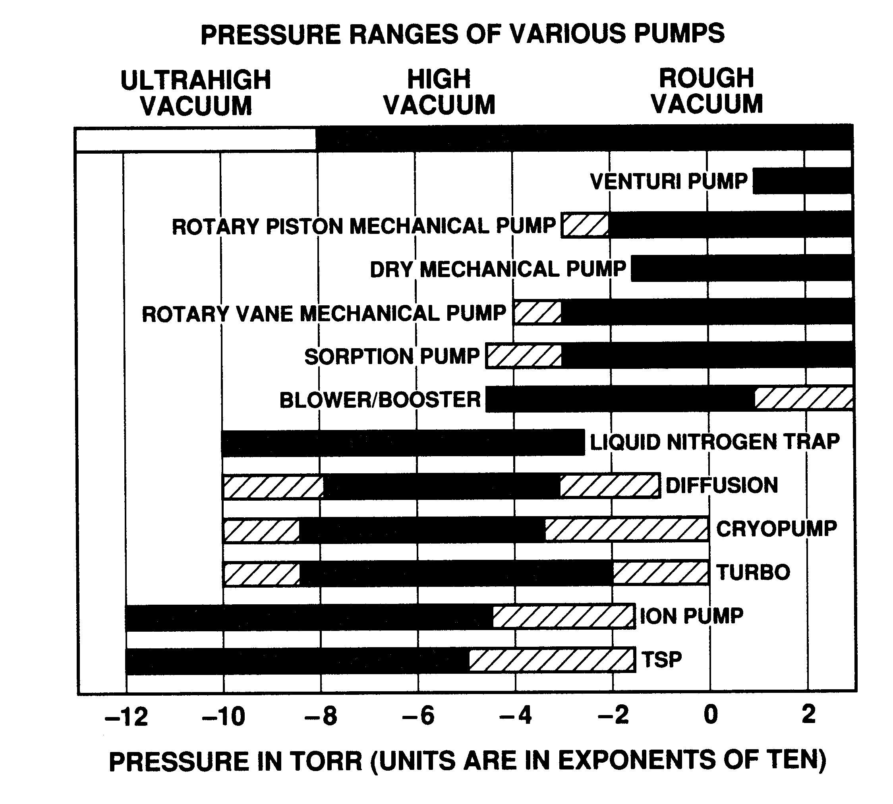

Typical pump combinations used for different pressure ranges. Ultrahigh runs from 1E-12 Torr to ~1E-8 Torr. High vacuum runs from ~1E-8 Torr to 1E-3 Torr. Rough vacuum runs from 1E-3 Torr to 760 Torr or ATM. (Figure from Basic Vacuum Practice, Varian Vacuum)
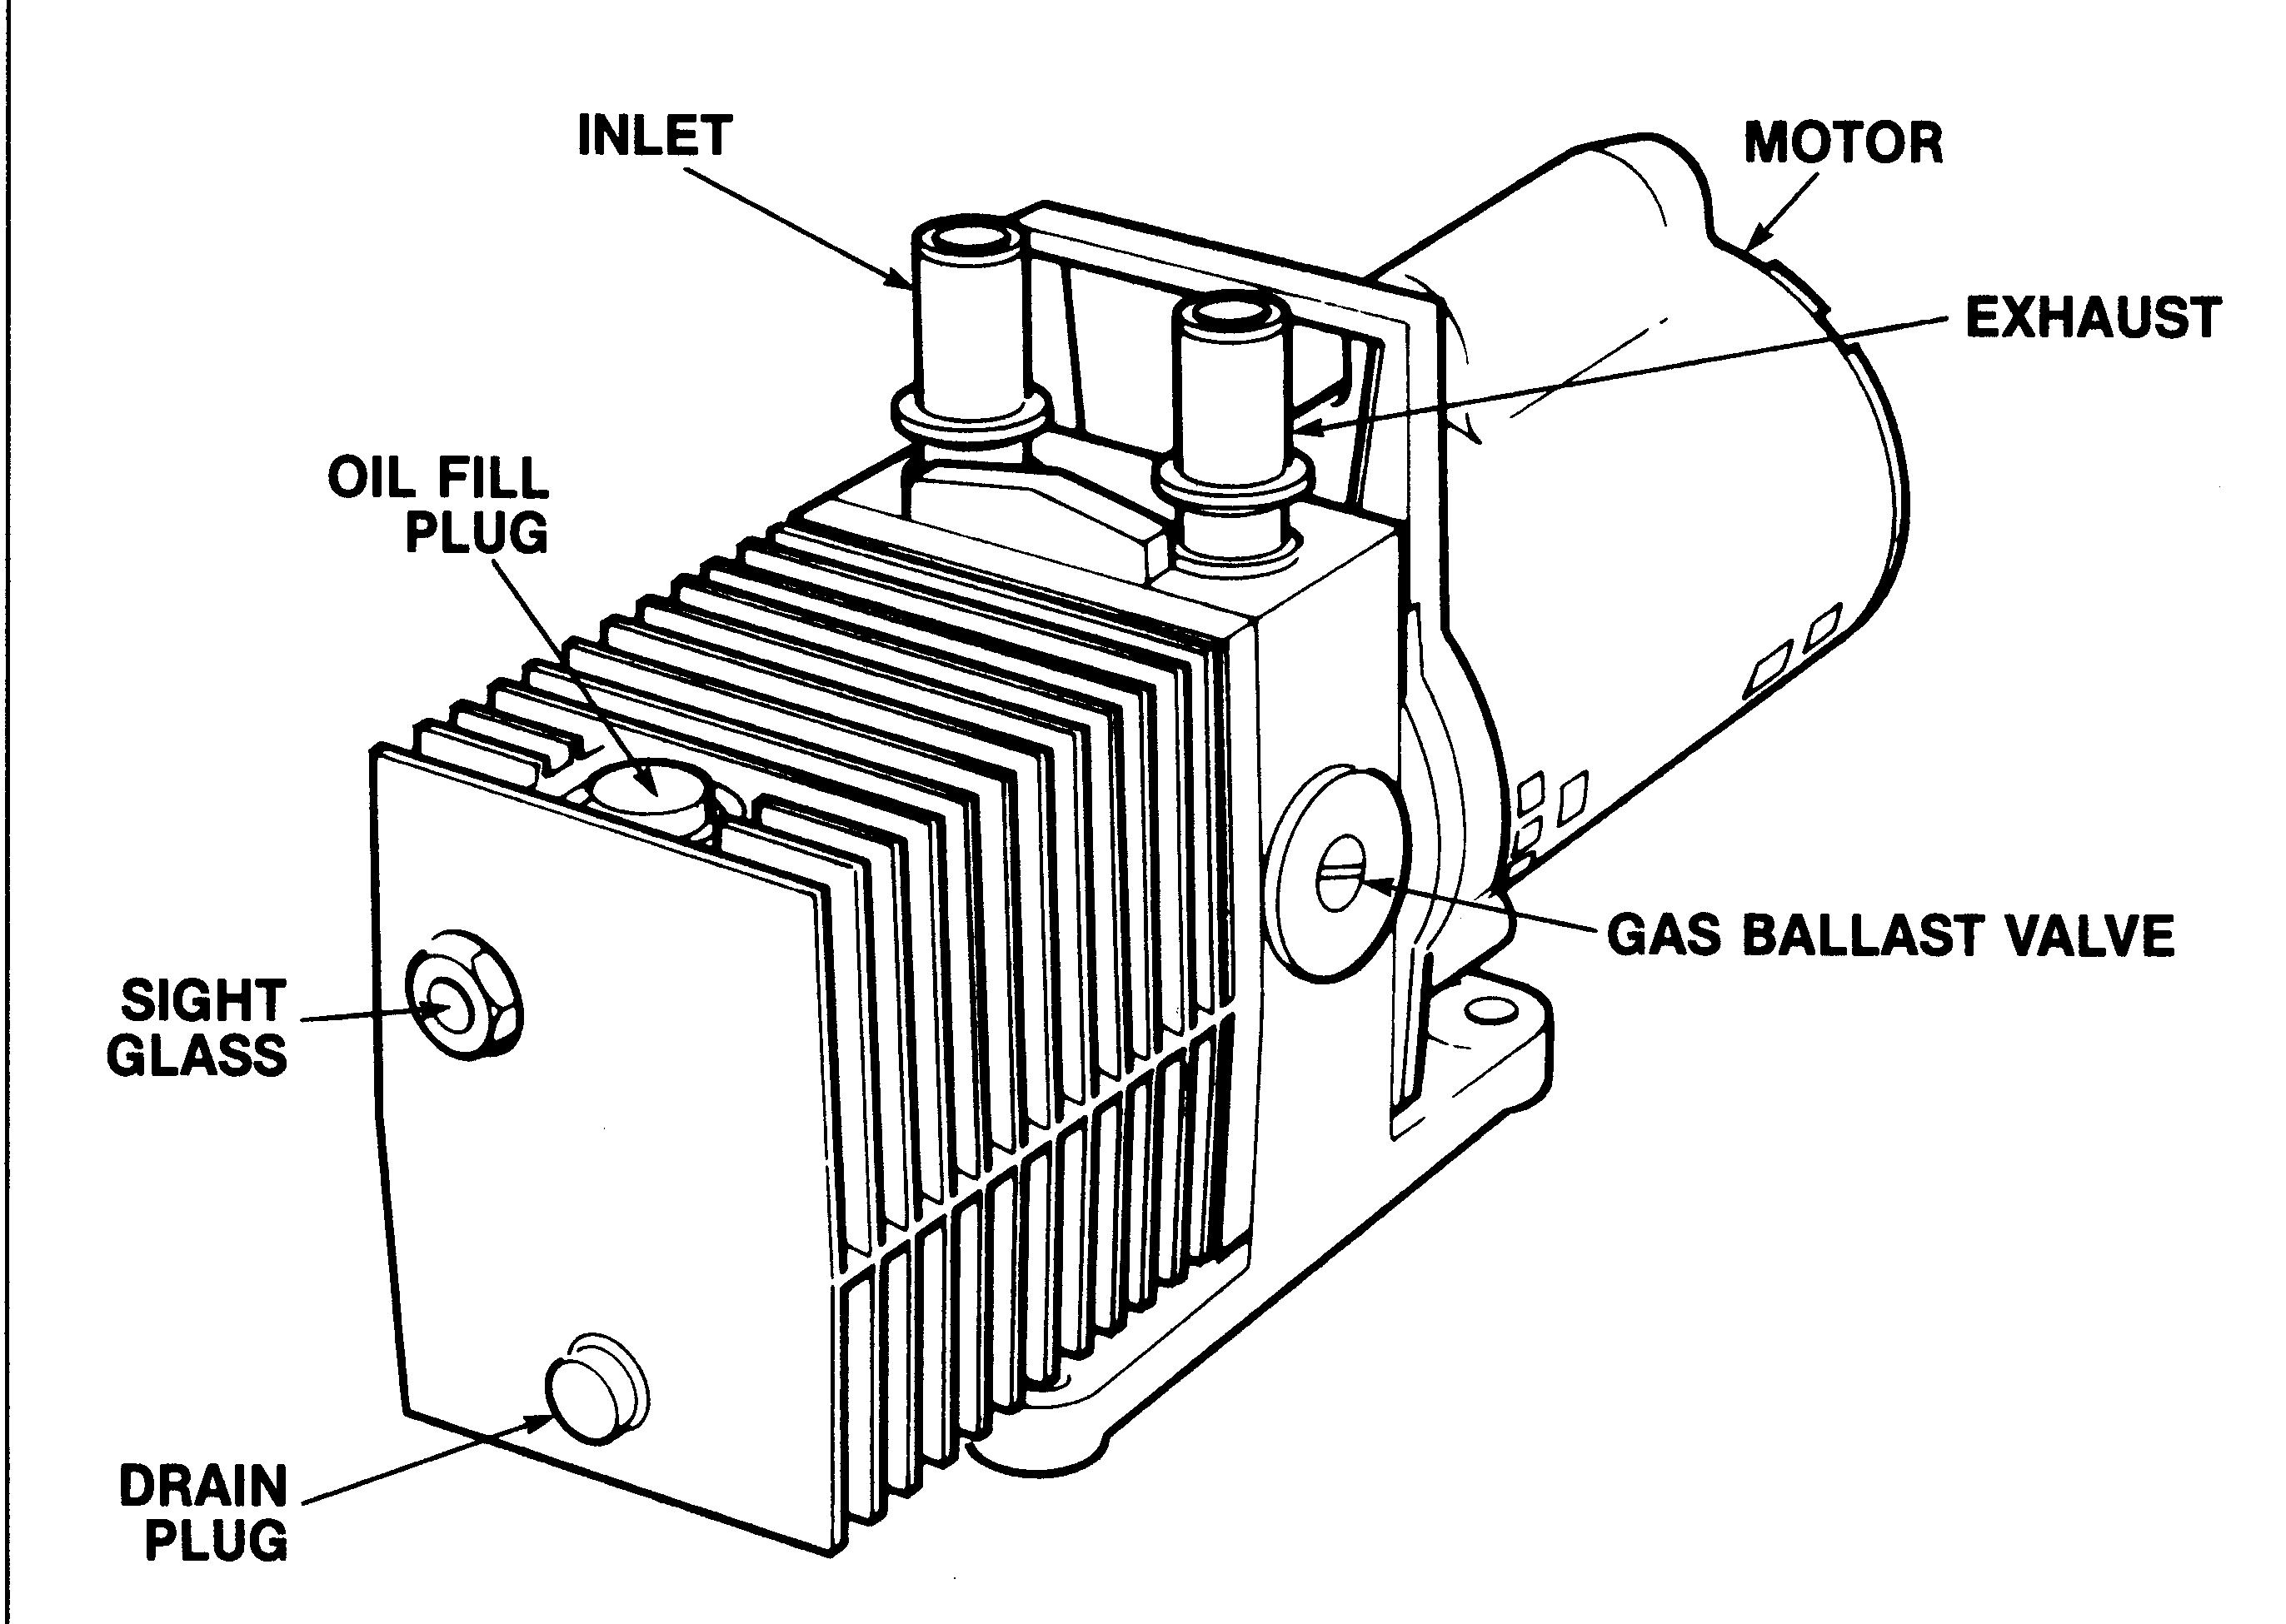

Typical housing for a ‘wet’ rough pump that is of the rotary mechanical pump type. (Figure from Basic Vacuum Practice, Varian Vacuum)
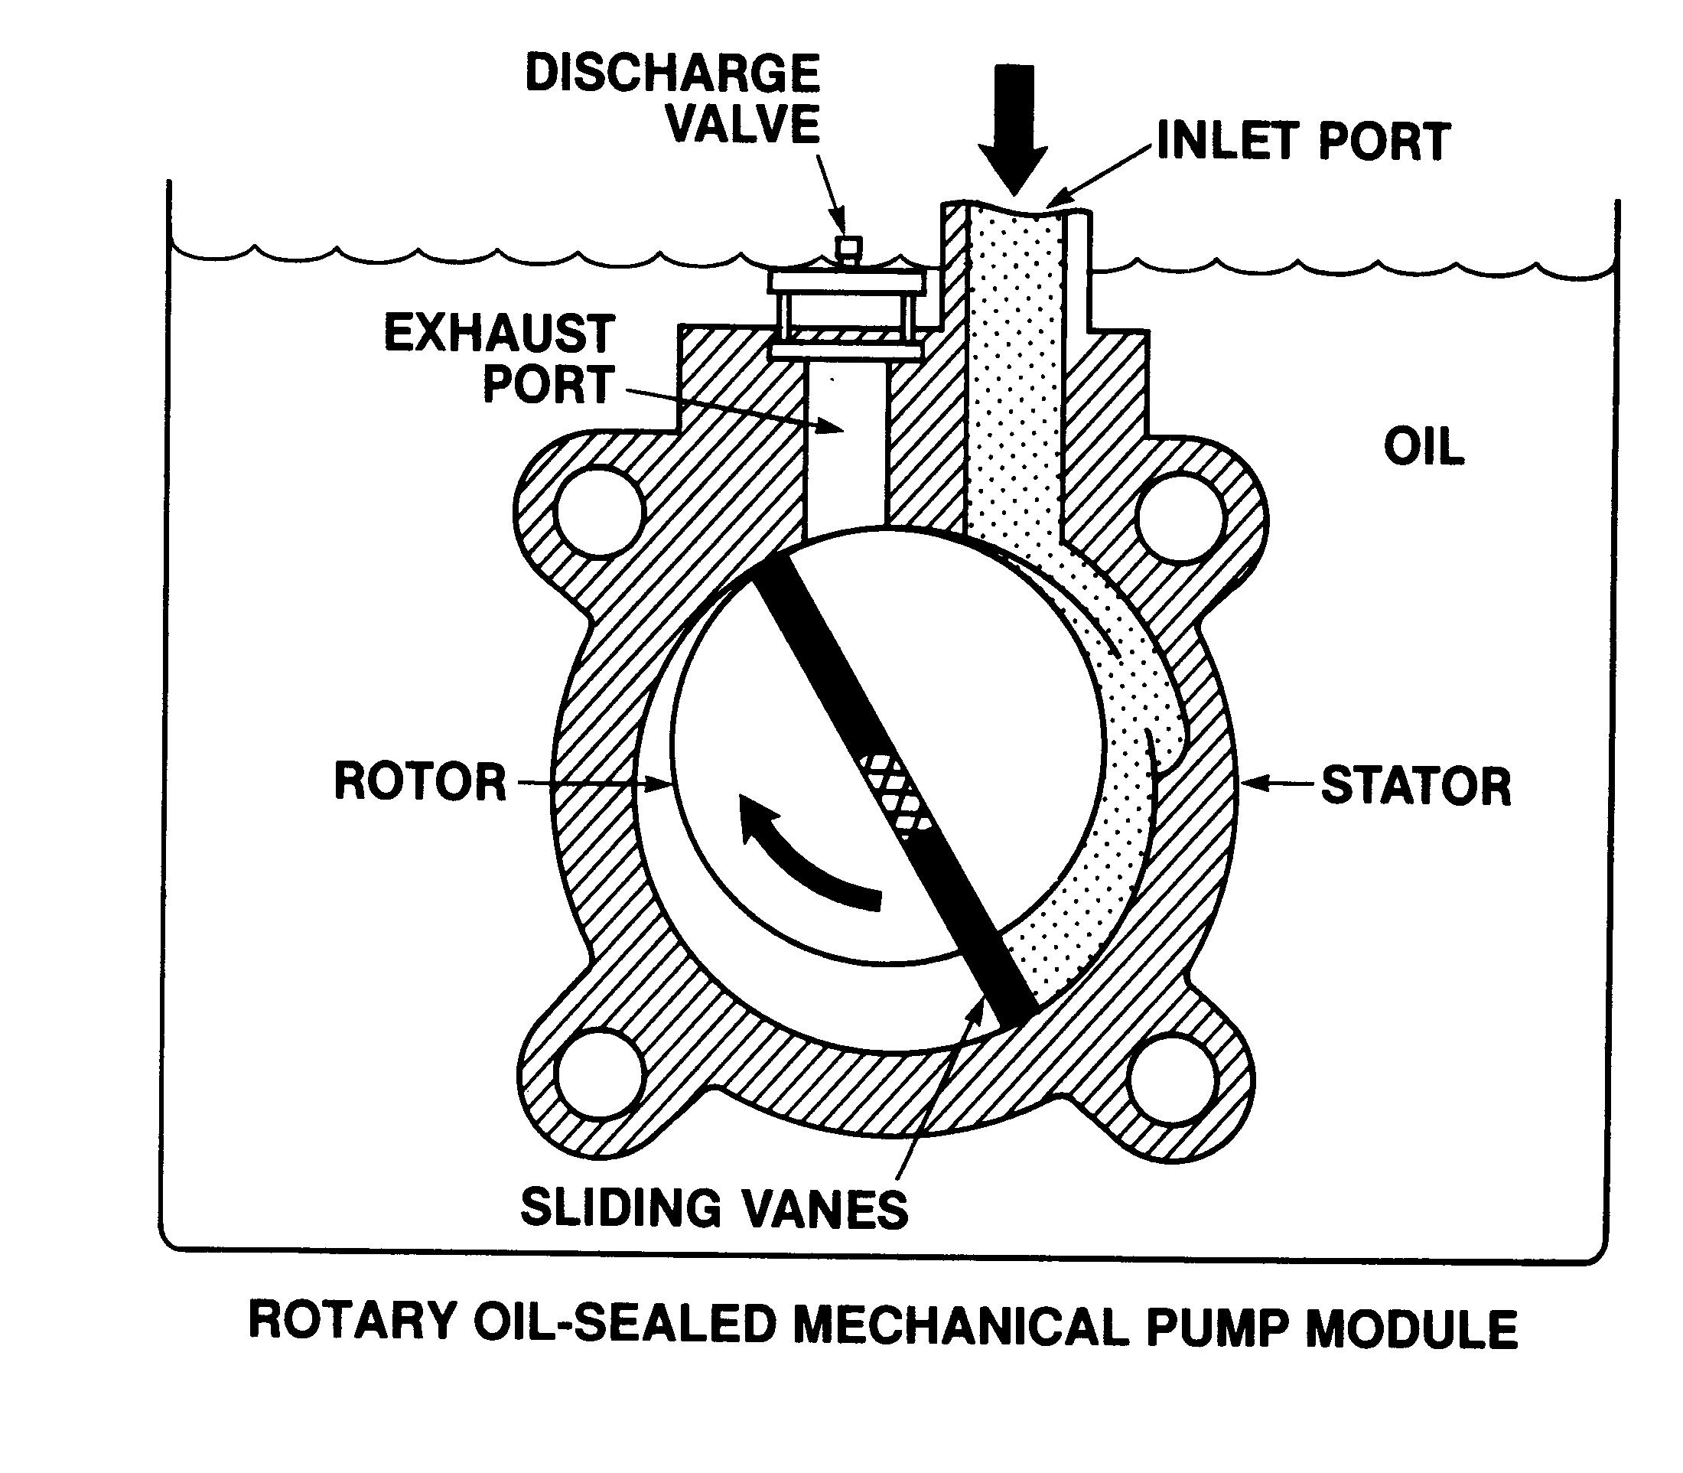
Most ‘wet’ rough pumps are of the rotary mechanical pump type. Often there are several stages or modules to the pump which allows a typical base pressure of about 10 mTorr and an outlet pressure of atmosphere. (Figure from Basic Vacuum Practice, Varian Vacuum)
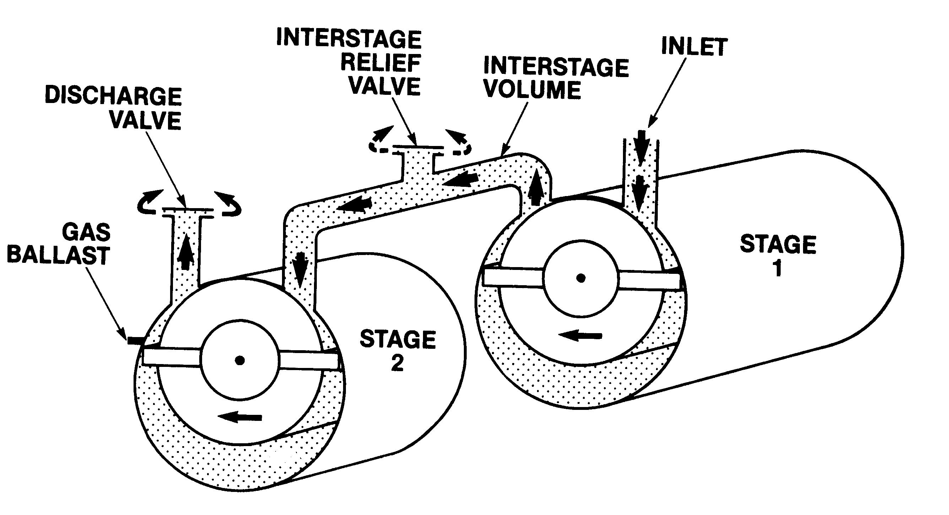

Multi stage ‘wet’ rough pumps are of the rotary mechanical pump type.
(Figure from Basic Vacuum Practice, Varian Vacuum)

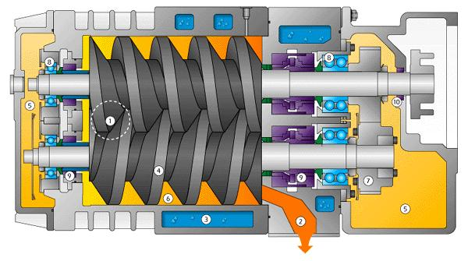

Wet pumps are now being phased out in favor of dry screw and dry rotary pumps.
This pump works by pushing gas from the inlet (1) along the gas path (6) to the exhaust (2). Because the screws are interleaved, the gas is trapped in pockets formed by the outer-wall and the screws.
Marked items are 1) inlet, 2) Exhaust, 3) water jacket 4) screw, 5) oil, 6) gas path, 7) timing gears, 8) bearings 9) shaft seals, 10) oil seal
(Picture from www.buschpump.com/cobra_cutaway.html)
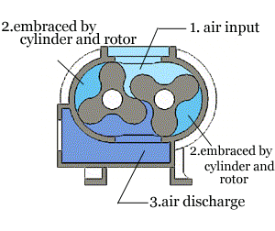
Typical setup of a roots blower (From www.rootsblower.com.tw/)

Movie of a roots blower (From www.rootsblower.com.tw/)

Roots blowers have limited use to only those systems needing ~10’s to 100’s mTorr operating pressures.
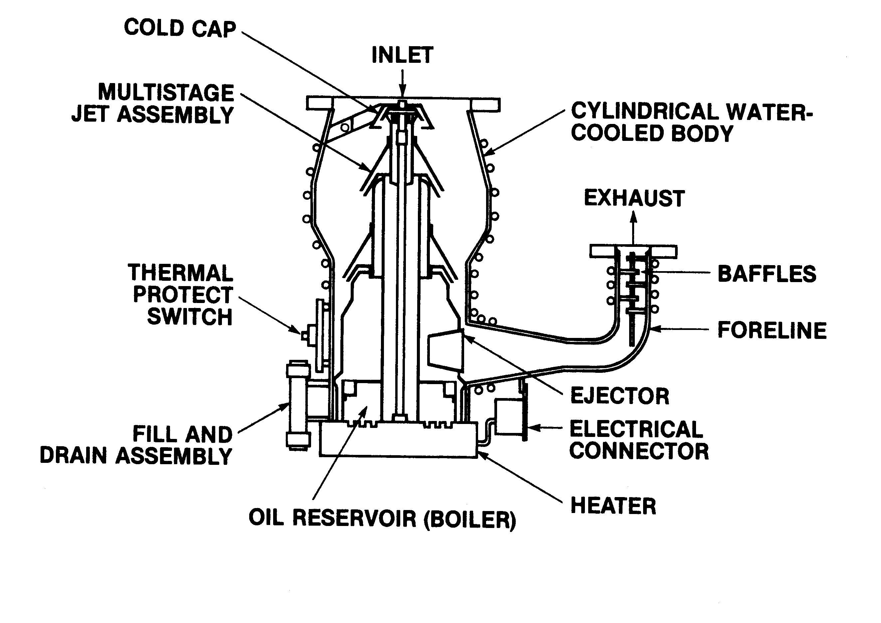

Set up for a diffusion pump. Diffusion pumps used to be the most common high vacuum pump. However in the last two decades they have been replaced with Turbomolecular pump.
Super heated oil vapor in the base of the pump is forced up the central tubes to the central jet assembly. The oil vapor, which is now traveling at supersonic speeds, is reflected downward (and outward) off of the jet toward the cooled walls. During the trip to the walls, this oil entrains the gas particles and draws them down into the oil reservoir, where they are pumped out the exhaust port. (Figure from Basic Vacuum Practice, Varian Vacuum)
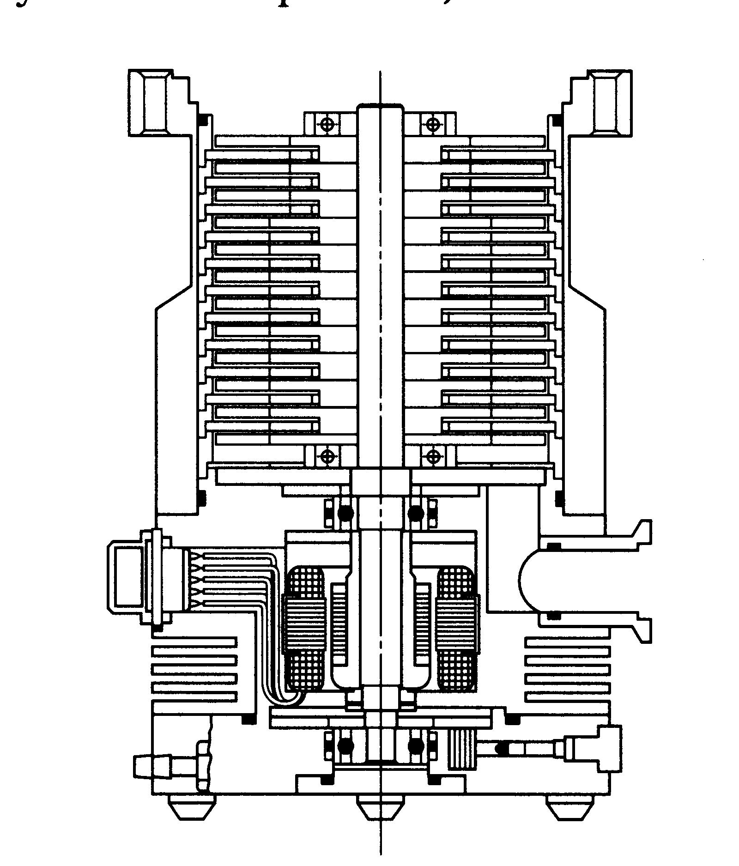
Turbomolecular pump (TMP). This is the most common type of pump for high vacuum processes. The pump consists of a series of rotors (rotating fans) and stators (fixed fans) with opposed blades. (The TMP is like a jet engine!) (Figure from Basic Vacuum Practice, Varian Vacuum)
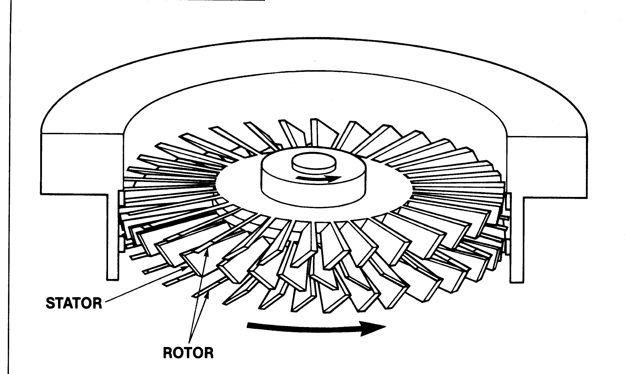

The rotors and stators for a turbo pump. Typically the rotors turn at ~25,000 RPM. The rotors push the gas downward and around. The blades of the rotors and stators are aligned such that the gas hits the underside of the stator blades, which cause the gas to move further downward and in the opposite rotation. Compression on a turbo pump might be as high as 1E9, with a base pressure near 1E-8 Torr and outlet pressure near 10 mTorr. (Figure from Basic Vacuum Practice, Varian Vacuum)

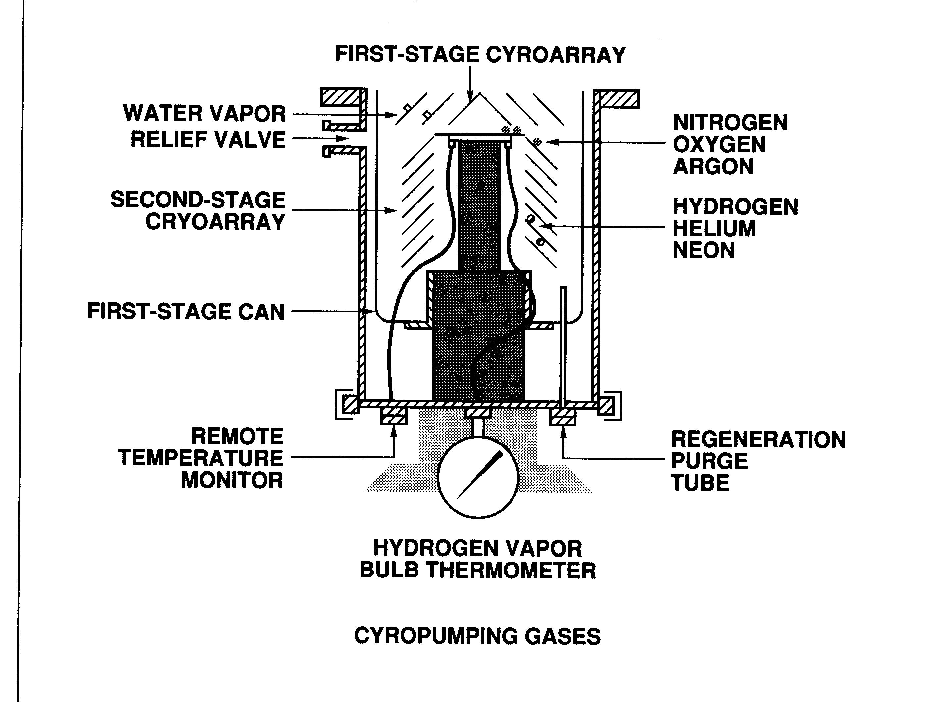

Cryopumps are the second most common high vacuum pump system. They are typically only used in systems that do not have a significant use of feed gas. (An example would be e-beam systems.)

They usually have two pumping mechanisms. First, they have highly cooled vanes that freeze out most gas types. Secondly, for He, H/H₂ and Ne, they have adsorption traps, typically C, that confine the more mobile gases. (Figure from Basic Vacuum Practice, Varian Vacuum)

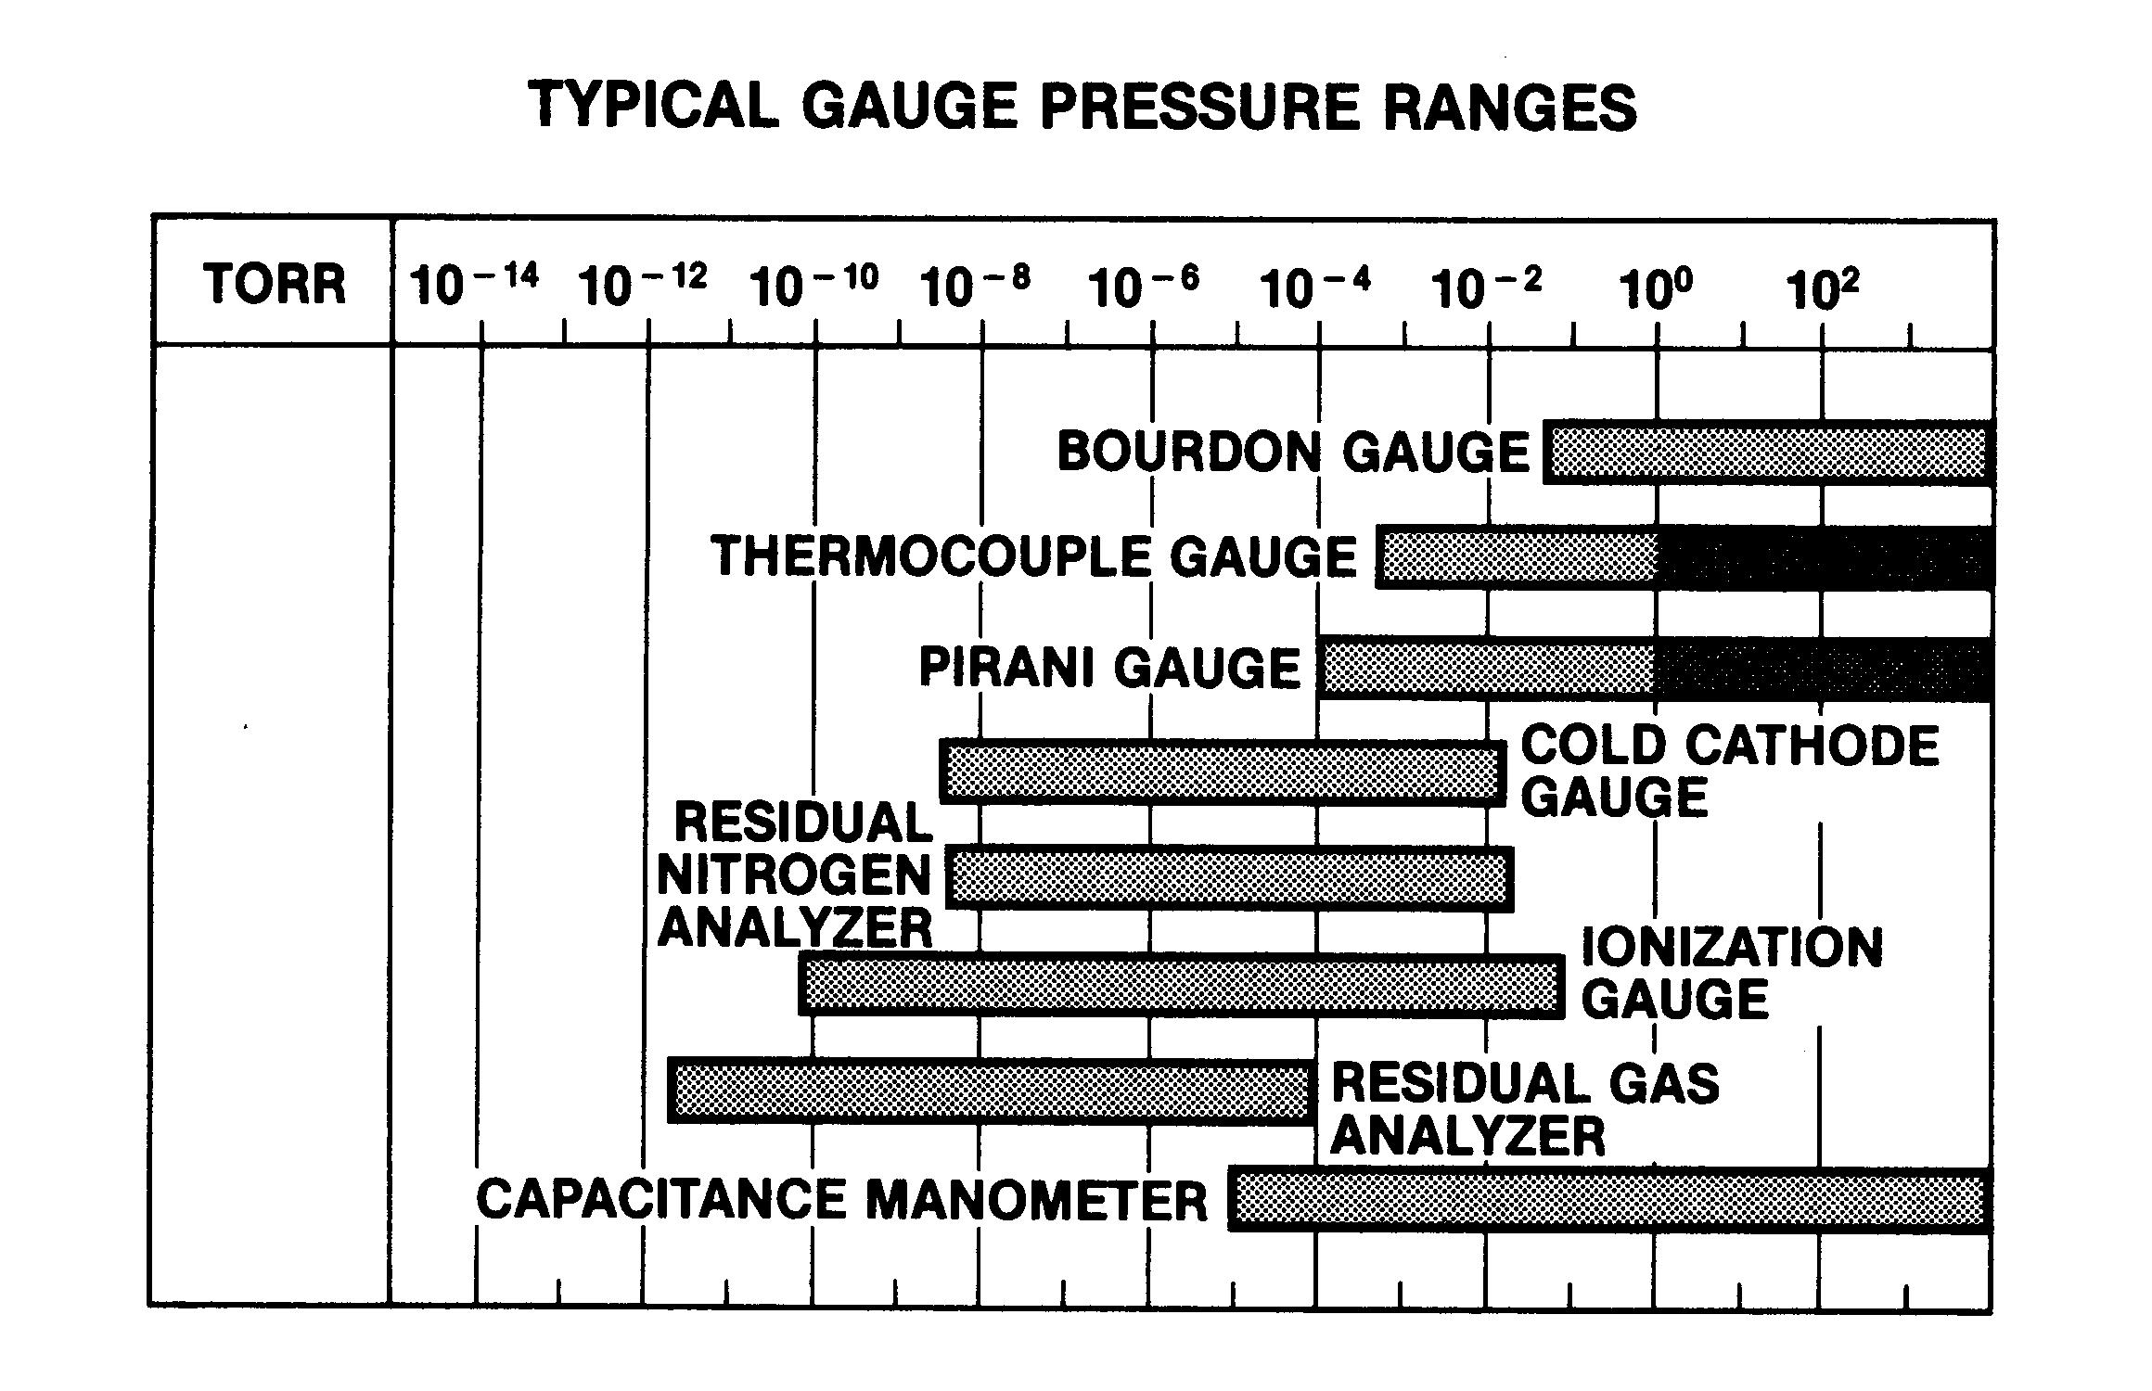
Typical pressure gauges. Only two of these, Bourdon and Capacitance Manometer, are direct measurements of the pressure. The others rely on secondary measurements to deduce the pressure. (Figure from Basic Vacuum Practice, Varian Vacuum)
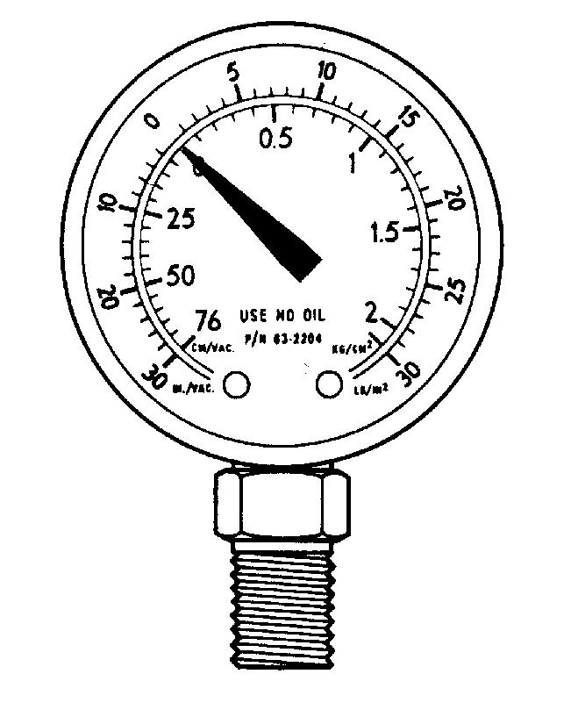

Bourdon Gauge. (Figure from Basic Vacuum Practice, Varian Vacuum)

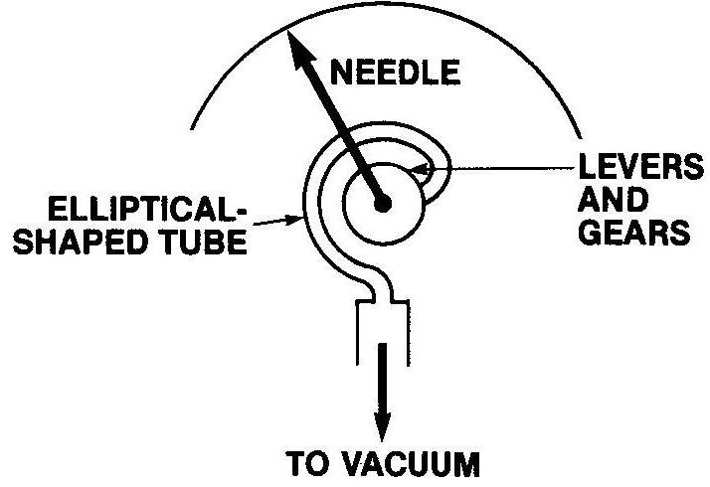

Bourdon Gauge insides. The elliptically shaped tube bends as more external pressure is applied, or it has lower pressure inside. This bend vs pressure is determined, allowing one to determine the inside/outside pressure differential. (Figure from Basic Vacuum Practice, Varian Vacuum)

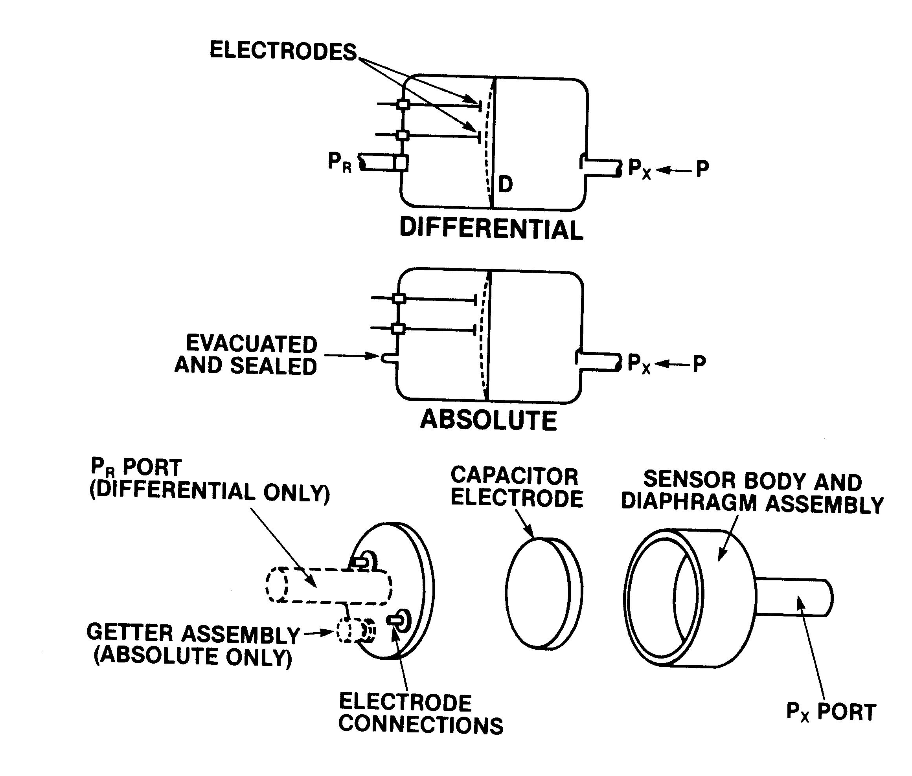
Capacitance manometer or Baratron gauge. (‘Baratron’ is a trademarked name, of MKS Instruments.) The gauge operates measuring the position of a diaphragm. This measurement is really a measure of the change in capacitance between two electrodes. As the diaphragm changes shape, due to the pressure, the capacitance changes. Thus the pressure can be measured.

(Figure from Basic Vacuum Practice, Varian Vacuum)

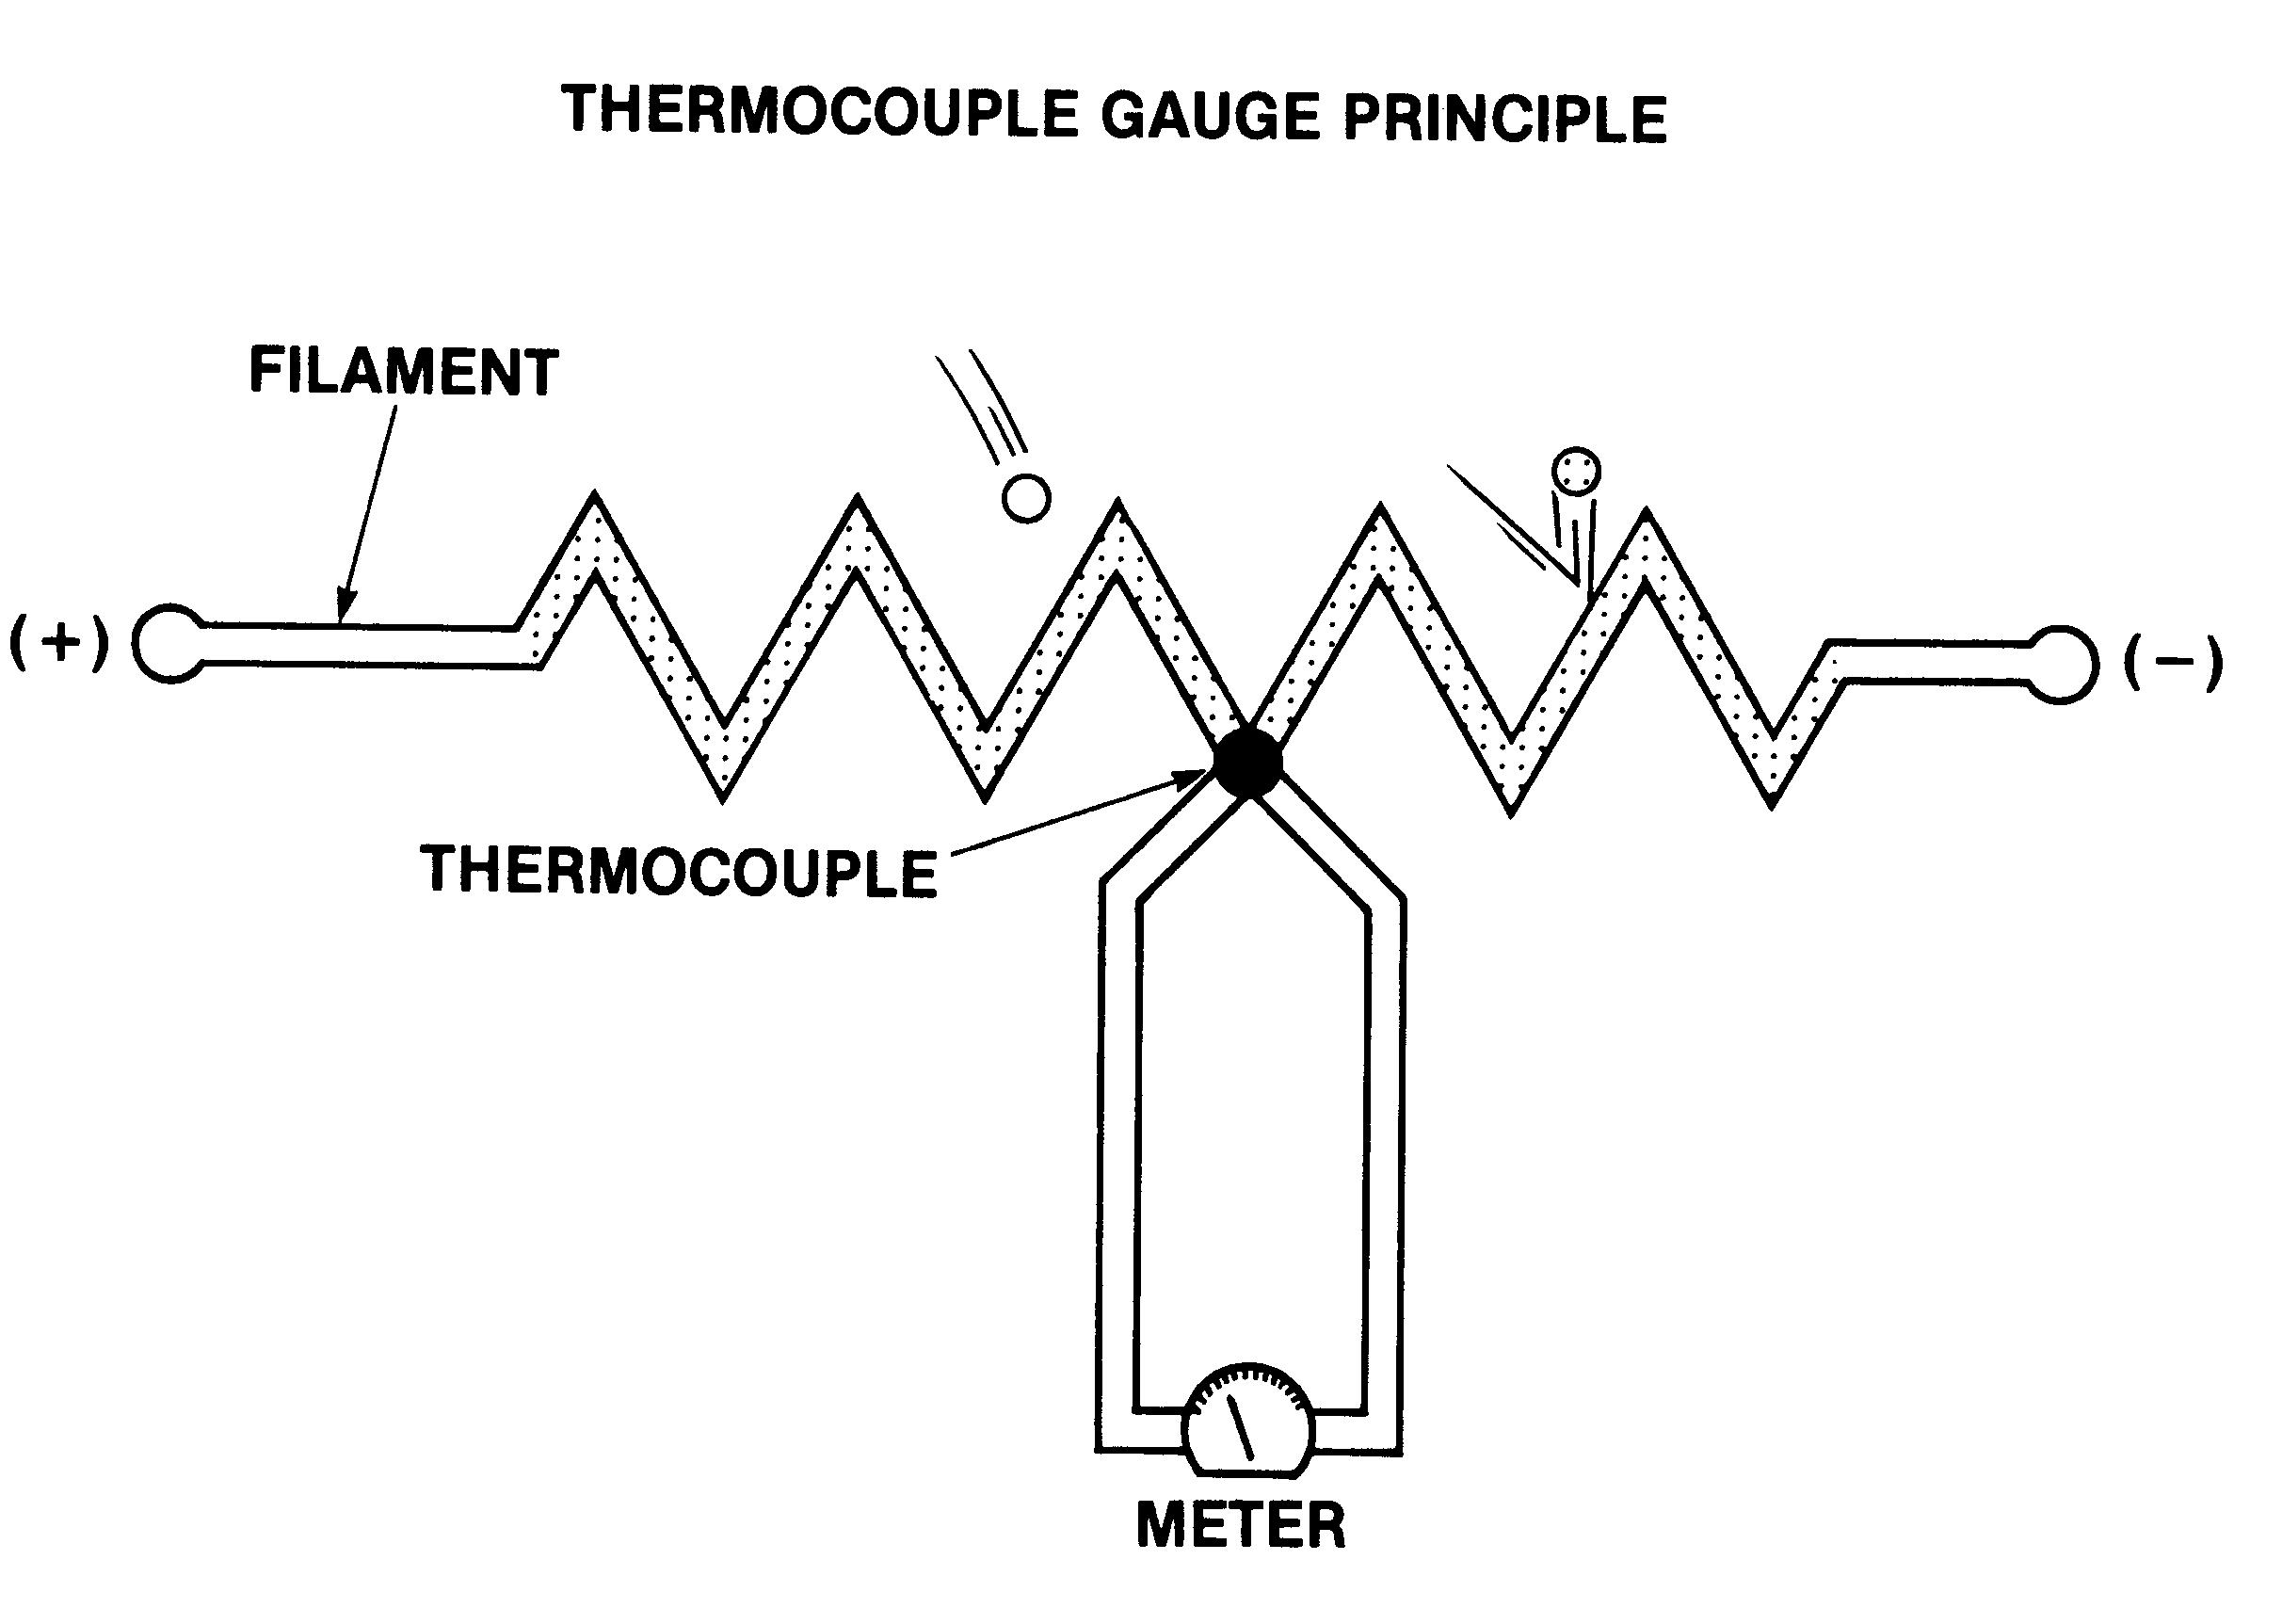
Thermocouple gauge operates by driving a current through a resistor of resistive wire. The temperature of the wire is determined by this heating as well as the cooling due to radiative cooling thermal cooling out the ends at via gas molecules carrying away heat. Under certain regimes, pressures greater than 1 mTorr, the dominate cooling mechanism is loss of energy to the gas molecules. (Note that the cooling gas dependent!) By measuring the temperature of the wire, and knowing the gas type, one can determine the pressure.

(Figure from Basic Vacuum Practice, Varian Vacuum)

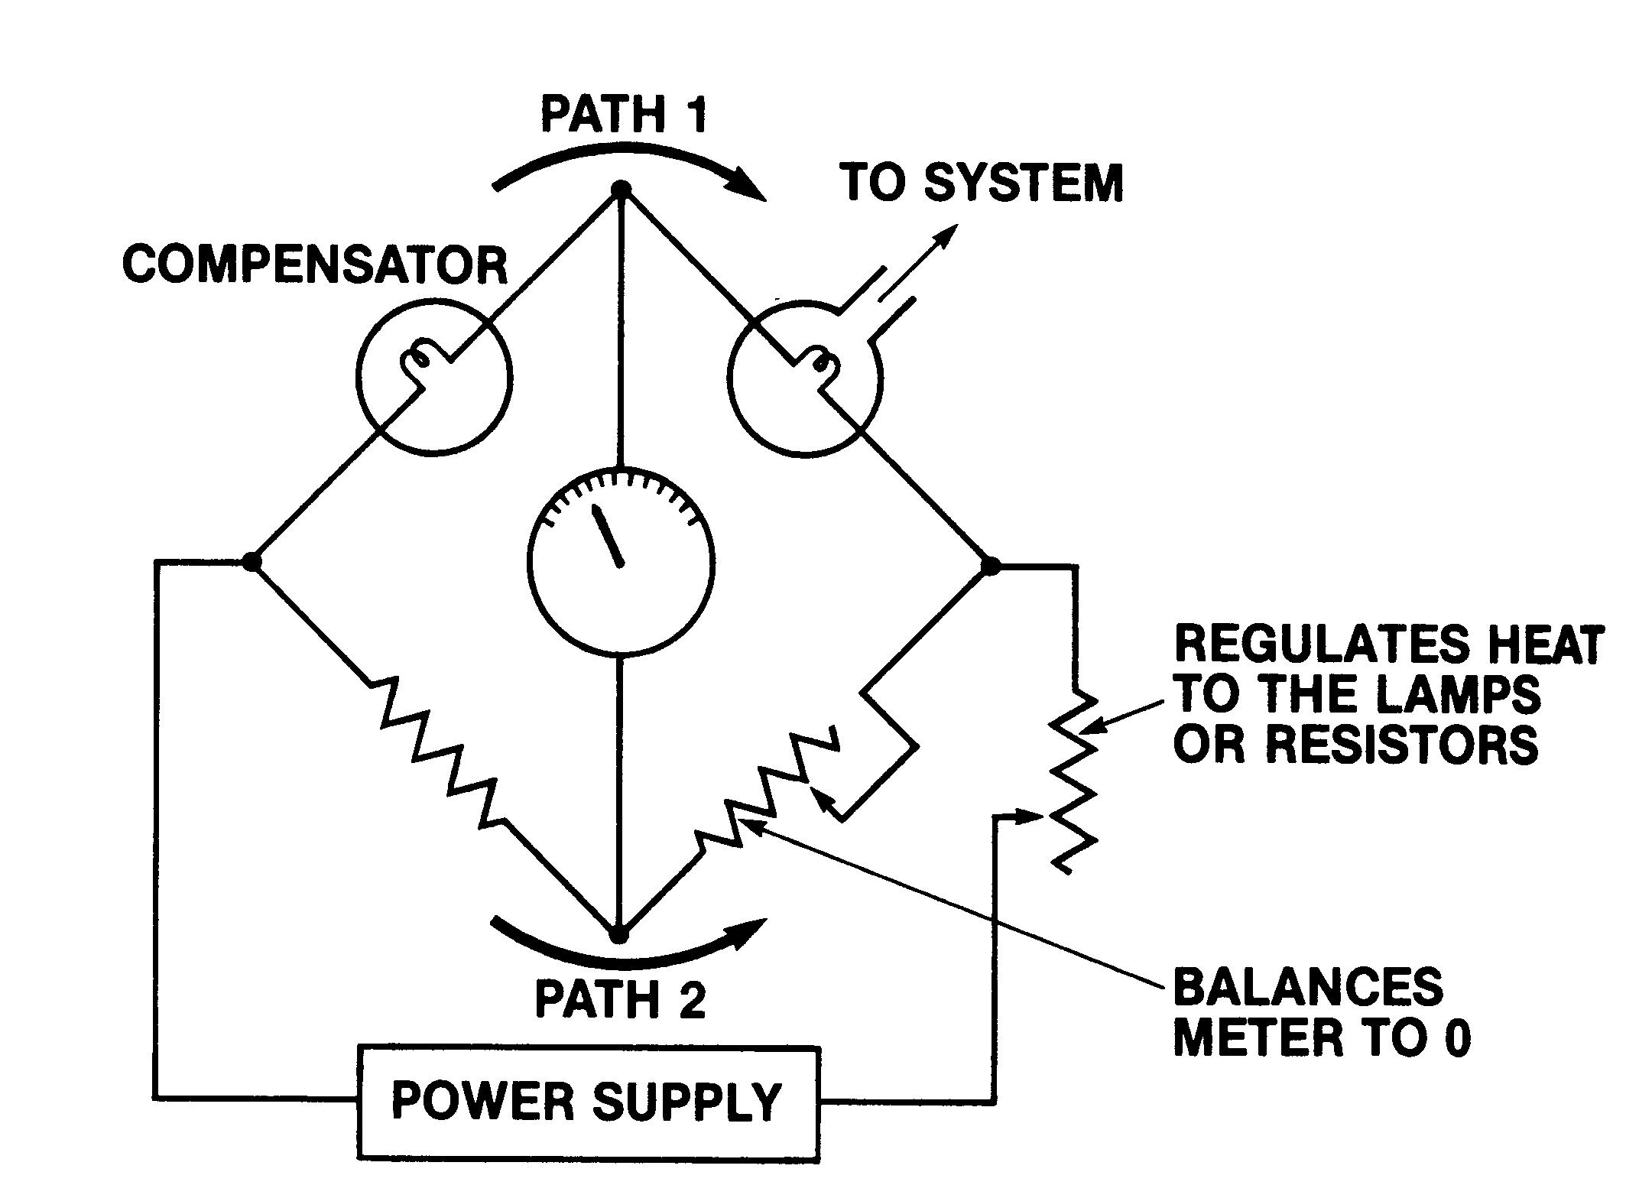

Pirani Gauge. Pirani gauges are very similar to thermocouple gauges. Here, however, one measures the resistance in the heated wire. Resistance is a function of temperature. Typically, the higher the temperature, the higher the resistance. In the balance bridge circuit, the current flow in path 1 and 2 are set to be the same. The variable resistor in path 2 is used to balance the voltage across the central meter. When this is done the ratio of the resistors is the same as the ratio of the resistances in the two heated filaments. (The second filament is the ‘compensator’ and it is located in a area with well characterized pressure and temperature.) By determining the relative resistance, one can deduce the temperature of the filament and hence the pressure – after one has assumes what is the gas type

(Figure from Basic Vacuum Practice, Varian Vacuum)
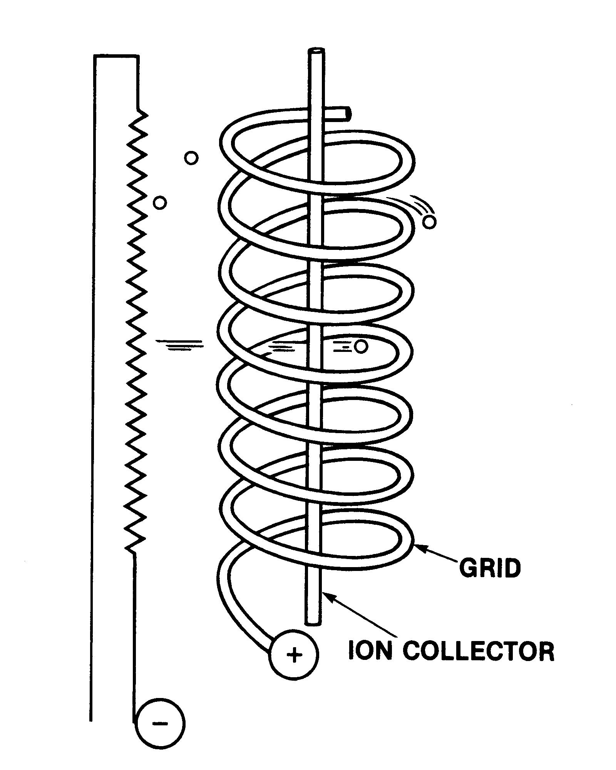

Ionization gauge. Ionization gauges work in the following manner. Electrons are boiled off of a heated filament. (Shown on the left on side of the figure.) These electrons are accelerated toward the collector grid by a bias between the filament and grid. Many of the electrons do not hit the grid directly but rather miss it and pass in to the area between the grid and the ion collector. (The electrons make several pass past the grid before hitting it, resulting in an electron cloud around the grid.) While inside the grid, some of the electron will ionize the local gas. These ions are collected by the collector. The amount of current is determined by the gas type and the gas density.

(Figure from Basic Vacuum Practice, Varian Vacuum)

Lecture 3 “Introduction to material processing” is covered in a separate document (power point slides).

