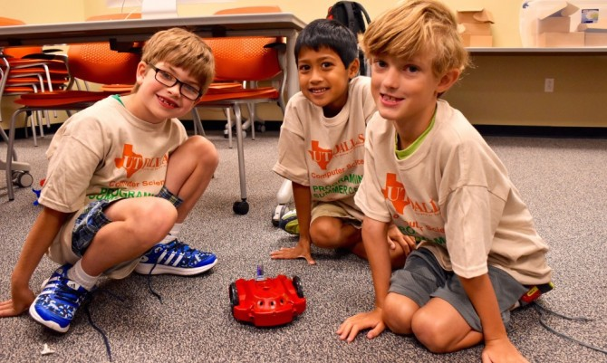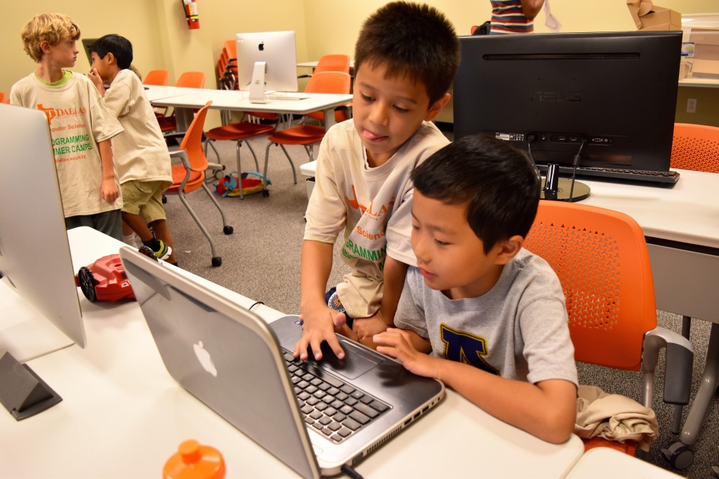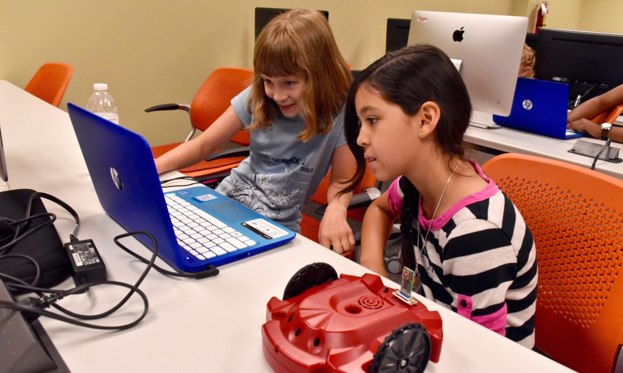

CS.utdallas.edu

This summer students from all over North Texas and beyond, ranging in age from five all the way to seventeen, came to the UT Dallas Computer Science department to explore the world of Computer Programming. During the eleven weeks of summer classes, the [Center for Computer Science Education and Outreach](http://www.utdallas.edu/k12/) (CCSEO), operated by Drs. [Jey Veerasamy](http://utd.edu/~jeyv/) and [John Cole](http://www.utdallas.edu/~John.Cole/), both UT Dallas Computer Science professors, offered over [100 coding camps](http://www.utdallas.edu/k12/summer/), including residential camps. Each week approximately 200 k-12 students attended different coding camps on subjects that included playing with robots, animations using Scratch, Advanced Problem Solving with [Dr. Ivor Page](http://www.utdallas.edu/~ivor/), 3D Printing, Enjoyable Programming using Alice, and an intensive Cyber Defense Camp taught by Kevin Henson of the Cyber Defense Center (CDC) and Cyber Defense Labs.

As part of the summer outreach program, knowledgeable UT Dallas CS students helped with the teaching with guidance from the UT Dallas CS faculty. At the CCSEO, UT Dallas CS Professor and Associate Director of the CCSEO, John Cole, “believes that just as children can learn to read and write earlier than most people believe, they can also be taught the logical processes of programming very young. They key is using age-appropriate programming environments. The CCSEO offers a smooth path from the earliest grades through high school and beyond.”

Summer camp participants were exposed to several programming languages including Alice, Java, C++, as well as Python for the campers who were more advanced and proficient in programming. In general, these camps tend to be geared towards middle and high school students. However, the CCSEO also offers coding camps to early starters (k-5th grade) including 2D animations, Exploring Scratch, playing with robots, and game making with Alice. In summary, the CCSEO caters to campers of every age.

The CCSEO also offered intensive summer courses including [Advanced Problem Solving](https://drive.google.com/file/d/0B5Sd-HLJYzgFLXFIbHlJeDlzelJNaEtwX0FuLS1Qd2dXU3E4/view) with Dr. Ivor Page and a four-week summer [Cyber Defense Camp](http://www.utdallas.edu/k12/cyber/) taught by Kevin Henson of the Cyber Defense Center (CDC) and the [Cyber Defense Labs](http://www.cyberdefenselabs.org/). Dr. Page’s course covers a broad selection of Algorithmic techniques such as recursion, brute force, greedy methods, divide and conquer, and dynamic programming. During their time with Dr. Page, the campers became more confident and mature programmers by being exposed to ACM International Collegiate Programming Contest (ICPC) university-level contest problems. The [UT Dallas Cyber Security Research and Education Institute](http://csi.utdallas.edu/), in partnership with the Cyber Defense Center (CDC), continued its second year of offering this course to gifted high school students interested in building the foundation for a future in the field of Cyber Security. The hands-on camp challenged the student with various topics including; web/cloud based security, computer structure and logic, operating systems management, hardware trouble shooting, digital forensics, and network security and architecture. Students were able to work closely with CDC professionals on their projects while training to compete in the national [Cyber Patriot Competition](https://www.uscyberpatriot.org/). The CCSEO also offer [off-site](http://www.utdallas.edu/k12/offsite/) coding camps sponsored by the State Farm Corporation.

**UT Dallas Center for CS Outreach Codes with K-12 Campers**

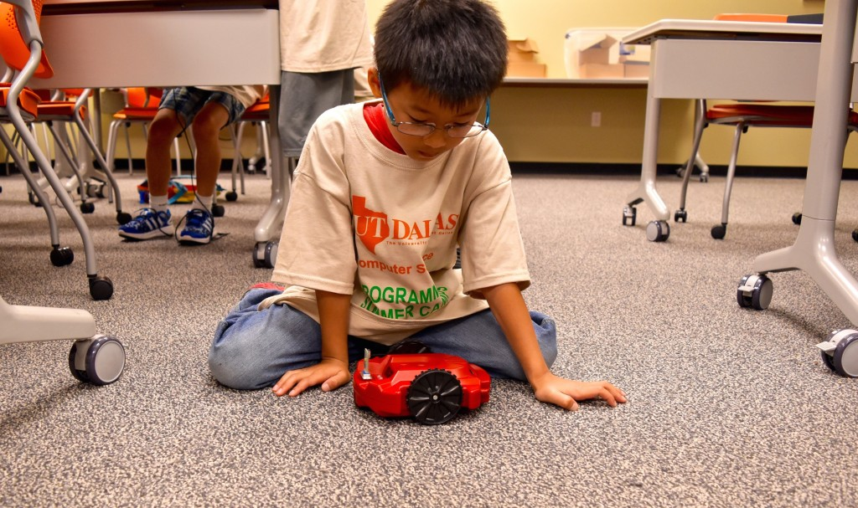

CS.utdallas.edu

***byline*[Name]**

Integer metus.

Lorem.



###### Donec sed sem.?

Vestibulum porta dictum est. Lorem ipsum dolor sit amet, consectetuer adipiscing elit. Duis hendrerit congue nunc.

###### Sed sit amet lacus?

Cras lacus lorem, fringilla a, adipiscing ut, congue ac, tortor. Sed aliquet vestibulum sem. Class aptent taciti sociosqu ad litora torquent per conubia nostra, per inceptos hymenaeos.

###### Mauris felis?

Pellentesque commodo. Phasellus lacinia, nisi semper pulvinar tincidunt, orci magna ultrices dui, sit amet laoreet nunc nulla eu justo. Cras sed risus euismod velit fermentum condimentum.

Sed

Ipsum Augue?

Mauris nonummy, turpis ac lacinia ultrices, ligula nisl tempor odio, eget viverra dolor massa at lacus. Donec ultrices arcu id massa. Pellentesque vel lectus. Sed at mauris. Nunc facilisis ipsum nec urna. Proin rhoncus, magna eu tristique condimentum, leo justo imperdiet odio, vehicula ultrices enim diam et nunc. Sed consequat ultricies nunc. Mauris nulla. Nam sem nisi, fringilla semper, tristique id, cursus vel, pede. Nunc lacus. Sed feugiat. Curabitur fringilla justo non nisi. Class aptent taciti sociosqu ad litora torquent per conubia nostra, per inceptos hymenaeos. Vivamus elementum ultrices eros. Fusce diam purus, porta et, ullamcorper a, egestas id, mi. Nullam cursus. Nullam auctor, eros vitae pellentesque fringilla, sem augue dignissim enim, vitae interdum velit lorem ut metus. Duis consectetuer lacus id tellus.

In vehicula malesuada velit. Etiam ante dui, interdum tempor, cursus sit amet, accumsan vitae, tellus. Suspendisse varius sollicitudin nisl. Pellentesque habitant morbi tristique senectus et netus et malesuada fames ac turpis egestas. Donec pretium augue nec dolor. Ut vestibulum. Donec non nisi nec tellus consequat tincidunt. Mauris ultricies nulla. Ut nec augue. Mauris et risus et odio vestibulum lacinia. erat. Cras vestibulum magna nec nisi. Nam semper congue mi.

#### Vivamus nisl.

# Nam orci.

##### Aenean ipsum dui, porta sit amet, viverra nec, placerat vitae, mi. Sed eget metus eu felis convallis congue.Pellentesque rutrum pede ac velit.

LoremIpsumDolor