A GOAL-ORIENTED SIMULATION APPROACH FOR OBTAINING GOOD PRIVATE CLOUD-BASED SYSTEM ARCHITECTURES
Lawrence Chung¹, Tom Hill², Owolabi Legunsen¹, Zhenzhou Sun¹, Adip Dsouza¹,
Sam Supakkul³
^{1,2}The University of Texas at Dallas, 800 West Campbell Road, Richardson, TX 75080, USA ¹{chung, owolabi.legunsen, zxs101020, amd061000}@utdallas.edu, ²tom.hill.fellow@gmail.com, ³ssupakkul@ieee.org

ABSTRACT
The fast-growing Cloud Computing paradigm makes it possible to use unprecedented amounts of computing resources at lower costs, among other benefits such as fast provisioning and reliability. In designing a good architecture – the numbers, types and layouts of devices – for a cloud-based system, which meets the goals of all stakeholders, such goals need to be factored in from the earliest stages. However, there seems to be a lack of methodologies for incorporating stakeholder goals into the design process for such systems, and for assuring with higher confidence that the designs are likely to be good enough for the stated goals. In this paper, we propose a goal-oriented simulation approach for cloud-based system design whereby stakeholder goals are captured, together with such domain characteristics as workflows, and used in creating a simulation model as a proxy for the cloud-based system architecture. Simulations are then run, in an interleaving manner, against various configurations of the model as a way of rationally exploring, evaluating and selecting among incrementally better architectural alternatives. We illustrate important aspects of this approach for the private cloud deployment model and report on our experiments, using a smartcard-based public transportation system.
Keywords: Cloud Computing, System Architecture, Goal-Oriented, NFR Framework, Simulation Model, CloudSim, Little’s Law, Requirements Engineering
- INTRODUCTION
Would it be possible to predict whether a cloud-based service will indeed be good enough from the perspectives of multiple stakeholder goals, such as profitability, performance and scalability? Can we do this in the early stages of development, before committing to potentially costly and time-consuming implementation and testing? Answering these questions affirmatively is important to people who want to take advantage of the many benefits, such as cost reduction, fast service provision, reliability, and the like, promised by Cloud Computing [1], [2]. In particular, designers of proposed cloud-based systems will want to investigate how to come up with designs that meet the goals of all stakeholders before it is too late, disruptive or expensive to make changes. This paper proposes one approach for doing this by using goal-orientation together with cloud computing simulations that are cheap and quick to set up, since goal-oriented techniques allow for capturing stakeholder goals and using them in exploring, analyzing and selecting among architectural design alternatives. In the proposed approach, goal orientation and simulation are used in an interleaving, iterative manner – goal-oriented aspects can be carried out simultaneously, and in any order with, simulation modeling and analysis.
By nature, early stage design in cloud-based systems is multi-stakeholder, multi-objective, multi-dimensional and large scale. It is “multi-stakeholder” in the sense that there are different types of stakeholders (e.g., cloud vendors, service providers, and end users) and “multi-objective” in that the goals of one group of stakeholders differ from those of another group and goals are oftentimes competing and conflicting, even within the same group. The “multi-dimensional” nature concerns the fact that stakeholder goals need to be simultaneously investigated for different stakeholder groups at different levels of abstraction (hardware level, Virtual Machine (VM) level, database level, etc.). It is also “large scale” because very large numbers of individuals in each stakeholder group need to be considered while designing such systems, necessitating the use of different kinds of workloads in assessing the quality of system design. These characteristics make cloud-based system design quite challenging. Without a systematic method, such as the one proposed in this paper, it would be a daunting challenge to understand, develop, and successfully operate cloud based systems. This goal-oriented, simulation-based approach provides a fast way with little financial and manpower resources to tackle the challenge.
Users’ requirements for cloud computing architecture, as well as the role of goal-oriented requirements engineering in Cloud Computing adoption have been described [3], [4]. However, there still needs to be a more systematic approach for integrating these into the architecture design process for cloud-based systems, towards reaching the level of rigor and success attained by goal-oriented techniques in traditional (not cloud-based) Software Engineering. Perhaps, the lack of such a rational approach in cloud-based system design is the main culprit in what has been described as “solutions that are looking for a problem” in the cloud [5]? Our main aim in this paper is to describe a systematic approach which may be used to design cloud-based systems based on stakeholder needs. We borrow heavily from best-of-class Goal-Oriented Software Engineering [6] techniques, while showing how such might be used in a realistic system design scenario. We also focus on the so-called private cloud deployment model, in which one entity (the Cloud Service Creator) owns and operates the datacenter but gives shared access to other entities who subscribe on a pay-as-you-go basis.
The use of simulations for investigating complex system behavior is not new. However, in the Software Engineering community, there has been a recent increase in the recognition of the role that simulations can play in the early stages of system design, especially for evaluating and validating design decisions. This is perhaps due to growing realization among researchers that rising levels of systems complexity need to be matched by more reliable ways of investigating designs in the early stages. The marriage of goal-orientation (techniques for exploration, selection among, and evaluation of architectural alternatives based on stakeholders’ goals) and simulation (which is fast and easy to set up) is expected to be highly beneficial but challenging. Some work has recently emerged in this regard, for using simulation to confirm and reconfirm architectural decisions [7], for runtime monitoring and system maintenance [8], [9] and for simulating and optimizing design decisions in quantitative goal models [10]. The Cloud Computing field has also been quick to recognize the utility of simulations in investigating infrastructural level concerns [11], [12]. Our use of simulation is for investigating the impact of Cloud-Computing infrastructural design choices on the proposed system’s ability to meet the needs of its stakeholders.
At a high level of description, our approach starts with the capture of stakeholder goals plus some domain characteristics such as workflows. The goals are then refined and extended quantitatively with numbers obtained from the domain, using estimation methods that we propose. All these are subsequently used to create a simulation model as a proxy for the cloud-based system architecture. Lastly, simulations are run iteratively, in an interleaving manner, against various configurations of the model as a way of rationally exploring, evaluating and selecting among incrementally better architectural alternatives that have a better chance of meeting the stakeholder goals.
The main contributions of this paper are as follows:
- A method of combining goal-oriented requirements engineering techniques with simulation for cloud computing.
- A technique for complementing the qualitative goal models in the NFR Framework [58] with a quantitative approach.
- The development of an interactive, iterative and interleaving simulation technique based on this quantitative approach as well as stakeholder needs.
- A new visual notation, along with heuristics and guidelines for reasoning about the goal models in the presence of the quantitative additions.
In the rest of this paper, Section 2 provides a background to our approach, including an overview of the real world system used for illustration and some key Goal-Oriented Requirements Engineering concepts to be used in the rest of the paper. Section 3 gives step-by-step details of our proposed approach as applied to the system under study. We discuss our experimental outcomes in Section 4 and related work in Section 5. We conclude and give thoughts on future directions in Section 6.
- BACKGROUND
  - Application Domain Overview: The “myki”
The “myki” [13] is a contactless smartcard system, recently created to automate and harmonize ticketing on all channels of public transport (trains, buses and trams) in Victoria, the most densely populated State in Australia. 547 million passengers boarding were reported on all modes of transportation in 2010 and the tram system in Melbourne is the largest in the world. Fig. 1 shows some essential end-user related activities within the “myki”. These include adding value to smartcard (Fig. 1, Top Up), swiping card to enter vehicle (Fig. 1, Touch On), swiping card to leave vehicle (Fig. 1, Touch Off) and the automatic computation and deduction of fares. Other transactions include checking the card balance, viewing past transactions, reporting and blocking a lost card, getting periodic reports and system initiated third party payment transactions to banks. All transactions require real time communication with, and processing in, the data center. The ability of the cloud datacenter to handle such large workloads is an important question that all stakeholders will like answers to, beforehand, if possible.
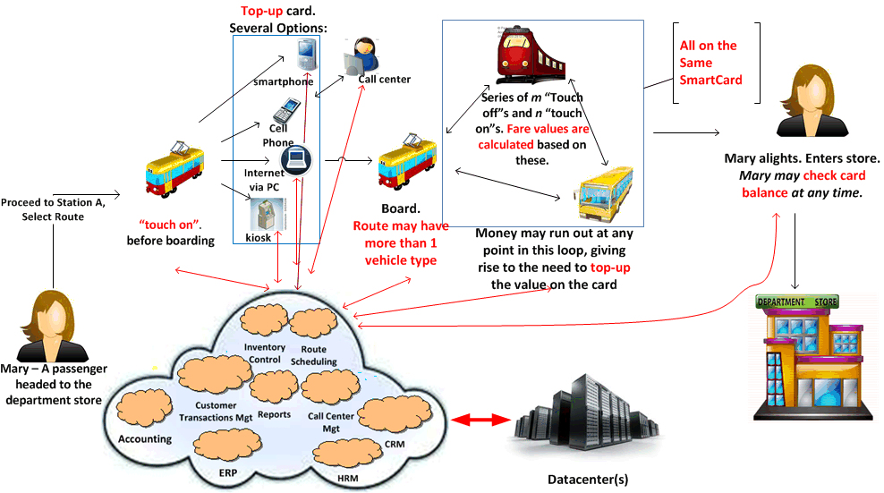
Figure 1: In the “myki”, very many transactions must be processed in real time. How do we come up with a cloud-based design to satisfy this and other design constraints for all stakeholders?
The authors think that as Victoria seeks to remain one of the most livable places in the world, future improvements to the myki system are likely to become more and more important to all stakeholders. An examination of the issues associated with such a system [14] as well as projections of possible future improvements [15] might cast the “myki” as a possible candidate for migration to the cloud, in our opinion. To further motivate the use of the “myki” system as an example of how cloud-based system architecture might be designed, we consider the hypothetical cases in which (1) Melbourne earns the right to host the Summer Olympics (2) The Federal Government of Australia votes to adopt the “myki” for all public transportation in all of Australia. Technical considerations for such futuristic assumptions will likely lead architects to consider whether proposed designs will scale to the resulting increases in workload, beyond what was originally deployed. Questions about profitability and performance will also become more critical as design considerations. These goals interact and can be in conflict. For example, as end users demand higher performance levels at lower prices, the costs to service providers may increase. In this paper, we focus on such scalability, performance and profitability goals and show how our approach might be used to derive an architecture that is more likely to be good enough in the presence of multiple stakeholder groups, whose goals are also usually incompatible with one another.
  - Our Perspective on Cloud Computing
Assuming a virtualized datacenter, our view of what constitutes a cloud is as follows:
“A (private) cloud consists of a collection of virtual machines running on hosted infrastructure (including servers, processors, storage and network) owned by one stakeholder group who gives shared access to many customers in other stakeholder groups”
In Section 2.3, we elaborate more on the important stakeholder groups in Cloud Computing but the diagram in Fig. 2 shows a side-by-side depiction of the most essential concepts in the “myki” system with those in the cloud, based on our stated perspective on cloud computing.
  - Stakeholders in Cloud-Based System Development
In coming up with fair system with respect to the goals of intended users, identifying the stakeholders is foundational to the development process [16], [17]. In their respective Cloud Computing Reference Architecture (CCRA) proposals, both IBM and NIST have proposed different stakeholder groups that should be identifiable in any cloud-based system development project [18], [19]. We follow the IBM perspective because it seems to be based on their experience in actually designing and building cloud-based solutions for their many clients. Moreso, if adopted by The Open Group (to which IBM has submitted their proposal), we feel that the IBM CCRA has a higher chance of becoming an industry standard. The IBM CCRA identifies the following groups of stakeholder roles:
- Cloud Service Consumer
This is an organization, a human being or an IT system that consumes service instances delivered by a particular cloud service. The service consumer may be billed for its interactions with cloud service and the provisioned service instance(s).
- Cloud Service Provider
The Cloud Service Provider has the responsibility of providing cloud services to Cloud Service Consumers. A cloud service provider is defined by the ownership of a common cloud management platform (CCMP). This ownership can either be realized by running a CCMP by himself or consuming one as a service.
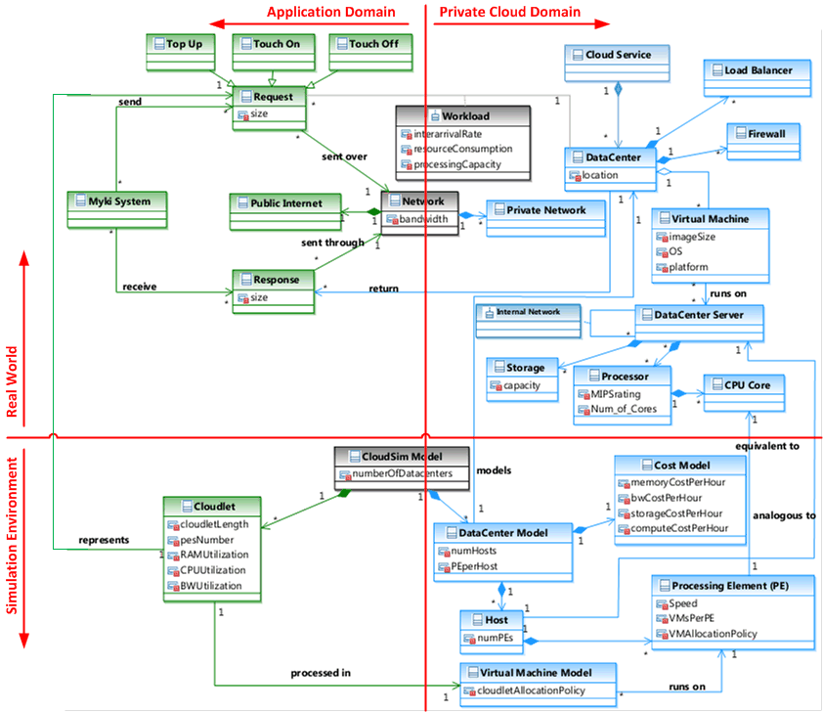
Figure 2: High-level view of the most essential concepts in the “myki” (left) and our view of a private cloud (right) for the real-world (top) and Simulation environments (bottom)
- Cloud Service Creator
The Cloud Service Creator is responsible for creating a cloud service, which can be run by a Cloud Service Provider or directly exposed to Cloud Service Consumers. We note that the Cloud Service Provider may comprise two distinct roles: a Service Development Architect responsible for modeling and deploying the application in the datacenter and a Service Delivery Architect responsible for running the application, mapping Virtual Machines (VMs) to hardware infrastructure and providing a cost model.
- End User
It is surprising that the End User is not treated as a separate stakeholder group in neither the NIST nor IBM CCRA. The reason for this omission is unstated but it seems both CCRAs assume that End User requirements are known to the Cloud Service Consumer who then uses these as a basis of selecting the services in the first place. We depart from this thinking and treat the End User as a separate stakeholder group, following the well-established fact from Software Engineering that the number one source of project failures is a lack of understanding of the End User’s requirements [20].
Fig. 3 shows the hierarchy of these groups of stakeholders while Table 1 describes them within the “myki”.

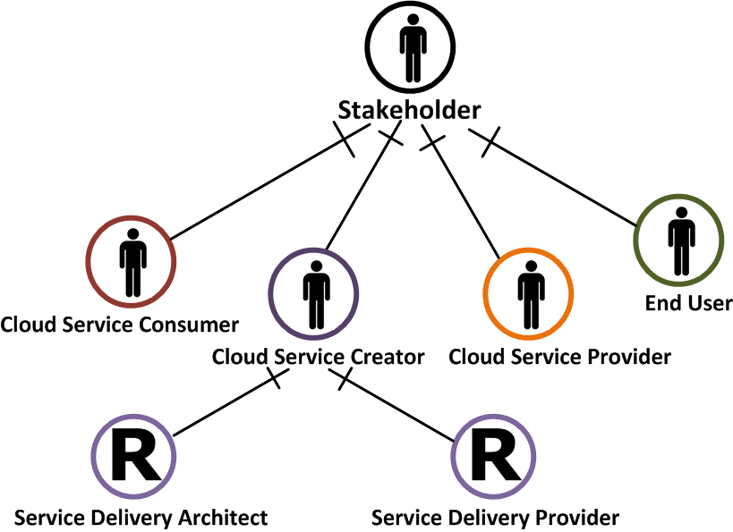
Figure 3: A Hierarchy of Stakeholders and roles in Cloud-Based System Design
  - Goal-oriented Requirements Engineering with the NFR Framework
A closer look at the “Goals” column in Table 1 reveals that most of the goals are expressed in subjective, non-functional terms [21]. This is typical and the problems associated with the elicitation, analysis and specification of stakeholder requirements (expressed in terms of such non-functional goals) has been studied and described in the Software Engineering literature ([6], [22] and [23]). Also, frameworks like KAOS [24], i* Framework [25] and the NFR Framework [58] have been proposed for dealing with stakeholder goals. The Softgoal Interdependency Graph (SIG) proposed as part of the NFR Framework is useful for depicting, analyzing and reasoning about softgoals - goals that are addressed not absolutely, but in a good enough sense. These kinds of goals are the focus of this work (we focus on performance, scalability and profitability for clarity and brevity). Hence, SIGs are used subsequently. A high level SIG for some goals in the myki system is shown in Fig. 4. Stakeholders are shown as agents and roles in the spirit of the i* Framework.
In SIGs, softgoals are shown as clouds with labels - a type and topic pair - beneath each cloud. Roughly, the type of a softgoal describes it while its topic (shown in square brackets) tells what it applies to. Softgoals may be refined by AND/OR decompositions. OR decompositions show design alternatives, where achieving one or more alternatives satisfices the parent softgoal. All alternatives in an AND decomposition must be achieved to satisfice the parent softgoal. The bottom leaves in a SIG should ultimately be operationalizing softgoals, represented as thick clouds and which can be actualized by an assigned agent in the domain. SIGs assist in reasoning about the interactions and conflicts among the stakeholders’ goals by depicting the degree of positive or negative contributions among softgoals with pluses (+) and minuses (-). For example, the softgoal, Profitability[cloud service] may be “helped” by the softgoals, Cost Effective[myki system] and Maximize[datacenter utilization].
Role | Entity | Description | Goals
End User | Passengers | Patrons who need to pay fares to travel from one location to another and carry out essential activities in their daily lives | Quick and convenient request processing.
Cloud Consumer | KAMCO | They consume cloud services in order to provide services for end users to carry out their activities within the system. | Costs should not affect profit margins.
Cloud Provider | CSP | A fictional Cloud Service Provider, CSP Inc., is assumed in this paper. | Good server utilization factor. Right brokering and resource allocation policies.
Cloud Creator | HP | Owns and runs the Datacenter which is backbone of the private cloud. | Meeting SLAs agreed to with Cloud Service Providers.
Table 1: Identifying Cloud Based System Development Stakeholders in the “myki” system

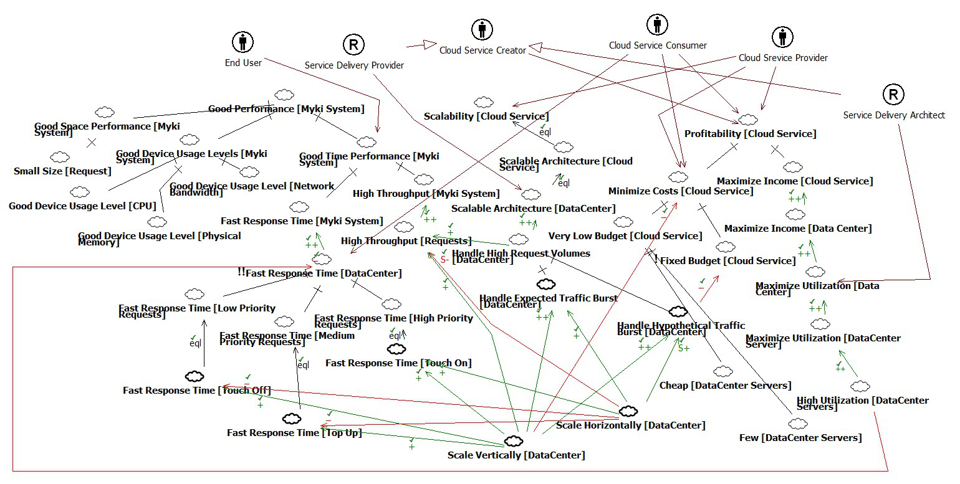
Figure 4: A decomposition of “myki” stakeholder goals using a Softgoal Interdependency Graph (SIG)
SIGs also allow for showing the level of importance of a goal relative to others in the goal model. A goal preceded by “!!” is considered very critical, one marked with “!” is critical and one that is not marked with any exclamation is neutral. As an example, Fig. 4 also shows a conflict between the (very critical) softgoal, !!Fast Response Time[Datacenter] and High Utilization[DataCenter Servers] which is needed to improve profitability. This is so because the goal, !!Fast Response Time[Datacenter] is very critical to end-users and, hence, the Cloud Consumer will require that the system should have very good response times. However, the goal, High Utilization[DataCenter Servers], which is important to the profitability of the Cloud Service Creator, entails making such architectural decisions like using less powerful servers or adding more load to existing servers instead of buying new ones. Such decisions will save cost but are likely to have a negative impact on the !!Fast Response Time[Datacenter] softgoal. Hence, in Fig. 4, the goal, High Utilization[DataCenter Servers] (indirectly) helps the goal Profitability[Cloud Service] but hurts the goal !!Fast Response Time[Datacenter]. Similar reasoning is behind the positive and negative contributions among the other goals shown in Fig. 4. The technical challenge is how to come up with a private cloud architecture which is good enough inspite of such incompatibilities.
  - Using CloudSim for Cloud Based System Design
CloudSim [26] has been proposed and used as a tool for simulating and investigating cloud computing environments, based on the following premise:
“The core hardware infrastructure services related to the Clouds are modeled in the simulator by a Datacenter component for handling service requests. These requests are application elements sandboxed within VMs, which need to be allocated a share of processing power on Datacenter’s host components. By VM processing, we mean a set of operations related to VM life cycle: provisioning of a host to a VM, VM creation, VM destruction, and VM migration”
In this paper, we use Cloudsim to investigate the impact of design choices made in the datacenter configuration on concerns at a higher level of abstraction, closer to stakeholders’ goals. CloudSim was chosen mainly because, to the best of our knowledge, there was no other cloud simulation tool available when the research began. Other cloud simulation tools have since been proposed [27], [28] and will be investigated in the future. The two relevant CloudSim concepts with which we are concerned in this paper are:
- Cloudlets
In CloudSim, Cloudlets may be used to represent an application or a request to an application. Cloudlets consume assigned resources and utilize them for a time calculated as a length in Million Instructions (MI) divided by the VM performance in Million Instructions per Second (MIPS). This paper uses cloudlets as single requests that arrive for processing in the datacenter.
- Datacenter
In CloudSim, a data center is modeled as an aggregation of computing hosts which, in turn, consist of Processing Elements (PE). A PE is analogous to a CPU core. VMs are deployed on PEs in the simulator.
In a way, a Cloudlet object in CloudSim encapsulates the left-hand side of the domain model in Fig. 2 while a Datacenter object can be made to represent the right hand side. This is so because it is the generation of requests by users in the application domain that lead to design constraints on the architecture of the system to be deployed in the cloud – essentially a virtualized datacenter according to our stated view of what constitutes (private) clouds. Hence using CloudSim for cloud-based system design involves 3 phases:
- Obtaining relevant information like stakeholder goals, usage patterns and constraints from the application domain;
- Mapping the information from (a.) into a simulation model in CloudSim which is then used for investigating whether various configurations and workloads can meet stakeholder goals; and
- Mapping results from (b.) back into a system design deployment in the cloud
Section 3 describes how these phases are may be carried out for the “myki”.
- THE PROPOSED APPROACH
This approach is a 6-step process which starts with an identification of stakeholders and their goals and ends with a design that is more likely to be good enough in the presence of conflicting stakeholder goals. Additionally, application domain characteristics are obtained and translated into constraints on the system design using the CloudSim simulation model. Simulations are used to confirm and reconfirm the quality of architectural decisions at different stages of the process.
The Gane-Sarson DFD in Fig. 5 shows the 6 steps, which are not meant to be followed in strict sequence. Rather, they are envisioned for use in an interactive, interleaving and iterative manner whereby aspects of multiple steps may be carried out in parallel while revising outcomes of earlier steps where necessary, depending on new information gained from the later steps. Also, the steps represent a single experimental run that may be carried out iteratively until a good enough design is obtained. The results presented in this paper do not cover Step 6, which is part of our future work.
  - Step 1: Stakeholder and Goal Identification
Proper identification of stakeholders and their goals is the basis of a successful design process – one which results in a system that has a better chance of meeting the goals of all

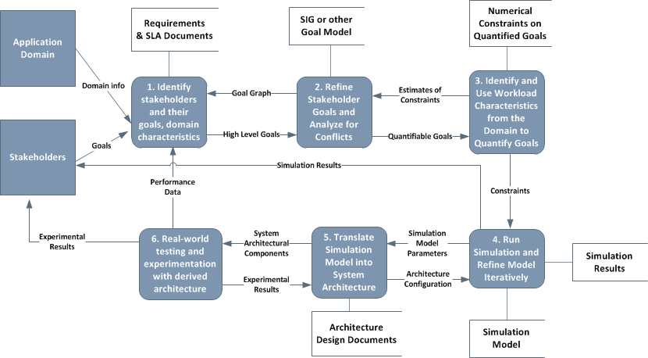
Figure 5: A 6-step process for combining goal-orientation and simulation in cloud-based system design
its intended users. Typically, the goals of stakeholders will be discovered, analyzed and refined during the requirements elicitation phase of the project. Techniques for such goal-oriented elicitation for cloud-based system development have been proposed [3], [4]. Table 1 summarizes the results of such elicitation for the 4 stakeholder groups discussed in Section 2.3, for the “myki”.
  - Step 2: Analyzing Stakeholder Goals for Conflict Identification
Having identified the stakeholder goals, the next step is to represent the goals, along with the stakeholders interested in them in the form of a SIG diagram. Other frameworks can also be used but we have selected the SIG for reasons specified in Section 2.4. Fig. 4 shows one such representation wherein stakeholder(s) interested in a particular goal, as well as any specific roles that they play in the system, are shown alongside the high-level goal model. In Fig. 4, stakeholders are represented as agents (circled stick symbol) and roles (circled R) in the spirit of the i* Framework. The resulting diagram is henceforth referred to as an Agent-SIG. Subsequently, the Agent-SIGs are simpler than Fig. 4 for clarity in presenting the interaction between stakeholders, their goals, simulation results and the interrelationships between these. In practice, even more model refinement would be required, whereby each high level goal is sufficiently AND/OR decomposed until specific operationalization, assignable to an agent in the domain is derived.
  - Step 3: Quantitatively Augmenting the Qualitative Goal Model with Domain Specific Information
In order to use simulation, which is quantitative, to evaluate the impact of design decisions on the degree of satisficing of softgoals, it is necessary to augment the qualitative goal model (Agent-SIG) from Step 2, shown in Fig. 4, with numbers that guide decision making. This entails the translation of stakeholders’ requirements from the application domain into numerical target values that the eventual system design is expected to meet or exceed for the related softgoals to be considered satisficed. We refer to these target values as “design constraints”. Typically, these constraints will be evident, at least partially, during the requirements elicitation phase for a cloud-based development project [4] and can be of different types. In this paper, we focus on design constraints related to profitability, scalability and performance goals. This section shows how initial estimates of design constraints on these goals may be obtained, in the “myki” example. These estimates will be used to create a baseline design which is then improved upon in subsequent iterations.
One question concerns the impact of errors in the initial estimates on the number of iterations needed for our technique to converge. We plan to experimentally investigate this in the future. However, conventional wisdom, based on experience with iterative techniques in Numerical Analysis, seems to suggest that the number of iterations in the overall process will tend to increase in direct proportion to the errors in the initial estimates. To this end, we feel that special care should therefore be taken while estimating the design constraints. Also, to start the process of estimation, one softgoal needs to be selected. We suggest the selection of a softgoal that is deemed very critical to the end-user (“customer is king”) and/or a softgoal which allows the creation of a queuing or similar performance model.
It is important to point out that the aim of this step is not to replace any of the reasoning or elaboration activities and techniques normally associated with goal models. Neither is it meant to be a proposal for a new kind of quantitative goal model. Rather, it complements existing techniques in order to further facilitate the use of goal-orientation with simulation. The utility of the SIG produced in Step 2 to the activities in Step 3 includes:
- The SIG can help stakeholders negotiate and agree on target values that define what it means for the goals in the SIG to be considered good enough.
- It helps requirements engineers to discover what domain specific phenomena need to be quantified and fed into the simulation model.
- It serves as the basis of reasoning about the degree to which the softgoals have been satisficed.
In the rest of this section, we show how the performance, scalability and profitability goals for the “myki” were quantitatively augmented, based on refinements shown in Fig. 4.
3.3.1 Quantifying Performance Goals
In refining the high-level performance softgoal, Good Performance[Myki System], as shown in the Agent-SIG of Fig. 4, we adopted the classic NFR Framework definitions and approach to dealing with performance goals, referred to as the Performance sort [22], [54]. To start the estimation process, we considered the end-user goal, !!Fast[response times] to be very critical from the End User’s perspective. Thus, this softgoal is selected initially. We note, however, that this choice is by no means unique and will vary from project to project. Next, we try to answer the question of what it might mean for the performance related softgoals in the qualitative goal model to be considered satisficed.
For the “myki” one key performance objective is for the system to process individual transactions within the smallest amount of time possible, while still processing the maximal volume of requests per day. This objective fits well into the interaction among space performance, time performance and device utilization as espoused in the Performance sort technique and captured in the Agent-SIG of Fig. 4. But, how do we derive these quantities like number of simultaneous transactions, maximum processing time per request, and total number of requests per day which, among others, form the key performance variables that are of interest to stakeholders? The maximum allowable processing time for each request will ideally be stated in the SLA agreements. For the sake of discussion in this paper, we take this value to be 12 seconds, comparable to what is common in most POS systems [29]. For the number of requests per day, we found that the current workload on the “myki” system is 800,000 requests per day (rpd). This value, combined with other domain knowledge from the existing system is then used along with Little’s Law, as shown in Section 3.3.1.1, to compute how many simultaneous requests the datacenter must be able to handle in order to meet the performance goal of 12 seconds average response time.
Realistically, a more refined treatment might be desirable in identifying and deriving numerical values for the related performance variables. For instance, instead of computing the processing times or number of requests per day for all requests as an aggregate like we do in illustrating our ideas in this paper, these values may be computed for the individual types of request (i.e. touch on, touch off, top-up). All the estimation techniques discussed in the rest of this section will remain applicable, and the increase in the amount of computations is expected to be offset by the benefits to performance engineers in terms of a more detailed view of the system under investigation.

3.3.1.1 Estimating Performance Variables using Little’s Law
Given the way that we are choosing to measure the performance goal for the “myki”, as described in the previous section, we need a way to relate the different performance variables together mathematically. In our case, we found Little’s Law [30] to be useful. Little’s Law defines a relationship among a queuing system’s average arrival rate, average processing time and average throughput. Little’s Law states that, if
λ = average number of items arriving per unit time,
L = average number of items in the queuing system and
W = average waiting time in the system for an item.
Then, L = λW (1)
Because cloud-based systems will consist of requests that are eventually processed in a datacenter, with some reasonable assumptions, we think that it should be possible to model most (private) cloud-based applications as queuing systems over which Little’s Law can be applied to gain intuition for creating the simulation model to be used during system design.
3.3.1.2 Some Assumptions made in using Little’s Law for the “myki’
In using Little’s Law to create a queuing model for the arrival of requests in the datacenter, the following assumptions were made about the system:
- The datacenter is a single channel server.
- The datacenter will handle all requests uniformly.
- Data needed to process requests is completely and accurately contained within the datacenter.
- The response time for a request is equal to the processing time of each request in the datacenter, neglecting latencies in client devices and the network.
- Multiple datacenters may conceptually be treated as a single datacenter, assuming the right task scheduling and resource allocation policies among them.
These assumptions make it possible to model the entire “myki” as a queuing system in line with the fundamental assumptions of Little’s Law. In addition to these assumptions, the datacenter is initially treated as a black box into which requests flow and out of which responses come after some processing time. The internals of the datacenter are then considered as the model is improved subsequently.

3.3.1.3 Calculations and Estimates
In computing the smallest amount of time possible while still processing the maximal volume of requests per unit time, the following facts from the domain, adapted from information obtained from actual “myki” engineers, were used:
- The system currently handles 800,000 requests per day (rpd)
- 75% of requests arrive during, and are split equally between, the morning and evening rush hour periods. The remaining 25% are evenly spread over the rest of a 12-hour day.
- Rush hour is between 0700-0930 and 1700-1900 on weekdays in Melbourne.
Current average request arrival rates per day are as follows:
- Morning rate = 300,000 requests ÷ 2.5hours = 120,000 requests per hour
- Evening rate = 300,000 requests ÷ 2hours = 150,000 requests per hour
- Non-rush hour rate = 26,667 requests per hour
To compute the average number of requests to be simultaneously processed in the datacenter under any of these workloads, let
L = average no. of requests processed simultaneously by the datacenter;
W = average processing time per request = 1 minute = 0.01667 hour;
λ = arrival rate of requests to the datacenter = 150,000 requests/hour.
By (1), L = λW = 150,000 requests/hour X 0.01667 hour = 2500 requests
This implies that, to handle the same workload as the current system, the cloud-based system should, on the average, be able to handle 2500 requests simultaneously. For other design scenarios, such as the hypothetical nationwide adoption of the “myki” system, similar calculations can be used to find out how many requests the system must be able to process simultaneously. This value is then used subsequently to form input to the simulation model. Instead of randomly selecting and testing designs from the design space, the designer is, thus, handed a more precise starting point. Note that we have assumed a uniform distribution for the request inter-arrival rates for brevity. Little’s Law holds regardless and other probability distribution functions may be investigated in practice.
3.3.2 Quantifying Scalability Goals
The concept of a scalability goal has recently been more precisely defined in terms of specified scaling assumptions [59], wherein a scalability goal is
“a goal whose definition and required levels of goal satisfaction make explicit reference to one or more scaling assumptions”.
In turn, a scaling assumption is
“a domain assumption specifying how certain characteristics in the application domain are expected to vary over time and across deployment environments”.
We found this definition and related treatment of scalability more suitable for our goal-oriented simulation approach, since it allows us to evaluate possible system behavior based on domain assumptions. There are other definitions of scalability as a system goal (e.g., [60]) which may be more germane to other kinds of projects.
In order to use this definition, however, the question arises as to what domain characteristic(s) the scaling assumption(s) should be based on. We restrict our focus in this paper to workload-related domain characteristics. Specifically, at the risk of appearing to use a rather crude measure of scalability, we will only use the definition of scalability as “acceptable performance under increasing workloads” [61]. It is not our aim in this paper to show the proper treatment of the individual softgoals. Rather, we try to show the impact of design decisions on the degree to which multiple softgoals are simultaneously satisficed. More detailed treatment of scalability as a softgoal may be found in the Software Engineering literature [59], [60].
We define our scaling assumptions in terms of four kinds of workloads outlined in Table 2. The Current workload refers to the amount of load currently handled by the “myki” while the Peak workload represents the expected load at peak capacity. The values used for the Current and Peak are somewhat obfuscated from real data obtained from “myki” operators. Next, in order to show how the cloud might be used to scale this system even further, the Olympic workload considers the case where the Cloud Service Consumer needs the system to handle temporarily large spikes in usage as may occur, if Melbourne were to host the Summer Olympics in the near future. Lastly, the Australia workload seeks to see how

Workload | Requests/day | Justification
Current | 800,000 | Statistics from current system
Peak | 3,000,000 | Expected workload at capacity
Olympics | 6,000,000 | Assuming that influx of tourists causes use of public transport to double
Australia | 16,814,521 | If Melbourne current usage is representative of national patterns, this number is proportional to the peak capacity that the current system is expected to handle.
Table 2: Different workloads to which the “myki” is expected to scale in the cloud
scalable the system might be for very large scale permanent expansion in its use, as may occur if every state in Australia decides to adopt the “myki”. Both the Olympic and Australia scenarios are purely hypothetical although it should not be hard to see how they may correspond to real-world use cases. All four workload types represent the scaling assumptions that we have made and are by no means exhaustive.
One factor that needs to be accounted for is whether other system goals are expected to have fixed or changing target values as the workload varies. Cases where system goals are expected to remain fixed have been defined as scalability goals with fixed objectives (SGFO) while those in which the system goals can vary have been defined as scalability goals with varying objectives (SGVO) [59]. For the “myki”, one SGFO is that the system should be able to handle all scaling assumptions while maintaining VM utilization between 40% and 75%, where utilization is computed as the fraction of time during which each VM is busy. An example of SGVO would be that some reasonable amount of performance degradation, in terms of longer response times, might be expected for the Australia scaling assumption.
3.3.3 Quantifying Profitability Goals
Constraints that impact on profitability can be viewed from the perspective of multiple stakeholder groups. For the “myki”, passengers care about how much they are charged per transaction as well as how much taxpayer money the Government is spending to support the system. Cloud Consumers want to make enough money from fares to offset costs incurred in using the cloud service. Cloud Service Providers and Cloud Service Creators will similarly want to ensure that the cost of the services provided are offset by what they charge to their respective clients. We assume that annual cash inflow from fare collection for the Current workload is about $100,000,000, that revenues in other workloads are directly proportional and that fare collection is the only revenue source. Will cloud usage make the system cost-effective/profitable to all stakeholders? Will the system be able to sustain itself without Government help? This is important as it is not likely that fare prices charged to passengers will change merely because the system is migrated to the cloud platform. Also, prices charged by Cloud Service Creators (HP in the “myki” example) are typically fixed. Hence, the system design will need to ensure minimal costs. For simplicity, we consider the system cost effective and profitable for all stakeholders as long as Cloud Computing and Server costs do not exceed 5% of total revenue in the Current, Peak and Olympic Workloads and 50% in the Australia workload.
  - Step 4: Iterative Simulation and Model Refinement
The aim in this step is to translate the constraints from Step 3 (Section 3.3) into simulation models that serve as a proxy for the actual cloud-based system, through which the quality of design decisions can be investigated for impact on the satisficing of softgoals within the goal model (SIG).
    - Cloud Computing Simulation Modeling with CloudSim
In CloudSim, modeling the cloud is essentially an activity in deciding the parameters of a suitable virtualized datacenter, which is then internally converted to a discrete event simulation model For our experiments, the constraints on the system design, derived from the previous step are used to inform initial parameter selection which is then improved subsequently, based on simulation results and the degree of stakeholder goal satisfaction. Next, we briefly describe initial parameter selection, modeling and simulation model refinement steps.
      - Mapping from Quantified Goals to CloudSim Model
In Section 2.5, we gave a high level introduction to the two main CloudSim concepts that are needed to model a cloud-based system design: Cloudlets and Datacenters. In this Section, we show how the analysis done so far can be mapped to into a Simulation Model in CloudSim, in terms of these two entities.
3.4.1.1.1 Modeling Application Requests as Cloudlets
Table 3 describes some attributes of the Cloudlet class that were used in the simulations. The cloudletLength attribute represents the number of CPU instruction cycles consumed by a request. Existing techniques for estimating resource usage in virtualized environments (e.g., [31]) do not use such fine grained parameter and work mainly for existing systems. Our approach focuses on early stages of development. Hence, the challenge is to more reliably approximate this low-level, machine and implementation dependent variable before system development. We propose some techniques for approximating this value, depending only on information that can be estimated at design time:
- If the system exists and it is possible to obtain/estimate the number of instructions currently being processed per second, the server hardware being used and the utilization of the server, then the number of instructions in a request may be approximated from:
MIPS rating of the server
Requests/sec at 100% utilization
- If the server on which the system is being run can be determined but there is no way to obtain/estimate the requests per second, then the tpmC metric of the server may be obtained from the TPC-C benchmark [32] and used in the formula given in (i). In

this case, however, the complexity of the transactions in the system under study has to be estimated as a fraction or multiple of those in the TPC-C (or similar) benchmark.
- If the requests per seconds can be obtained/estimated but not the MIPS rating of the actual server used, then the MIPS rating of a server with the closest semblance to the one being used may be used as an approximation
- If neither the MIPS rating nor the number of requests can be estimated, the problem may be narrowed down by taking a look at the architecture application and estimating the number of instructions in each component.
For the myki system, assuming HP ProLiant BL680c G7 servers running on Intel Core i7-980X processors (147,600 MIPS) process the 800,000 requests per day at the common server utilization of 15%, calculations yield 11.07 million instructions (MI) per request. Using the peak value 3,000,000 requests per day under the same assumptions yielded a value of 2.95 MI/request. We take this as a range within which the actual value may lie. Calculations using the method in (ii) above yielded a value 7.01 MI/request. Interestingly, this is within the range obtained from the first method. This gives some initial confidence
- Attribute | Value | Meaning/Rationale
cloudletLength | 12 MI | Obtained from calculations
pesNumber | 1 | 1 CPU core of the right capacity is sufficient to process this cloudlet.
cloudletFileSize | 1913 bytes | Typical file size at checkout for most e-commerce sites
utilizationModelCPU | Full | Each cloudlet will use an entire CPU core
utilizationModelRam | Full | Same meaning as in CPU
UtilizationModelBw | Full | Same meaning as in CPU
Table 3: Some Cloudlet Properties for a Single Request. Meanings of variables available in the CloudSim API online
Property | Value | Explanation
Number of Datacenters | 1
PEs per host | 36 | Assuming HP ProLiant BL680c G5 Servers running on the Intel Xeon X7460 processor (36 cores).
Number of Hosts | 70 | 70 X 36 = 2520 > 2500, Assuming 1 VM per PE, 1 request per VM.
MIPS per PE | 11,757 MIPS | Comparable to the MIPS of a single core in the Intel Core i7 920 (Quadcore) running at 2.66 GHz.
Storage Cost | $0.0134/GB/hr | Extrapolated from Microsoft Azure pricing.
Compute Cost | $0.04/hour | Extrapolated from Microsoft Azure pricing.
Bandwidth Cost | $0.00028/GB/hr EGRESS | Extrapolated from Microsoft Azure pricing.
Memory Costs | $0.05/MB/hr
Table 4: Initial Datacenter Configuration. (Host: a server installation,
PE: Analogous to a CPU core.)
about the estimation methods and suggests that multiple methods may be used complementarily. We conservatively use the worst case computed value of 12 MI per request in the rest of this paper.

3.4.1.1.2 Modeling the Data Center Architecture
The practice in the myki system of routing all requests through a single datacenter makes it plausible to model the initial cloud data center as being in single location. The data center configuration shown in Table 4 is the proposed initial design and derives mostly from the estimated design constraints discussed previously. 1–to-1 mapping of VM to CPU core and request to VM have been pessimistically used in coming up with the baseline and will be optimized subsequently.
3.4.2 Using Simulation to evaluate degree of Goal Satisfaction
The multidimensional nature of cloud-based system design requires that the impact of design decisions on goal satisfaction be simultaneously evaluated with respect to the stakeholders, their goals, the proposed system configuration and various workloads that the system is required to support. To better manage this iterative evaluation, we introduce the visual notation in Fig. 6 to help the designer assess impact of particular designs the stakeholder goals. Design constraints (Sections 3.3.1 to 3.3.3) inform the mapping from application domain constraints to simulation model parameters. Hence, the notation in Fig. 6 is proposed to help visualize the impact of design decisions within the simulation model on the satisfaction of design constraints, in various iterations. When combined with the Agent-SIG diagram from Fig. 4, this notation can facilitate reasoning about the various dimensions involved in cloud based-design. We illustrate the use of this notation subsequently, for the “myki” example.
The visual notation may be interpreted as follows:
- Simulation model parameters are shown at the bottom of the diagram for different experimental runs, showing both request parameters (in green) and datacenter parameters (in blue), stacked on each other to save space. For example, the leftmost configuration (Run 1) at the bottom of Fig. 6 follows from Tables 3 and 4.
Progression from the simulation model configuration in one experimental run to the next depends on design decisions based on the degree to which all stakeholders’ goals have been met. We illustrate this in the “myki” design in subsequent sections.
- Design constraints derived from the domain are linked to the goals they impact on by dashed lines. Exact constraints that must be met in order to meet a goal (and satisfy interested stakeholders) are shown in red boxes while constraint values derived from simulation are shown in lilac boxes.
- Constraints may be linked to parent goals or to sub-goals.
- The degree of constraint satisfaction is mapped to the degree of goal satisficing in
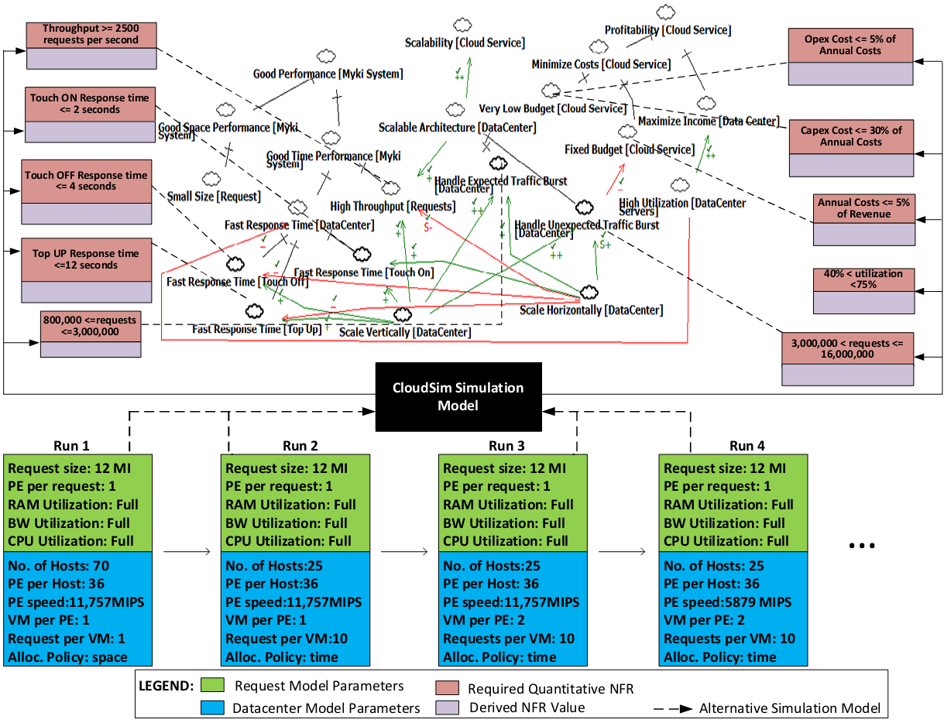
Figure 6: Visual notation for assessing impact of design decisions, represented in the simulation model, on the degree of goals satisfaction during some sample iteration steps.
the NFR Framework according to Table 6, which reads as, “If the degree of goal satisfaction is as shown in the Constraints row, then the associated softgoal shall be satisficed to the degree shown in the Associated Softgoal row for the matching case”.
- Normal rules for reasoning about SIGs remain. Quantities derived from quantitative requirements and simulation results are used as a sort of claim softgoal [58] to more properly justify why the softgoals are assigned various degrees of satisfaction.
- Reasoning about the interaction among the constraints, softgoals and simulation results is based on the rules shown in Table 5. For example, in the Agent-SIG of Fig. 8, the form of the “Response Time <= 12 seconds” (RT12, for short) constraint matches RULE 1 (row 1) in Table 5. Simulation results show that, for all 3 scenarios response times are are (much) less than 12 seconds. Therefore, by Case 1 of RULE 1, the RT12 constraint is considered satisfied. Case 1 of Table 6 is then used to infer that the softgoal, !!Fast Response Time[Touch On], is satisficed, since RT12 is linked to it. For the “40%<utilization<70%” (UtilRange, for short) constraint in Fig. 8 matches RULE 4 in Table 5. Since the utilization values obtained from simulation are much lesser than the required lower bound, by Case 2 of RULE 3, UtilRange is, thus, unsatisfied. Next, Case 3 of Table 6, the softgoal, High Utilization[Datacenter Servers] to which UtilRange is linked, is denied. The other associations between constraints and goals in Fig. 8 are treated similarly.
One issue concerns the implicit assumption we have made in the describing the visual
RULE | FORM | Case 1 |  | Case 2 | Case 3 | Case 4 | Case 5
1 | var ≤ y | Result | res < y | res = y | res > y | res >> y | !def(res)
 |  | Constraint | sat | p.sat | p.unsat | unsatisfied | unknown
2 | var ≥ y | Result | res > y | res = y | res < y | res << y | !def(res)
 |  | Constraint | sat | p.sat | p.unsat | unsatisfied | unknown
3 | x≤var≤y | Result | x<res<y | res = y  or  res = x | res < x  or  res > y | res << y  or  res >> y | !def(res)
 |  | Constraint | sat | p.sat | p.unsat | unsatisfied | unknown
4 | var<y, var>y or x<var<y | Treat as the Rule 1,2 or 3 most closely associated, but leave out Case 2
5 | var = y | Result | res = y | res ≠ y | N/A | N/A | N/A
 |  | Constraint | sat | unsatisfied | N/A | N/A | N/A

(Abbreviations: var=”variable whose value is being measured”, x & y = “the (upper or lower) bound on the value of var”, res = “the actual value of var obtained from simulation results”, sat = “satisfied”, p.sat = “partially satisfied”, p.unsat = “partially unsatisfied”, !def(res) = “res is undefined”)
Table 5: Reasoning about the impact of simulation results on constraint satisfaction
 | Case 1 | Case 2 | Case 3 | Case 4 | Case 5
Constraint | Satisfied | Partially Satisfied | Unsatisfied | Partially Unsatisfied | Unknown
Associated Softgoal | Satisficed | Weakly Satisficed | Denied | Weakly Denied | Undecided
Table 6: Mapping levels of constraint satisfaction to the degree of softgoal satisficing
notation, viz.: constraint symbols can only link to one softgoal. What if multiple constraints link to the same goal, having different levels of satisfaction? One option is to extend normal SIG reasoning techniques to handle this situation. This is open to further research.

3.4.3 Initial Simulation, Results and Analysis

For the Current, Peak and Olympic workloads, using the estimated arrival rates and initial configuration discussed earlier, the first simulation experiment shows a very small, constant processing time and cost per request as shown in Table 7 and Fig. 7. For the !!Fast[response times] softgoal alone, this is a good thing. But, considering other goals, this is unlikely to lead to a fair system for all stakeholders. Annual Cloud Computing costs grow too quickly (cost as percentage of revenue is almost constant) as a 1-to-1 VM to request mapping is used (see iteration 1, Table 7 and Requests per minute and VM Usage graph, Fig. 7). The updated Agent-SIG in Fig. 8 indeed shows that multiple goals in the system have indeed been sacrificed in order to satisfice the critical performance softgoal while the Agent-SIG in Fig. 9 shows which stakeholders’ goals is (un)met. Steps taken to improve this initial design are discussed next.
I | Workload | Host | VMs | RPM | Policy | p.time | p.cost | a.p.cost p | a.s.cost | t.a.cost
1 | Current | 70 | 2500 | 2500 | space | 0.14 | 2158.61 | 4,043,766.76 | 1,400,000.00 | 5,443,766.76
 | Peak | 261 | 9375 | 9375 | space | 0.14 | 8306.14 | 15,560,056.15 | 5,220,000.00 | 20,780,056.15
 | Olympics | 521 | 18750 | 18750 | space | 0.14 | 16612.3 | 31,120,112.31 | 10,420,000.00 | 41,540,112.31
2 | Current | 4 | 125 | 2500 | DW | 19.85 | 141.01 | 18,693,518.32 | 80,000.00 | 18,773,518.32
 | Peak | 14 | 469 | 9375 | DW | 19.54 | 738.18 | 97,096,234.02 | 280,000.00 | 97,376,234.02
 | Olympics | 27 | 938 | 18750 | DW | 19.54 | 1476.37 | 194,193,783.39 | 540,000.00 | 194,733,7839
3 | Current | 7 | 250 | 2500 | time | 0.60 | 216.84 | 1,701,061.25 | 140,000.00 | 1,841,061.25
 | Peak | 27 | 938 | 9375 | space | 0.10 | 1021.63 | 1,307,129.33 | 540,000.00 | 1,847,129.33
 | Olympics | 53 | 1875 | 18750 | time | 0.60 | 2048.60 | 16,070,808.36 | 1,060,000.00 | 17,130,808.36

(Abbreviations: I=”Iteration”, RPM = “Requests per minute”, Policy = “Cloudlet Allocation Policy”, DW = “Dynamic Workload Allocation Policy”, p.time = “Processing time per request”, p.cost = “processing cost for all RPM”, a.p.cost = “Annual Processing Cost”, a.s.cost = “Annual Server Cost”, t.a.cost = “Total Annual Cost”
Table 7: Simulation results for 3 iterations over the Current, Peak and Olympics workloads for different configurations. Annual costs are extrapolated from simulation times.
Figure 7: Graphical view of some of the results in Table 6

3.4.4 Model Refinement
Based on the simulation results in the first run, the current configuration, if deployed, is not likely to result in a fair system from the viewpoint of all stakeholders. Hence, the system design, as captured in the simulation model, will need to be improved towards meeting the goals of as many more stakeholders as possible. To do this, new architectural decisions are made based on insights from the initial results as well as the currently unmet stakeholder goals. For instance, the following decisions were made to improve the initial design for the Current workload:
- Assuming the 3-tiered software architecture style, the initial design for the Current workload suggests having 2,500 VMs, each having its own front-end, business logic and database. This is infeasible because while the front end and business logic layers may be horizontally scaled out like this, traditional database management systems do not lend themselves to such scaling out. Hence, the decisions to use one central database, have the VMs communicate with it via a load balancer (as a transaction processing (TP) monitor) and use a second database server for failover. These decisions will be reflected in the final architecture
- The baseline design used a queue length of 1. To improve utilization, let VMs handle 20 requests threads at once.
- The size of each VM is reviewed downwards and the allocation policies are changed from the space-shared policy used in the baseline to a time-shared policy for both cloudlets and VMs. These policies are defined in CloudSim [26]
- Because of the above improvements, the number of servers used in the processing of requests is reduced from 70 to 25.
- With the changes to the baseline design, the database tier is observed to be the most likely bottleneck. Database architects will have to manage this effectively.
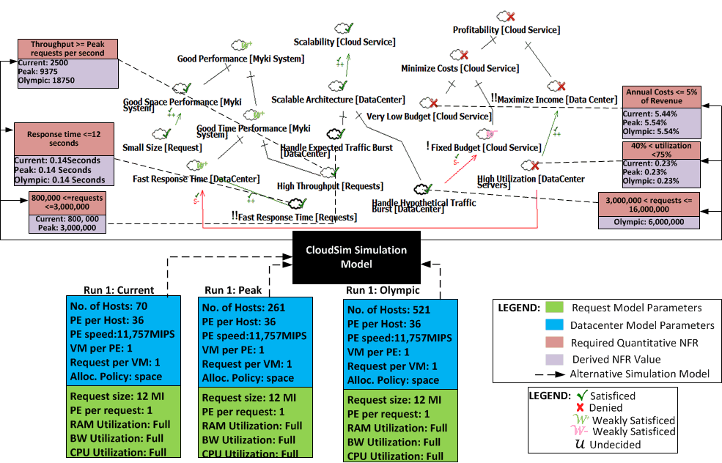
Figure 8: Updating the augmented SIG with Simulation results. Multiple goals are denied while satisficing one critical softgoal
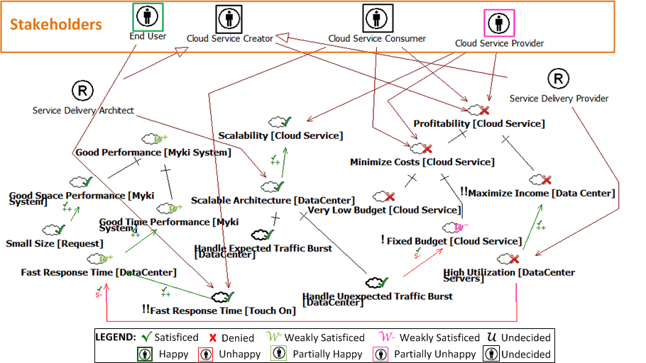
Figure 9: Updated Agent-SIG showing that meeting one critical softgoal satisfies some stakeholders but will likely result in an unfair system for other stakeholder groups.
Similar modifications are made for the Peak and Olympic workloads and the simulations are re-run. Simulations based on these improvements show some improvements in meeting other stakeholder goals. The results are shown in Fig. 7 as well as the second row in Table 7 which show that, although we use fewer VMs and Hosts (Servers) and the system is better able to scale, the response time and cost constraints have been violated. Fig. 10 shows updates to the augmented Agent-SIG after running the simulation for the “improved” configuration. Note that Fig. 10 combines the augmented SIG with the Agent-SIG diagrams for brevity.
To improve even further, we reduce the number of requests handled per VM from 20 to 10, since it seems that having greater queues consumes more computational resources and leads to the much higher response time and cost factors. We also change the request (cloudlet) allocation policy within CloudSim from DynamicWorkload policy to a time-shared policy and explore the possibility of allocating more VMs per CPU core. The results of these are shown in the third row of Table 7 and in Fig. 7. As Fig. 11 shows, these changes result in a design that is likely to better meet the stakeholder goals. Further refinements and optimizations can be carried out, if needed.
The analysis so far has evaluated whether certain configurations are good enough to meet stakeholder goals for a particular kind of workload. More specifically, with respect to the workloads described in Section 3.3.2, while the design so far may cater to the Current, Peak and Olympic workloads, it may not be good enough for the Australia workload considering
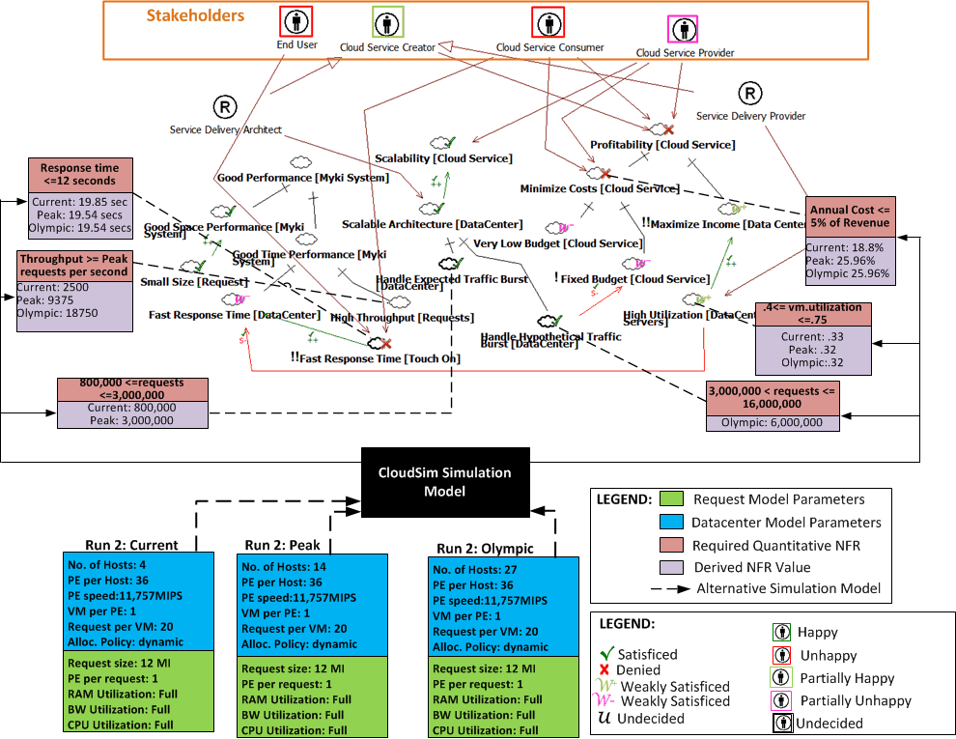
Figure 10: Improving initial design for scalability (utilization) sacrifices performance and profitability.

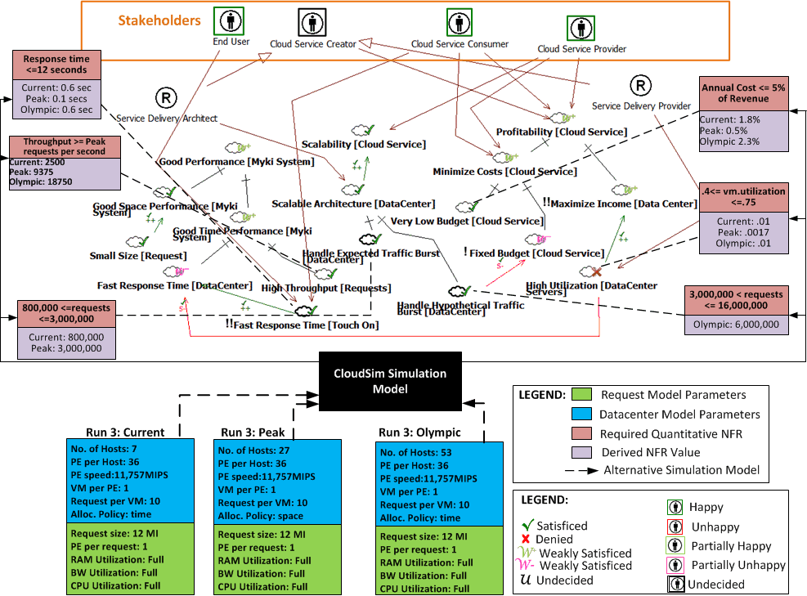
Figure 11: The configurations in the third run seems to satisfice the profitability and performance goals simultaneously, while partially satisficing for scalability (poor utilization)
its wider geographical scope and much larger scale. In the next section, we show how a good enough design for the Olympic workload may be derived, assuming the same constraints but with much larger budget and revenues.
3.4.5 Designing for a different workload type
The workloads considered so far shared some similar characteristics which enabled us to consider them simultaneously. In this section, we consider a workload with significantly different characteristics: the Australia workload. This workload results from the hypothetical case that all 6 states in Australia adopt the “myki”. Designing for this workload will differ significantly from others considered so far in the following ways:
- The budget and revenue from fare collection will be about 6 times as large as the Melbourne only case (there are 6 states in Australia)
- A choice will have to be made between using a centralized datacenter like the one utilized so far or a set of datacenters distributed around Australia, since distance from datacenter is likely to lead to added performance bottlenecks
- If multiple datacenters are to be used, how many should be used and where should they be located for best performance, given the fixed cost?
- If multiple datacenters are used, network and other costs will be more significant.
Granted that many application-level and data storage related optimizations will need to be made for best performance in the Australia workload, we continue to use the same request model from earlier examples to keep the discussion simple. First, we evaluate the profitability, scalability and performance tradeoff for a single datacenter configuration and see how well this meets stakeholder goals. Based on the simulations, more datacenters can be considered in the architecture. Keeping with the same assumptions and estimation technique from Sections 3.3.1.2 and 3.3.1.3, Table 8 and Fig. 12 shows the results of running the simulation for the Australia workload, using the earlier described visual notation.
For the second run, we randomly halved the capacity of the datacenter and bandwidth costs used in the first iteration for the Australia workload and used 2 such datacenters instead of 1, we observed some interesting results, as shown in Table 8 and Fig. 13. First, requests sent to the datacenter closest to them had a much less processing time (12.8 seconds) than

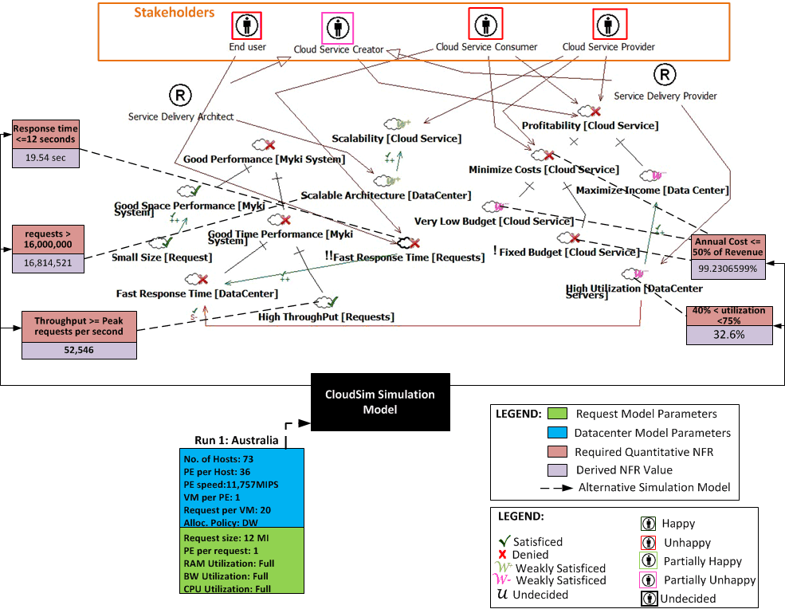
Figure 12: Even with optimizations that worked for the other workloads, using a single datacenter for the Australia workload does not meet most of the stakeholder requirements.
I | Hosts | VMs | RVM | p.time | a.cost p | a.cost h | t.a.cost
1 | 73 | 2628 | 52546 | 19.54 | 1,945,142,017.49 | 1,460,000.00 | 1,946,602,017.49
2 | 73 | 2628 | 52546 | DC1:12.8 | 1,089,811,117.77 | 1,460,000.00 | 1,091,271,117.77
 |  |  |  | DC2: 31.74

(Abbreviations: I=”Iteration”, RPM = “Requests per minute”, Policy = “Cloudlet Allocation Policy”, DW = “Dynamic Workload Allocation Policy”, p.time = “Processing time per request”, p.cost = “processing cost for all RPM”, a.p.cost = “Annual Processing Cost”, a.s.cost = “Annual Server Cost”, t.a.cost = “Total Annual Coast”)
Table 8: Simulation results for the Australia Workload. Annual costs calculated from simulation times.
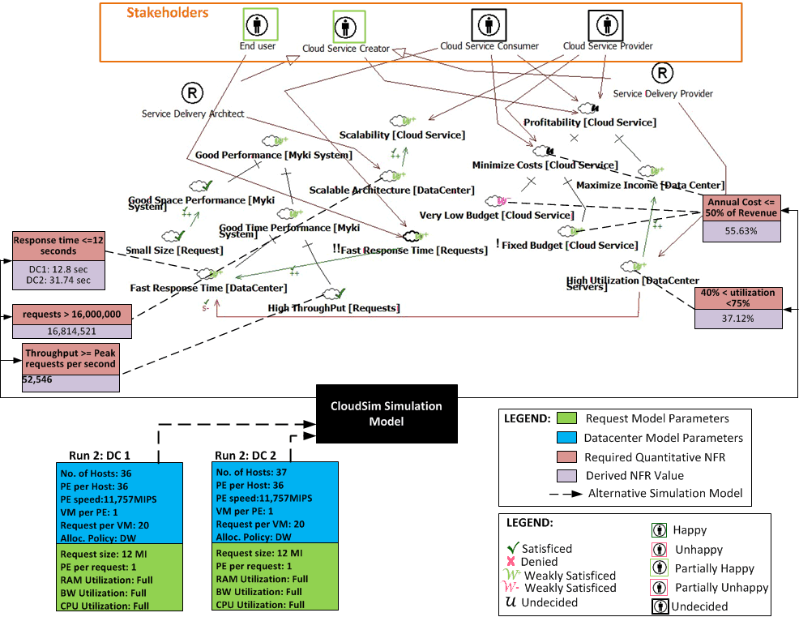Figure 13: Using two datacenters (DC1 and DC2) shows higher chances of meeting stakeholder goals. Better selection of datacenter locations, among other things, could lead to more improved results
requests sent to the datacenter farther away (31.74 seconds). Secondly, even though the average processing time for the 2 datacenter scenario (22.27 seconds) was just a little higher than the average processing time in the 1 datacenter scenario, Cloud Computing and Server costs reduced drastically. These results suggest that, with more careful planning, locating bigger datacenters nearer to more densely populated regions reduce costs and improve performance even further, while maintaining good scalability. This seems to confirm earlier findings [34] on the impact of the distance from datacenters on cloud computing costs and performance. This issue has also been defined as a research problem in Cloud Computing, the solution to which may lead to techniques for optimizing among datacenter location, network performance, costs and other variables [35].
3.5 Step 5: Translating Derived Model into System Architecture
In this Step, results from the simulation process are translated back into private cloud architecture in the application domain. In Steps 1 and 2 (Sections 3.1 and 3.2) we discussed how to obtain information from the application domain that imposes design constraints on the cloud based system. Steps 3 and 4 (Sections 3.3 and 3.4) showed how to translate these constraints into the CloudSim simulation model which is then used, as a proxy for real system architecture, to investigate whether certain configurations will meet the goals of the system. If the configuration is not good enough, changes are made and simulations used to reconfirm their quality, until a satisficing design is obtained.
The simulations in Step 4 have the desired effect that they narrow down the design space
from infinitely many designs to a more useful subset. However, it is likely that there will still be a large number of designs in this subset and exploring them all is practically infeasible. One solution is to iteratively explore and select among incrementally better alternative designs based on the final simulation model. To do this, one starts with a few candidate designs, perhaps armed with the knowledge of creating similar systems in the cloud. These are then evaluated and the one which is most optimal with respect to the tradeoffs in the stakeholder goals is then selected and further improved. Techniques and criteria for selecting among architectural alternatives in Software Engineering have been proposed [36], [37]. In this paper, because of space constraints, we simply show one candidate design and discuss how architects may improve on it in real-world applications.
In Fig. 14 we show one such candidate design for the “myki”, where the datacenter equivalents of elements from the simulation model are referred to as the “Request Processing Unit (RPU)” for convenience. The numbers and capacities of the devices in the RPU have been omitted from Fig. 14 since these vary from workload to workload. In addition to the profitability, scalability and performance goals, the Service Delivery Architect will have to optimize the datacenter architecture for other design goals. For instance, because sensitive personal (credit card) information are critical considerations, other likely bottlenecks in the real-time processing of such large volume of requests are (i) the transactional nature of current RDBMS implementations (which makes scalability harder to achieve) and (ii) the fact that third party servers will need to be contacted (e.g. for processing credit card payments) over which the designers of the “myki” have no control. These and other constraints have been identified [38] but cannot be directly simulated in CloudSim. Hence, in the real world, the architect will have to account for these and other goals in the system design while still satisfying the system’s constraints and meeting the goals of all stakeholders. This is one reason why some devices like firewalls and management servers which were not considered in the simulation model appear as part of the system architecture shown in Fig. 14.
3.6 Step 6: Testing and Real World Experimentation
In the previous five steps, particular care has been taken to consider as many factors as possible. Despite this, mapping from designs obtained from the ideal world of the simulator into real test beds may not be exact. Some reasons for such divergence of the simulation model from reality include non-functional requirements like security as well as other design considerations which cannot be included as part of the CloudSim Simulation model. Hence, before buying or provisioning new hardware for this task, an additional cost cutting measure might be to use one of the numerous available virtual test beds [39], [40]. While some of these may come at a cost, the savings from detecting a failure in these test beds are likely to significantly outweigh the cost finding them after implementation and purchasing hardware. Also, in setting up a test bed, a large number of industry proven reference architectures for different kinds of cloud-based systems are available for use [41]. This may provide a useful starting point and save more costs. In the future, we plan to develop strategies for setting up such test beds, both as a way of validating the practical utility of our approach and for providing a rational way of navigating private cloud testing options.
If after setting up the (real or virtual) test beds, the design is found not to match expectations, prior steps in the process might need to be revisited and improved in a new iteration. This is repeated until all stakeholder goals are considered satisficed, perhaps after series of (re)negotiations.
4 DISCUSSION
When compared with other existing techniques [10], [42] for using simulation in early stage system development, the approach described in this paper provides three key benefits. First, it considers a proper treatment of multiple stakeholders’ goals as its starting point and
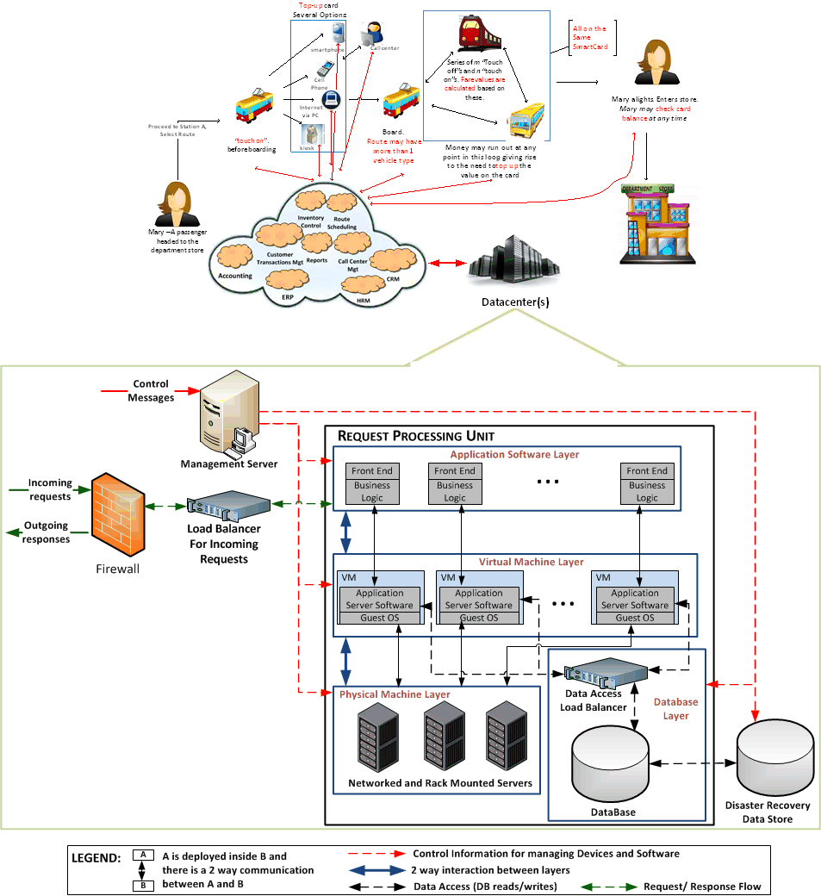Figure 14: One possible private cloud system architecture for the “myki”, based on 3-tier software architecture. Numbers, layout and capacities of devices in the “RPU” are derived directly from simulation for various workloads. Other components added to keep with Private Cloud best practices.
uses this as a frame of reference throughout the entire process, giving rise to higher confidence that the design will be more likely to meet the goals of intended stakeholders. Secondly, it gives more room for human judgment and domain knowledge to guide progress through every phase, providing designers with greater control and flexibility. Third, it relies on analysis techniques that are already well known and used in the Software Engineering community, thus the learning curve required to use the approach is expected to be minimal.
Determining the cause and resolution of conflicts in the requirements engineering process for cloud-based systems can be tricky because they could arise solely from the goals, from the stakeholders themselves, from the system’s domain or the interplay of these and other factors. This is even more complicated when the multi-dimensional, multi-stakeholder, multi-objective and large scale nature of cloud-based systems is factored in. This work shows one qualitative way of dealing with this interconnectedness of problem sources towards better resolution of such conflicts while attempting to prevent them from manifesting in the eventually developed system.
As an aid to the requirements negotiation process, we expect that this work would provide a more accurate decision support than verbal negotiation and conflict resolution since simulations are actually used to provide more objective evidence of how design decisions affects the goals of each stakeholder in the cloud-based system development process. Another benefit of using simulation in this approach is that since real-world request (inter)arrival rates and other factors are impossible to determine in reality, the designer can evaluate how the system behaves under different known probability distribution functions.
Without a systematic approach such as the one described in this paper, evaluating whether cloud-based system architecture will be good enough to meet stakeholder goals could be quite challenging, expensive and time consuming. For example, this may involve purchasing as well as manually/physically configuring a cloud and/or testing it. However, from a science of design perspective, two major concerns that still need to be more properly addressed in order to make this approach more robust are:
- How can convergence after very few steps be ensured?
- Do the incrementally better architectural alternatives considered via the simulation model actually approach the global “optima” in the design space?
Addressing these issues will be important in making sure that the modeling costs involved in using the proposed approach does not get so significant as to outweigh the potential time and cost reduction. Although our current results look promising, an essential part of our future work will entail the incorporation of other techniques (e.g., [10]) into our approach which may help ensure quick convergence. Providing tool support for our approach is also another avenue by which modeling costs may be further reduced, and one that we are also considering, going forward.
In Software Engineering, an important part of quantitatively complementing qualitative Goal-Oriented analysis frameworks has been to formally define sound and complete axiomatization that unambiguously define how reasoning might be done about the quantitative goals. Prior work on this include those which discuss quantitative reasoning in the NFR Framework [43], quantitative extension to the NFR Framework to aid requirements traceability [44] and formal reasoning about alternatives in KAOS goal models [45]. In this paper, we gave heuristics for reasoning about levels of goal and stakeholder satisfaction when SIGs are quantitatively extended with design constraints obtained from the domain. Hopefully, this will be a good starting point for the formalizations needed to reason about the quantitative extensions to the SIG as presented in this paper.
Finally, we wish to re-emphasize that, in this paper, we presented the 6 steps in our approach in sequence purely for pedagogic reasons. Such a purely incremental/sequential approach is neither intended nor recommended to be followed in practice. Rather, practitioners may run multiple steps in parallel, revisit earlier steps based on outcomes of latter steps or alter the sequence - whatever is more suited to the nature of each project. The iterative, interleaving and interactive nature of our approach, as intended, was discussed earlier in Section 3.
- RELATED WORK
A recent goal-oriented simulation technique [10] attempts to fully automate the search through the design space for a design that results in an optimal degree of goal satisfaction. This technique utilizes a multi-objective optimization algorithm and converges on a set of Pareto-optimal solutions which approach the global optima within the sample space considered. This technique, however, requires significant amount of mathematical/probabilistic modeling and extension of the goal model with numerical values prior to the automation steps. It therefore has the disadvantage that it may not scale very well to very large goal models with a lot of interrelationships since the amount of mathematical modeling required prior to automation may grow exponentially with the size and complexity of the goal model. Also, since the sample of the design space considered is randomly generated and automatically searched, it “robs” human designers of the opportunity to guide the process – something that may be crucial for very critical systems. Our approach allows human architects to guide the process. We have been experimenting with using this Genetic Algorithm based technique [10] complementarily with the one described in this paper, since each one seems to address the other’s perceived shortcomings. It is noteworthy that the inequality expressions in the various constraint symbols (Section 3.4.2) bear some semblance to the objective functions used to guide the algorithmic search through the design space [10]. We hope to build on this similarity, among others, in creating a hybrid from these two approaches, if possible.
Another approach for using simulation to evaluate non-functional aspects of cloud-based system designs uses results from queuing theory to predict whether a cloud-based system with a fixed capacity will remain stable [42] over time. Stability is measured by the ability of the system to maintain constant response times as more and more requests arrive in the datacenter. However, evaluations are validated against theoretical queuing models such as the M/M/1 model, as opposed to actual stakeholder goals that necessitated such designs in the first place. Considering the multi-stakeholder, multi-objective nature of cloud-based design, it is not clear how such evaluations can be used for improving the system in a rational and fair manner.
In the non-cloud domain, the Architecture Simulation Model (ASM) Approach [7–9] has been proposed for use in evaluating system design alternatives with respect to specific non-functional goals like performance and scalability in both the design and maintenance phases of system development. The ASM originally proposed the integration of simulation, which is quantitative in nature with goal-orientation, which is qualitative in nature. It therefore served as an important the basis for the work described in this paper.
Designing a system to be fair to multiple stakeholders is a well-studied topic in the Software Engineering community. The importance of stakeholder identification and analysis in the design process [16], [24], [46] as well as techniques for dealing with conflicts that arise from the requirements of different stakeholders [47 – 49] have been described. In addition, the topic of negotiating among stakeholders in order to resolve conflicts have also been discussed [50], [51]. Integrating more of these results into our approach is likely to make it even more useful.
The work in this paper is related to early stage modeling, analysis and evaluation of system design which have also been well studied. Architecture validation during the analysis phase of system development via the Enterprise Architecture Simulation Environment (EASE) [52] and early stage performance modeling in the design of embedded control software [53] are some of the topics that have received attention in this area. Regarding the use of non-functional requirements for early-stage performance evaluation of designs, an ontology-aided performance engineering approach using the NFR Framework has been proposed [54].
Although Capacity Planning is expected to be less important in cloud-based systems than it has been for traditional enterprise systems, it can still be a critical success factor in an organization’s Cloud Computing Adoption strategy. To this end, several work on capacity planning for cloud-based systems have appeared [55–57]. However, these have been mostly focused on datacenter resource optimization techniques with little or no consideration of how decisions to use such techniques can affect the stakeholders of the cloud-based system. This work can help capacity planners to better integrate actual stakeholder needs into their work, considering the conflicts that may exist among such stakeholders and their goals.
- CONCLUSION
The goal-oriented simulation approach proposed in this paper starts with the capturing and understanding of multiple stakeholders’ goals, which are subsequently refined and quantitatively complemented, based on certain domain characteristics. A CloudSim simulation model is then built based on these, as the means of assessing the impact of design choices on the degree to which the various goals are satisficed. After a number of iterations the approach yields a design which may then be tested in a real cloud deployment. Other contributions made by this paper include a new visual notation to help in managing the complexity of the modeling process as well as heuristics for reasoning about the quantitative additions to the SIG, which is a qualitative goal modeling framework.
Our approach demonstrates one way of exploring, evaluating, and selecting among cloud-based system design alternatives with respect to stakeholder goals. This is likely to provide better rational decision support and even better cost savings for Cloud Computing, which seems to be among the most critical technological innovations for cost savings, while resulting in architectures that are more likely to be good enough despite the unique nature of cloud based system design and conflicts arising from stakeholders and their goals. Using this approach, architects can more rationally and systematically transition from stakeholder goals to the architectural design of a cloud computing-based system. The work also demonstrates the value of goal-oriented i.e. a rational approach to the science of design, especially when combined in an interleaving manner with simulation, in understanding and conquering the complexity involved in developing a cloud-based system.
We are currently working on how our approach can be applied to other layers in the XaaS model, in addition to the Infrastructure-as-a-Service (IaaS) layer explored in this paper, including the Platform-as-a-Service (PaaS) and Software-as-a-Service (SaaS) layers. In the future we plan to investigate how to make the approach converge much faster to satisficing architecture, while developing guidelines for ensuring that the design in each iteration is better than the ones in the previous iterations. Additionally, we plan to conduct a case study in which the results obtained from our goal-oriented simulation approach are compared with values obtained from the actual running system, as a way of further validating our approach. As a matter of fact, we have already started to run experiment, currently in the Google App Engine environment, which should help enhance the level of confidence in the validity of the results of the simulation runs presented in this paper.
- REFERENCES
[1] M. Armbrust, A. D. Joseph, R. H. Katz, and D. A. Patterson, “Above the Clouds: A Berkeley View of Cloud Computing,” UC Berkeley, Tech. Rep., No. UCB/EECS-2009-28, 2009
[2] P. Mell and T. Grance, “The NIST Definition of Cloud Computing,” National Institute of Standards and Technology, vol. 53, no. 6, p. 50, 2009.
[3] R. Clarke, “User Requirements for Cloud Computing Architecture,” 10th IEEE/ACM International Conference on Cluster, Cloud and Grid Computing, 2010, pp. 625–630.
[4] S. Zardari and R. Bahsoon, “Cloud adoption: a goal-oriented requirements engineering approach,” in Proceedings of the 2nd International Workshop on Software Engineering for Cloud Computing, 2011, pp. 29-35.
[5] T. J. Lehman and S. Vajpayee, “We’ve Looked at Clouds from Both Sides Now,” SRII Global Conference, 2011, pp. 342–348.
[6] A. van Lamsweerde, “Goal-oriented requirements engineering: a guided tour,” in Proceedings. Fifth IEEE International Symposium on Requirements Engineering,
2001, pp. 249-262.
[7] T. Hill, S. Supakkul, and L. Chung, “Confirming and Reconfirming Architectural Decisions on Scalability: A Goal-Driven Simulation Approach,” in On the Move to Meaningful Internet Systems: OTM 2009 Workshops, 2009, pp. 327–336.
[8] T. Hill, “Software maintenance and operations hybrid model: An IT services industry architecture simulation model approach,” in Research Challenges in Information Science (RCIS), Fifth International Conference on, 2011, pp. 1–6.
[9] T. Hill, S. Supakkul, and L. Chung, “Run-time monitoring of system performance: A goal-oriented and system architecture simulation approach,” in Requirements@Run.Time (RE@RunTime), First International Workshop on, 2010, pp. 31-40.
[10] W. Heaven and E. Letier, “Simulating and optimising design decisions in quantitative goal models,” in 19th IEEE International Requirements Engineering Conference (RE’11), 2011, pp. 79–88.
[11] A. Kertész, G. Kecskeméti, and I. Brandic, “Autonomic SLA-aware Service Virtualization for Distributed Systems,” in 19th International Euromicro Conference on Parallel, Distributed and Network-Based Processing, 2011, pp. 503–510.
[12] R. Jeyarani, R. V. Ram, and N. Nagaveni, “Design and Implementation of an Efficient Two-Level Scheduler for Cloud Computing Environment,” 10th IEEE/ACM International Conference on Cluster, Cloud and Grid Computing, pp. 585-586, 2010.
[13] “Official Home Page of the myki project.” [Online]. Available: http://www.myki.com.au/. [Accessed: 31-Oct-2011].
[14] A. C. Yoh, H. Iseki, B. D. Taylor, and D. A. King, “Interoperable transit smart card systems: Are we moving too slowly or too quickly?” Transportation Research Record: Journal of the Transportation Research Board, vol.1986, no.1, pp.69–77, 2006.
[15] N. Mallat, M. Rossi, V. Tuunainen, and A. Öörni, “An empirical investigation of mobile ticketing service adoption in public transportation,” Personal and Ubiquitous Computing, vol. 12, no. 1, pp. 57–65, 2008.
[16] H. Sharp, A. Finkelstein, and G. Galal, “Stakeholder identification in the requirements engineering process,” in Proc. Tenth International Workshop on Database and Expert Systems Applications, pp. 387–391, 1999.
[17] A. Anton, “Goal-based requirements analysis,” in Proceedings of IEEE International Requirements Engineering Conference (RE’96), pp. 136-144, 1996.
[18] “IBM Cloud Computing Reference Architecture,” 23-Jul-2010. [Online]. Available: https://www.ibm.com/developerworks/mydeveloperworks/blogs/c2028fdc-41fe-4493-8257-33a59069fa04/tags/ccra?lang=en. [Accessed: 08-Mar-2012].
[19] “NIST Cloud Computing Reference Architecture.” [Online]. Available: http://www.nist.gov/manuscript-publication-search.cfm?pub_id=909505. [Accessed: 09-Aug-2012].
[20] “The CHAOS report.” [Online]. Available: http://www.projectsmart.co.uk/docs/chaos-report.pdf. [Accessed: 08-Mar-2012].
[21] L. Chung and JCSP Leite, “On non-functional requirements in software engineering,” Conceptual modeling: Foundations and Applications, vol. 5, no. 4, pp. 285-294, 2009.
[22] J. Mylopoulos, L. Chung, and B. Nixon, “Representing and using nonfunctional requirements: A process-oriented approach,” Software Engineering, IEEE Transactions on, vol. 18, no. 6, pp. 483–497, 1992.
[23] E. S. K. Yu, “Towards modelling and reasoning support for early-phase requirements engineering,” in Proceedings of the Third IEEE International Symposium on Requirements Engineering, pp. 226–235, 1997.
[24] A. van Lamsweerde, “Requirements Engineering: From System Goals to UML Models to Software Specifications”, John Wiley & Sons, Chichester (2009)
[25] E. Yu, “Modelling strategic relationships for process reengineering,” in Social Modeling for Requirements Engineering, 2011, pp. 1-15.
[26] R. Buyya, R. Ranjan, and R.N. Calheiros, “Modelling and simulation of scalable Cloud computing environments and the CloudSim toolkit: Challenges and opportunities”, International Conf. on High Performance Computing & Simulation, pp.1-11, 2009.
[27] A. Nuñez, J. Vázquez-Poletti, A. Caminero, J. Carretero, and I. Llorente, “Design of a New Cloud Computing Simulation Platform,” Computational Science and Its Applications-ICCSA 2011, pp. 582–593, 2011.
[28] D. Kliazovich and P. Bouvry, “GreenCloud: a packet-level simulator of energy-aware cloud computing data centers,” in IEEE Global Telecommunications Conference (GLOBECOM 2010), pp. 1-5, 2010.
[29] “Point of Sales Systems (POS) - GAO Research.” [Online]. Available: http://www.gaoresearch.com/POS/pos.php. [Accessed: 08-Mar-2012].
[30] J. D. C. Little and S. C. Graves, “Little’s Law,” Operations Management, pp. 81-100, 2008.
[31] T. Wood, L. Cherkasova, K. Ozonat, and P. Shenoy, “Profiling and modeling resource usage of virtualized applications,” in Proceedings of the 9th ACM/IFIP/USENIX International Conference on Middleware, pp. 366–387, 2008.
[32] “TPC-C - Homepage.” [Online]. Available: http://www.tpc.org/tpcc/. [Accessed: 08-Mar-2012].
[33] R. N. Calheiros, R. Ranjan, and C. D. Rose, “Cloudsim: a novel framework for modeling and simulation of cloud computing infrastructures and services,” Arxiv preprint arXiv:, pp. 1-9, 2009.
[34] B. Wickremasinghe, R. N. Calheiros, and R. Buyya, “CloudAnalyst: A CloudSim-Based Visual Modeller for Analysing Cloud Computing Environments and Applications,” 24th IEEE International Conference on Advanced Information Networking and Applications, pp. 446-452, 2010.
[35] A. Greenberg, J. Hamilton, and D. Maltz, “The cost of a cloud: research problems in data center networks,” ACM SIGCOMM Computer, vol. 39, no. 1, pp. 68-73, 2008.
[36] R. Kazman, M. Klein, and M. Barbacci, “The architecture tradeoff analysis method,” Proc. 4th IEEE International Conference on Engineering of Complex Computer Systems, pp. 68 - 78, 1998.
[37] L. Chung, B. A. Nixon, and E. Yu, “Using non-functional requirements to systematically select among alternatives in architectural design,” in Proc. 1st Int. Workshop on Architectures for Software Systems, pp. 31–43, 1995.
[38] “Mapping Applications to the Cloud.” [Online]. Available: http://msdn.microsoft.com/en-us/library/dd430340.aspx. [Accessed: 08-Mar-2012].
[39] A. I. Avetisyan et al., “Open cirrus: A global cloud computing testbed,” Computer, vol. 43, no. 4, IEEE, pp. 35–43, 2010.
[40] “Cloud computing research testbed | Technical overview.” [Online]. Available: http://www.hpl.hp.com/open_innovation/cloud_collaboration/cloud_technical_overview.html. [Accessed: 10-Mar-2012].
[41] “Intel® Cloud Builders Secure and Efficient Cloud Infrastructure.” [Online]. Available: http://www.intel.com/content/www/us/en/cloud-computing/cloud-builders-provide-proven-advice.html. [Accessed: 10-Mar-2012].
[42] J. Wang and M. N. Huhns, “Using simulations to assess the stability and capacity of cloud computing systems,” in Proceedings of the 48th Annual Southeast Regional Conference, 2010, p. 74.
[43] P. Giorgini, J. Mylopoulos, and E. Nicchiarelli, “Reasoning with goal models,” in Proceedings of the 21st Int. Conference of Conceptual Modeling (ER2002), no. October, pp. 167 – 182, 2003.
[44] J. Cleland-huang, W. Marrero, and Brian Berenbach, “Goal-Centric Traceability?: Using Virtual Plumblines to Maintain Critical Systemic Qualities,” IEEE Transactions on Software Engineering, vol. 34, no. 5, pp. 685-699, 2008.
[45] A. van Lamsweerde, “Reasoning about Alternative Requirements Options,” Conceptual modeling: Foundations and Applications, LNCS, vol. 5600, pp. 380 - 397, 2009.
[46] L. Chung, D. Gross, and E. Yu, “Architectural design to meet stakeholder requirements,” In: Donohue, P(ed.). Software Architecture. Kluwer Academic Publishers. San Antonio, Texas.
[47] A. V. Lamsweerde and R. Darimont, “Managing conflicts in goal-driven requirements engineering,” Software Engineering, vol. 24, no. 11, pp. 908-926, 1998.
[48] B. Boehm and H. In, “Conflict analysis and negotiation aids for cost-quality requirements”, Univ. of Southern California, Tech. Rep., No USC-CSE-99-530, 1999.
[49] A. Finkelstein, M. Harman, and S. Mansouri, “‘Fairness Analysis in Requirements Assignments,” Requirements, pp. 115-124, 2008.
[50] H. In, D. Olson, and T. Rodgers, “A requirements negotiation model based on multi-criteria analysis,” in Proceedings of the Fifth IEEE International Symposium on Requirements Engineering, pp. 312–313, 2001.
[51] H. In, B. Boehm, T. Rodgers, and M. Deutsch, “Applying WinWin to quality requirements: a case study,” in Proceedings of the 23rd International Ionference on Software Engineering, 2001, pp. 555–564.
[52] S. S. Brink, “Enabling Architecture Validation in the Analysis Phase of Developing Enterprise or Complex Systems using Enterprise Architecture Simulation Environment (EASE),” in Military Communications Conference, 2007, pp. 1–8.
[53] S. Wang and K. G. Shin, “Early-stage performance modeling and its application for integrated embedded control software design,” Proceedings of the fourth International Workshop on Software and Performance (WOSP ’04), p. 110, 2004.
[54] P. P. Sancho, C. Juiz, R. Puigjaner, L. Chung, and N. Subramanian, “An approach to ontology-aided performance engineering through NFR framework,” Proceedings of the 6th International Workshop on Software and Performance, pp. 125 - 128, 2007.
[55] S. Mylavarapu, V. Sukthankar, and P. Banerje, “An optimized capacity planning approach for virtual infrastructure exhibiting stochastic workload,” in Proceedings of the 2010 ACM Symposium on Applied Computing (SAC ’10), 2010, pp. 386 - 390.
[56] R. Lopes, F. Brasileiro, and P. D. Maciel, “Business-Driven Capacity Planning of a Cloud-Based IT Infrastructure for the Execution Of Web Applications,” IEEE International Symposium on Parallel & Distributed Processing, Workshops and Phd Forum (IPDPSW), 2010, pp. 1-10.
[57] D. A. Menasce and P. Ngo, “Understanding cloud computing: Experimentation and capacity planning,” in Computer Measurement Group Conference, 2009.
[58] L. Chung, B. Nixon, E. Yu and J. Mylopoulos, “Non-Functional Requirements in Software Engineering. Kluwer Academic Publishers”, Dordrecht (2000)
[59] L. Duboc, E. Leiter, D. Rosenblum, "Systematic Elaboration of Scalability Requirements through Goal-Obstacle Analysis”, Software Engineering, IEEE Transactions on, vol.PP, no.99, pp.1, 2011
[60] C. B. Weinstock and J. B. Goodenough, “On systems scalability,” Software Engineering Institute, Technical Note CMU/SEI-2006-TN-012, 2006.
[61] Menasce, D., Vigilio, A., “Scaling for E-Business: Technologies, Models, Performance, and Capacity Planning”, Prentice Hall PTR, Englewood Cliffs (2000)

Descriptions from CloudSim Authors obtained from comments at http://groups.google.com/group/cloudsim
The abbreviations are not part of the original definitions, but have rather been used for brevity in the rest of the paper.

